

**VIETNAM NATIONAL UNIVERSITY – HO CHI MINH CITY - UNIVERSITY OF INFORMATION TECHNOLOGY**

**FACULITY OF INFORMATION SYSTEMS**



**INFORMATION SYSTEM ANALYSIS AND DESIGN**

**DORMITORY MANAGEMENT PROJECT**

**LECTURE: DUONG PHI LONG  
CLASS: IS201.N11.HTCL**

*GROUP NAME: KRATOS*

*ĐINH HOÀNG TRÍ – 20522046*

*NGUYỄN TẤN PHÁT – 20521736*

*HỒ TUẤN TRUNG – 20522068*

*NGUYỄN ANH NGUYÊN - 20521674*

January 9, 2023

# **PERFACE**

As you all know, Vietnam National University, Ho Chi Minh City (VNU-HCM) is one of two national university systems in Vietnam, located in Ho Chi Minh City, which is rated as one of 1000. Vietnam's best university/group of universities in the world. Ho Chi Minh City National University is a leading research and training center in Vietnam. Located in the government's planning, the urban area of ​​VNU in Thu Duc district, Ho Chi Minh City will be home to 6 member universities of VNU HCMC and other affiliated units. Every year, a large number of students come to study and live, so the urban area of ​​VNU is home to the largest student community in our country. To meet the accommodation needs of students, the dormitory of VNU-HCM has been built since 2000 and has been continuously expanded and improved. Up to now, the dormitory of VNU-HCM has met. accommodation for nearly tens, hundreds of thousands of students.

Students who choose the dormitory of VNU as a place to live during their university days want a safe place, a healthy environment, full facilities and benefits for a student. This is not an ordinary dormitory but also a place where students can train themselves physically and mentally. This requires the VNU-HCM dormitory to have strategies and actions to meet the needs of students, this is a big challenge for the dormitory and there are difficulties in the digital management process. Great student salary. To do this, it is required that the Dormitory must have a solution, an innovative management method, which must be different from the old management methods, recorded on old papers. This method must ensure effective management of large numbers of students year after year.

It is for the above reasons that Kratos team has the desire to build a dormitory management system of VNU-HCM and has conducted the project "Management of dormitory of Vietnam National University" and applied technology. information, current leading data management tools, supplementing and upgrading a few important functions for VNU Dormitory. In the process of implementing the project, the team inevitably makes mistakes, and we look forward to receiving your comments and suggestions.

# **THANK YOU**

First, the authors would like to express their sincere thanks to the teachers of the Faculty of Information Systems, University of Information Technology, Vietnam National University, Ho Chi Minh City, for their enthusiastic guidance throughout the study period. at school. The knowledge that the teachers have imparted is an important foundation for the group to be able to complete this topic.

The team would like to express their sincere thanks and deep gratitude to Mr. Duong Phi Long and Ms. Cao Thi Nhan, thank you and your teachers for their enthusiastic guidance and for creating the best conditions for the Kratos group to complete this thesis. The words of encouragement and sincere suggestions of teachers are valuable motivation to overcome difficulties when researching and implementing the project.

The teachers have enthusiastically guided, corrected and contributed many valuable comments to help the group complete their subject report well. During one semester of implementation, the Kratos team applied the accumulated background knowledge and combined with learning and researching new knowledge. From there, the team makes the most of what has been collected to complete the best project report.

The group tried very hard to apply the knowledge learned to build the project "Management of the National University Dormitory". However, in the implementation process, the team is not immune to shortcomings. Therefore, the group is looking forward to receiving suggestions from teachers so that the Kratos group in general as well as the group members can draw more lessons and experiences to improve the subject knowledge. and is the luggage for the group to carry out other topics in the future.

Best regards,

Group

Kratos

# **TABLE OF CONTENTS**

CONTENTS

**PERFACE** 1

**THANK YOU** 2

**TABLE OF CONTENTS** 3

**CHAPTER I: TOPIC OVERVIEW** 5

**1. Problems of project** 5

**2. Solution and goal of the project** 6

**3. Objectives of project** 6

**4. Scope of project** 7

**5. Developer tools & Technology** 7

**CHAPTER II: DETERMINATION AND ANALYSIS OF REQUIREMENTS** 8

**1. Situation survey/ Survey of current situation** 8

**1.1 Organization chart of the dormitory management center** 8

**1.2 Survey of business processes, major activities** 8

**1.3 Regulations and procedures in student management** 12

**2. Sofware requirement** 18

**2.1 Storage information** 18

**2.2 Feature requirements.** 18

**2.3 Non-functional requirements** 19

**CHAPTER III: ANALYST AND DESIGN** 20

**1. Use-case Diagram** 20

**1.2 List of actors** 24

**1.2 List of use-case** 24

**2. Use-case specification and activity diagram** 25

**2.1 Sign-in (for student)** 25

**2.2 Sign-in (for employee)** 27

**2.3 Sign-in (for administrator)** 30

**2.4 Manage employees** 32

**2.5 Payment cost (for administrator and employees)** 38

**2.6 Payment cost (for student)** 43

**2.7 Arrange room** 46

**2.8 View profile** 52

**2.9 View stay history** 53

**2.10 Manage student** 54

**2.11 Manage dorm room** 60

**2.12 Statistics (for Employee)** 66

**3. Sequence diagram and class diagram** 72

**3.1 Sign-in** 72

**3.2 Manage Employees** 74

**3.3 Payment cost (for Administrator and Employees)** 79

**3.4 Payment cost (for Student)** 83

**3.5 Manage Student** 85

**3.6 Manage dorm room** 90

**3.7 Statistics** 93

**3.8 Arrange room** 98

**3.9 View profile** 102

**3.10 View stay history** 103

**4. Class diagram and entity class diagram** 105

**4.1 Entity class diagram** 105

**4.2 Class diagram specification** 106

**5. State diagram** 112

**5.1 Arrangre room** 112

**5.2 Student** 113

**CHAPTER IV: IMPLEMENTATION AND TESTING** 114

**1. Introduction to the implementation environment** 114

**2. User Interface** 114

**CHAPTER V: CONCLUSION** 123

**1. Project achievement** 123

**2. Limitations** 123

**3. Development direction** 123

**CHAPTER VI: SELF ASSESSMENT** 124

# **CHAPTER I: TOPIC OVERVIEW**

## **1. Problems of project**

With the strong development of information technology, the application of management software in practice is no longer strange to Vietnamese people. We can come across software that supports management work everywhere, from business management software to coffee shops, convenience stores, restaurants, hotels.... To more complex ERP systems in large enterprises and corporations, with thousands of investigators and branches all over the place. The application of information technology to management has significantly reduced management costs and improved work management efficiency and saved human resources, time and money for businesses.

Established in 2000, the Dormitory Management Center affiliated to Vietnam National University, Ho Chi Minh City is the unit responsible for providing accommodation, food, health care, and taking care of the material and spiritual life of domestic students. , outside the area of ​​Thu Duc - Di An. Up to now, after more than 22 years of operation, the dormitory now has a capacity of hundreds and thousands of students with a campus consisting of Dormitory Zone A and Zone B. This is a place for healthy accommodation, activities, and entertainment, the quality of students from many universities and colleges located in the area.

With such a large scale of student management and such an extremely large amount of facilities, there are not many staff members currently in charge of student management, along with limitations in the management, operation and management processes. The number of students is constantly increasing due to the expansion of the Dormitory every year, causing many difficulties for the Dormitory management in managing students:

* Keeping records mostly in paper and Excel files is a waste of money and difficult to find information.
* There is no effective statistical tool, when statistics are needed, they must go through the management staff, the stages are complicated and then summed up, which takes a lot of time and effort.
* The relationship between the units in the Dormitory is weak, leading to information not being updated in time between the parties, data conflicts and violations of the properties of the data.
* The management and repair of facilities are all done in paper, so it is very inconvenient to make statistics and overlap in storage.

To solve the above problem, a more general solution is needed, an application of information technology in the management of building a system for student management of the dormitory. The built system must be an integrated management system, storing information centrally and responding to a wide range of users. Besides, it is also necessary to standardize the work process, so that the application of information technology is effective.

## **2. Solution and goal of the project**

Group Kratos plans to build a dormitory management system that allows the dormitory manager and director to have full access to the system, easily accessing necessary data such as student records, registering students, canceling student dormitory registration, living expenses (accommodation, electricity and water fees ...), especially managing student rooms, because a room can have many students. However, there must be a limit, ensuring that all registered students have rooms, avoiding data-touching and lack of rooms for students. Next is the quality of facility management problem, must ensure that each room has adequate facilities for students (bathroom, site, door ...) and there will be basic damaged materials that need to be repaired and replaced. In addition, the manager also manages additional staff in the dormitory (repair staff, cleaning staff, security staff, etc.). The management of too many things, too many objects, we need to build an extremely stable and tight system management system.

As for the student mode, students will need requirements such as 'How many rooms are available, 'What will the room space be like', 'Is the room fully furnished, facilities or not’, 'Can students change rooms if the existing room is not suitable?'… In general, we must answer the application that is requested by students especially price and facilities. It is the big recipe for the system management hostel.

## **3. Objectives of project**

In the scope of this subject, we would like to create an information responsible for allowing user follow latest information, showtimes of any available room of any available dorm.

There are some our systems main features:

* Output sheet for reports.
* Management input & output automatically.
* Manage information of dorm, students, rooms, employees.
* Manage information of students.
* Manage infrastructure.
* Manage cost.
* Latest information update.
* Backup.

## **4. Scope of project**

Because of limitations about time, human, our teams focus to some main features such as:

* Dorm management.
* Student management.
* Employee management.
* Infrastructure management.
* Cost management.
* Retrieval information.

## **5. Developer tools & Technology**

* Git / GitHub for version control.
* Visual Studio Code.
* Diagram Software and Flowchart Maker.
* SQL Sever Developer.

# **CHAPTER II: DETERMINATION AND ANALYSIS OF REQUIREMENTS**

## **1. Situation survey/ Survey of current situation**

### **1.1 Organization chart of the dormitory management center**

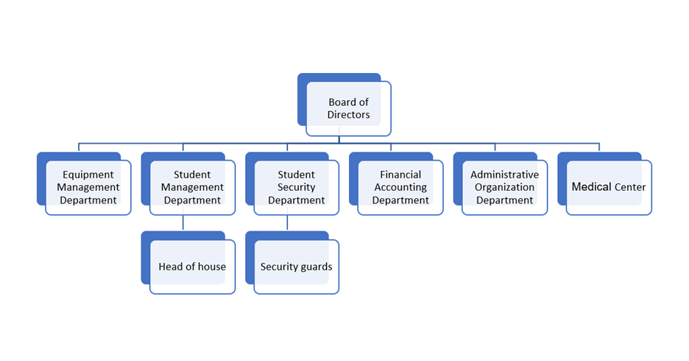

### **1.2 Survey of business processes, major activities**

#### *1.2.1 Functions and duties of the board of directors*

* + - The dormitory management center's board of directors currently consists of three members: one director and two deputies director.
    - Functions and duties of the board of directors: to run all activities of the dormitory and take responsibility comprehensive task of the operation of the dormitory management center before the leaders of VNU HCMC.

#### *1.2.2 Functions and duties of the administrative Organization Department*

* + Advising the director on the work: organization- officer, general administration, clerical storage, reception.
  + Implement regimes and policies for public officials and protect internal politics.
  + Make contact with units inside and outside VNU.
  + Organize the management of student services.

#### *1.2.3 Functions and duties of the device administration department*

* ***Function*:**
* Advising the director on the planning, basic construction, development, management and use of facilities (land, houses, architecture, machinery and equipment assets...) of the dormitory management center.
* Carry out asset procurement and track asset use for the tasks of the dormitory management center.
* ***Duty*:**
* Prepare and implement plans, additionally build and repair works and facilities for the work of the dormitory management center.
* Organize the implementation of processes in the formulation of investment projects, design, construction, supervision and acceptance and handover of minor repair works, machinery and equipment procurement projects in accordance with current regulations.
* Organize the management of facilities, assets, equipment, ensure electricity and water for daily life within the industrial park and related areas.
* Perform environmental sanitation in the dormitory.
* Procurement and allocation of working machinery and fire protection equipment of dormitory.
* Manage and effectively use labor, facilities and equipment assigned by the dormitory management center.

#### *1.2.4 Functions and duties of the accounting department*

* ***Function*:**
* Report to the board of directors on the management of financial and accounting activities.
* Implement centralized management and effective use of financial resources in accordance with the state's regulations.
* ***Duty*:**
  + Develop and implement short-term and long-term financial plans.
  + Urge, collect correctly, fully and promptly the fees of students, the revenues to pay the obligations of units and business households under the center, have financial collection and expenditure activities.
  + Pay salaries, allowances and other regimes to civil servants, contract workers, build facilities, repair and purchase equipment of the center in accordance with current regulations.
  + Carry out the work of synthesizing and reporting on financial activities according to the current regime. Preservation and storage of accounting documents in accordance with regulations.

#### *1.2.5 Functions and duties of the Student Management Department*

* ***Function*:**
* Receiving and managing students, taking care of material and cultural life mental chemistry for boarding students.
* ***Duty*:**
* Coordinate with relevant units to receive and arrange students into the dormitory.
* Organize the implementation of plans and plans for arranging rooms for students and trainees in the dormitory in accordance with regulations, ensuring science and convenience for the management of the center and learning of boarding students.
* Guide students to comply with the rules of the dormitory, ensure security order, healthy living and educational environment.
* Coordinate the evaluation of training results for boarding students. Make records of students violating the regulations, propose to monitor the results of resolving cases of student violations.
* The organization takes care of material and spiritual life for students in dormitory, captures and educates ideas and political consciousness for students. Organization of playgrounds, academic clubs, hobbies for students.

#### *1.2.6 Functions and duties of the student security room*

* ***Function*:**
* Ensure the security and order, safety of life and property within the dormitory
* ***Duty*:**
* Guide guests to business contacts, visitors to and from offices, students to enter and exit the dormitory in accordance with regulations.
* Make a plan to organize the implementation of fire prevention and fighting. Coordinate with units to regularly inspect equipment and fire protection. Standing fire protection of the center.
* Work closely with local police to effectively implement measures to protect political security, protect the lives and property of boarding students and center staff.

#### *1.2.7 Functions and duties of the medical center*

* ***Function*:**
* Facilities include emergency room, general internal room, patient reception room, dental - jaw - face room, medicine dispensing room and 10 disease storage rooms.
* ***Duty*:**
* Health care for employees and students at schools and units under VNU Ho Chi Minh City who are working and studying in Thu Duc area.
* Consulting on psychophysiology, student reproductive health, food hygiene and safety inspection, environmental hygiene, disease prevention in the dormitory.

#### *1.2.8 Head of house*

* ***Duty*:**
* Managing each block, working directly with students, being an important bridge between dormitory leaders and students, taking responsibility within their homes to manage and supporting students in the following tasks:
* Capture thoughts, aspirations, share information in students.
* Guide students to check in and check in from students at the end of the semester, sign the payment confirmation to the dormitory at the end of the academic year for students.
* Receive papers, records, information, opinions of students, process and respond promptly.
* Check, remind and guide students to implement internal rules and regulations.
* Propagating and mobilizing students to participate in movements launched by dormitory.
* Monitor electricity and water index and management, remind students to pay fees, summarize the use of equipment in rooms

#### *1.2.8 Security Guard*

Security guards are responsible for ensuring the safety of people, property, facilities, and equipment in the dormitory:

* Coordinate with the head of the house in guiding the implementation of internal regulations and regulations of the dormitory.
* Check and control people and vehicles entering and leaving the dormitory, keep documents of visitors to visit students, guide visitors to work contacts
* Perform room checks on students outside of office hours to ensure security, check the implementation of student rules, help students in case of accident, illness....
* Regularly check electrical, water, fire protection equipment...ensuring electricity and water demand and fire safety within dormitory

### **1.3 Regulations and procedures in student management**

#### *1.3.1 Regulations on semesters and length of stay*

The period of stay at VNU dormitory for one academic year is divided into two semesters main semester and a sub-semester, in response to the school's semester allocation member of the National University. The division of timelines is also the basis for the management center Dormitory accepts students and charges boarding fees.

* Semester 1: the main semester of the school year, usually counted from September 1 to the end January 31 of the following year. The conversion period is equivalent to 5 months.
* Semester 2: the main semester of the school year, usually counted from February 1 to the end 31/07. The conversion time is equivalent to 6 months.
* Semester 3: also known as summer semester, is an extra semester in the school year, usually from August 1 to the end of August 30. The conversion period is calculated as 1 month.

Regulations on timelines and semesters are subject to change depending on the actual situation and will be Dormitory management center widely informs students and member schools of VNU and on the dormitory website.

#### *1.3.2 Regulations on fees*

- Before the start of the semester, the board of directors and the finance department met to agree on the types of fees and charges collected during the semester.

- Types of boarding fees that students must pay when registering at the dormitory:

* Dormitory boarding fee is the amount students have to pay every month to stay at the dormitory (excluding monthly electricity and water fees). Students pay boarding fees Dormitory once for the whole semester, if the student leaves the dormitory before the end of the semester, Dormitory management center will consider refunding the amount of boarding fee based on the number of remaining months of the semester. Dormitory boarding fee has preferential treatment for students with permanent residence in the provinces that have contributed to the construction of dormitories.
* Facility or property bond is a required fee, students pay a lump sum at the beginning of each academic year, or at the beginning of the semester in which the student Registering in the dormitory for students entering the dormitory in the 2nd or 3rd semester. Money Substitute facilities to pay for minor repairs in the student room. At the end of the school year or when students leave the dormitory, The center will refund the remaining deposit based on the charging of the repair fee Damages in student accommodation.
* Application fee and KTX card is a mandatory fee, students pay once in at the beginning of each school year, or at the beginning of the semester in which the student enrolls in the dormitory for Students enter the dormitory in the 2nd semester.
* Health insurance: is an optional fee. Health insurance is compulsory for birth members according to state regulations. However, students may have participated in insurance at school or have insurance according to social policy, so dormitory does not Students are required to pay health insurance.
* Accident insurance: is an optional fee.

- For international students, PhD students, student’s fees will be calculated according to separate regulations with training units.

- Compensation fees and fines: the amount an individual or a student group payable when violating dormitory rules or damaging public property or property belonging to the student dormitory but the damage is of great value.

#### *1.3.3 Student admission process*

- At the beginning of each semester, the dormitory management center will organize the reception of students boarding in dormitory. Students who are allowed to stay at the dormitory of VNU are students who are currently studying studying at member schools of VNU-HCM and students at other schools in the Thu Duc area, have permanent residence in the provinces that have contributed construction of dormitory. In addition, the dormitory also accepts international students and students, PhD students at the request of VNU and state agencies.

- Students are divided into two subjects: old students and new students:

* **Old student:**

- Old students are students who have been boarding at the dormitory in the previous main semester.

- For the admission of old students, follow the following procedure:

* Before the end of the semester, the head of the house makes a list of students registered members of dormitory boarding in the next semester.
* The Student Affairs Department based on the actual situation at the dormitory proposed a mechanism old student allocation. The head of the house shall base on the mechanism to review and approve the registration student accommodation and arrange student accommodation (if necessary) or keep students in the old room.
* The Student Affairs Department based on the actual situation at the dormitory proposed a mechanism old student allocation. The head of the house shall base on the mechanism to review and approve the registration student accommodation and arrange student accommodation (if necessary) or keep students in the old room.
* **New student:**

- New students include newly admitted freshmen and freshmen 2 onwards have not been boarding at the dormitory in the previous main semester.

- For the admission of new students, follow the following procedure:

* VNU's member schools send the list of first-year students matriculated into the school for the dormitory management center. Student work room Students based on the list allocate students into blocks according to the rules determined.
* Students must complete the admission procedure at the school before doing so continue to the dormitory.
* Students come to the student affairs office and submit the required documents regulations of the dormitory.
* Students come to the accounting and finance department to pay the prescribed fees.

- If you are a 2nd year student or later and a student from a university outside of Vietnam National University, you will be allowed to continue accepted after accepting all former students and freshmen. Birth admission process members perform as freshmen.

#### *1.3.4 Process of collecting electricity and water charges*

- Monthly electricity-water fee is the amount the student room must pay for the cost monthly electricity and water use of the whole room. The price of electricity and water is calculated according to the regulations of the house water at a discounted price for students.

- The monthly electricity-water fee collection process is carried out as follows:

* At the end of each month, the head of the house goes to each student room to record the water and electricity index on the meter in each room.
* The head of the house shall base on the index recorded in the previous month to calculate the amount of electricity and water student room collective use. From there calculate the amount that the student room collective Must be close.
* After receiving a notice from the head of the house about the payment of electricity and water fees, the representative Represent the student accommodation to the accounting and finance department to pay fees. Closed student money, sign confirmation on the electricity and water statement to complete the fee payment.

- The accounting and finance department will report to each house head the progress of paying electricity and water bills block my house to manage, so that the head of the house urges students to pay. The case is too If the student does not pay the fee, the dormitory will cut off the room's electricity and water and handle it according to regulations determined.

#### *1.3.5 The process of repairing facilities in the student room*

- The following procedure describes the maintenance and repair of student accommodation facilities and is also the basis for deducting the facility deposit that the student has paid:

* At the beginning of the school year, when handing over the accommodation to students, the head of the house checks receive the damaged situation in the room. If any damage is detected, the dormitory will repair and do not deduct the student's facility deposit. After hand over any damage caused by the collective responsibility of the room.
* When there is a problem in the room, students come to report it to the head of the house depravity.
* Staff from the equipment management office came to the student room and repaired it. Replace damaged equipment.
* Staff of the equipment management department, based on the equipment price list and repair regulations, Asset depreciation regulations determine the cost of repairs and replacements.
* The equipment management department reports the repair cost to the house manager. Head of Recorder recorded in the facility management book.
* Based on the cost of damage and the object of damage will proceed to solve according to the following options:
  + If the damage is small and the student room is responsible for: Repair costs will be divided equally according to the number of students in the room and deducted Security deposit at the end of the school year or when the student leaves the dormitory.
  + If damage is costly or due to an individual student or a group of students caused, the head of the house collects the repair fee directly.

#### *1.3.6 Refund process for student fees*

- The dormitory will refund two types of fees to students: dormitory fees and security deposit facilities. Depending on the specific case, the head of the house will determine the amount of refund for the student pellets.

* **Dormitory boarding fee:**
* Dormitory fees are refunded to students when the student needs to end contract in the dormitory ahead of time. For the summer semester, the dormitory does not consider refunding the internal fee reside.
* Students go to the head of the house to complete the contract termination procedures at the dormitory. Head of house based on the remaining months of the semester to determine the refund amount to the student.
* Students go to the accounting and finance department to receive the refund and return the boarding card to student Button Room.
* **Facility deposit:**
* The dormitory refunds the student's facility deposit when the student wants to connect contract at the dormitory or at the end of the school year.
* The implementation of the repayment of the facility security deposit is divided into two fields fit:
* Students ending the contract at the dormitory before the deadline: students come to meet The head of the house completes the procedures for the termination of the contract. Head of the house based on the mechanical management book facilities to deduct repair costs from the facility bond of students. Students then go to the accounting department to receive the refund.
* At the end of the school year: the head of the house, based on the facility management book, implements calculate the remaining facility deposit for all students in the block house to manage. After that, students go to the accounting and finance department to receive money to return.

## **2. Sofware requirement**

### **2.1 Storage information**

The storage feature is one of the most important features of the system, which is the basis for implementing the system's features. To ensure effective management, the system needs to store the following information:

* Student information: personal information like full name, date of birth, region, contact information, university, and family contact information, ...
* Cost information: room retail cost, repair cost, cost of electricity and water per month.
* Accommodation information: block information, room information like room type, room name, slot of room, ...
* Material facilities repair information: repair date, repair cost, material facilities information repaired.
* Accommodation arrangements for students.
* Staff information: personal information, management scope information, …

### **2.2 Feature requirements.**

In addition, the system must also meet the following requirements:

* Query function able to respond to query requests from students/managers such as: find student information, find manager information, find room information, find bill information, ...
* Statistical and reporting functions: Assist management monitor the general situation of the dormitory
* Update function: The system must ensure that the update function is convenient and avoid errors due to the user's negligence
* Automatic functions: help users more convenient in operation such as calculate accommodation fee, electricity and water fee. Automatically generate query information

### **2.3 Non-functional requirements**

* Customer GUI requirements: multilingual, friendly interface, highly interactive.
* The management GUI: simple, close as report as possible, easy to query.
* Evolution: Easy to upgrade or increase utility modules.
* Convenience: The system has an intuitive, user-friendly and easy-to-use interface. Clear specifications and instructions for us
* Compatibility: Multi-adaption with popular web browsers (Edge, Firefox, Chrome)

# **CHAPTER III: ANALYST AND DESIGN**

## **1. Use-case Diagram**

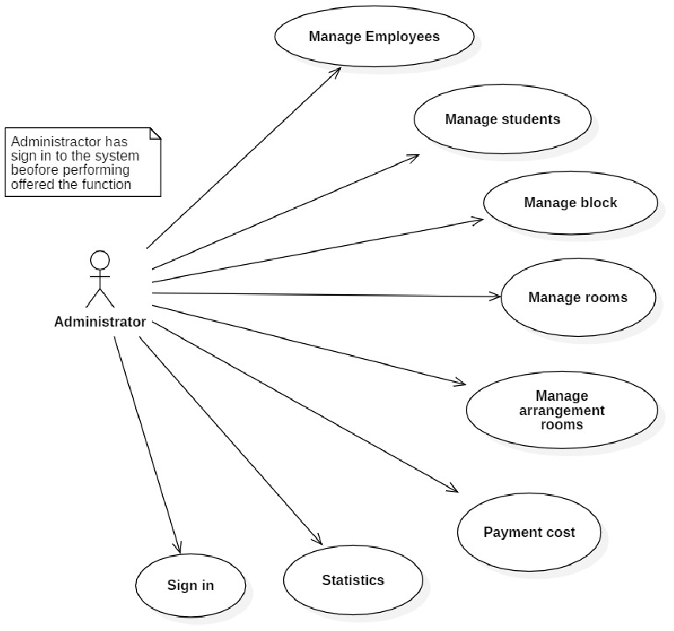

1. Use case diagram as a Administrator

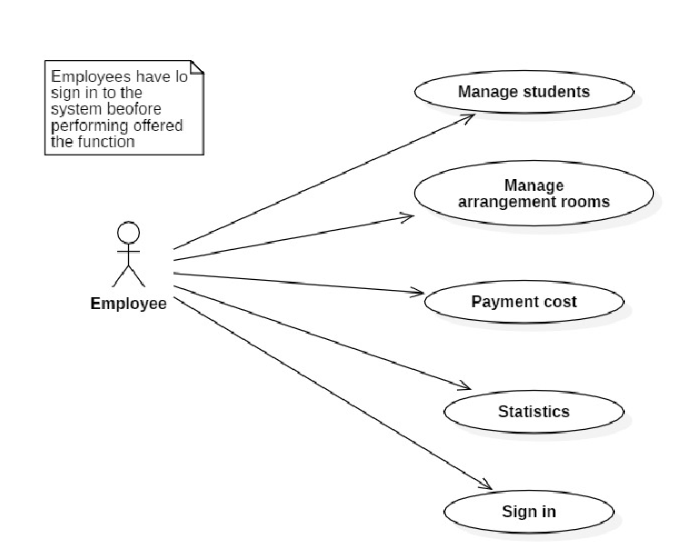

2. Use case diagram as Employees

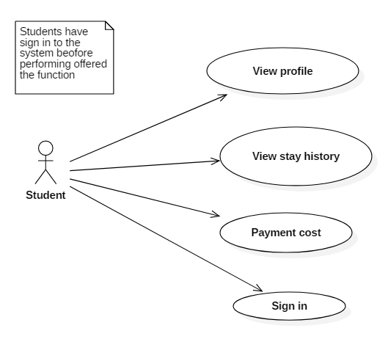

3. Use case diagram as student

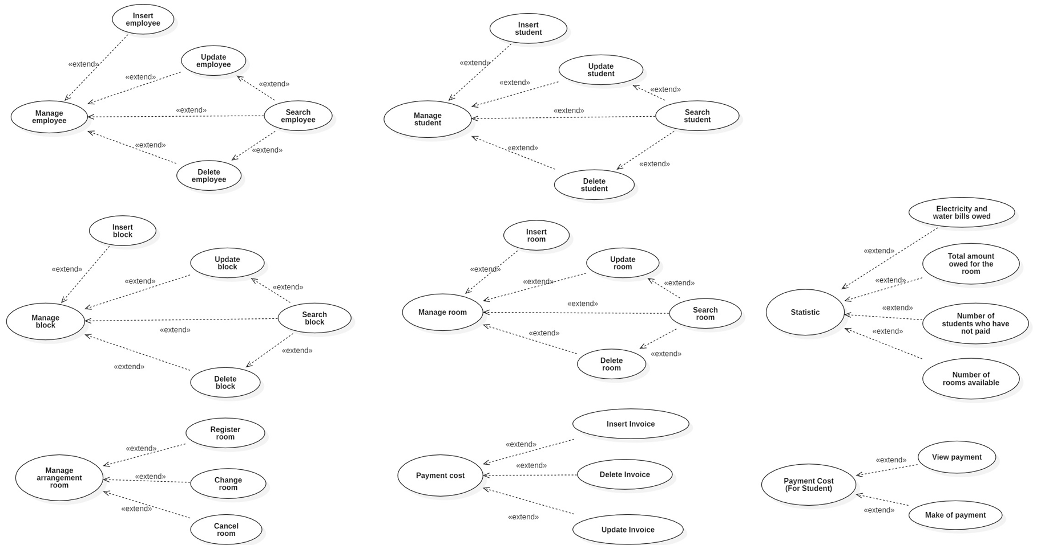

4. Administrators use-case diagram in details

### **1.2 List of actors**

|  |  |  |
| --- | --- | --- |
| **Index** | **Actor** | **Meaning** |
| 1 | Adminsator | Administrator manages the system |
| 2 | Employee | Employee who manages student activities and block |
| 3 | Student | Student who stays and use service of dormitory |

### **1.2 List of use-case**

|  |  |  |
| --- | --- | --- |
| **Role** | **Use-case** | **Meaning** |
| **Administrator's role** | Sign in | Sign in with admin role |
| Manage block | Insert/Update/ Delete/ Search block |
| Manage student | Insert/Update/ Delete/ Search Student |
| Manage employees | Insert/Update/ Delete/ Search Employees |
| Manage room | Insert/Update/ Delete/ Search Room |
| Arrange room | Register room, change room, cancel room for students |
| Payment cost | Payment of electricity, water costs and accommodation costs |
| Analysis revenue | Analysis revenue with various option |
| **Employees’s role** | Sign in | Sign in with Employees role |
| Manage student | Insert/Update/ Delete/ Search Student |
| Arrange room | Register room, change room, cancel room for students |
| Payment cost | Payment of electricity, water costs and accommodation costs |
| Analysis revenue | Analysis revenue with various option |
| **Student’s role** | View profile | Show student profile |
| View stay history | Show stay history |
| Payment cost | Payment of electricity, water costs and accommodation costs |

## **2. Use-case specification and activity diagram**

### **2.1 Sign-in (for student)**

|  |  |
| --- | --- |
| **Use-case name** | Sign in (for student) |
| **Description** | Students use their existing accounts to sign-in to the system for all services. |
| **Trigger** | Students click the “Sign in” button. |
| **Pre-condition** | Students’ devices must connect to the Internet.  The client's account already exists. |
| **Post-condition** | Students are notified when their sign-in is successful.  Students are redirected to the home page, where they can use all services. |
| **Basic flow** | 1. Student click "login" button.  2. The system displays the login page  3. Student enters email address, password and presses confirmation button.  4. The system validates email and password in correct format.  5. The system compares the student data entered with the existing account data in the system's database.  6. The system saves the client's login status according to the session  7. The system confirms the successful login and returns to the homepage.  8. The system remembers the student's login status. |
| **Alternative flow** | 3a. The system displays invalid information due to the wrong format.  Use-cases continue at step 2.  4a. The system displays invalid information due to the student’s account.  The information does not match with existing account information in the database.  Use-cases continue at step 2. |
| **Exception flow** |  |

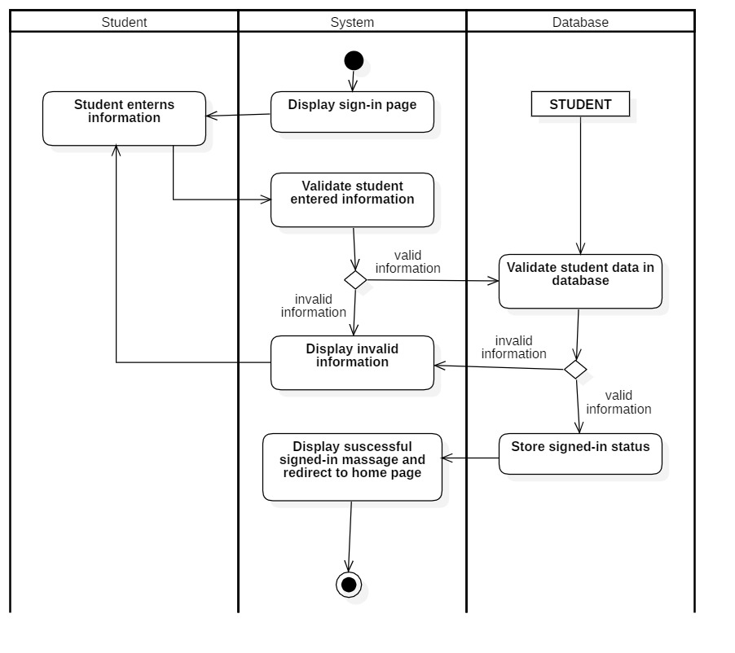

### **2.2 Sign-in (for employee)**

|  |  |
| --- | --- |
| **Use-case name** | Sign in (for employee) |
| **Description** | The employee uses an existing account to sign-in to the system with some roles. |
| **Trigger** | The employee clicks the “Sign in” button on the management page |
| **Pre-condition** | The employee’s device must connect to the Internet.  Employee’s account existed |
| **Post-condition** | The employee gets a notification when signing in successfully.  Employee is redirected to the management page |
| **Basic flow** | 0. The employee clicks “Sign in” button at management page  1. System display the login management page  2. The employee enters an email & password  3. The system validates that the employee entered the correct email & password format  4. The system verifies that the employee's account matches the one in the database.  5. The system stores the login status of the employee according to the session  6. The system displays successful login and redirects to the management page |
| **Alternative flow** | 3a. System displays invalid information due to the wrong format.  Use-case continues at step 2  4a. The system displays invalid information because the employee's account does not match the existing account in the database.  Use-case continues at step 2. |
| **Exception flow** |  |

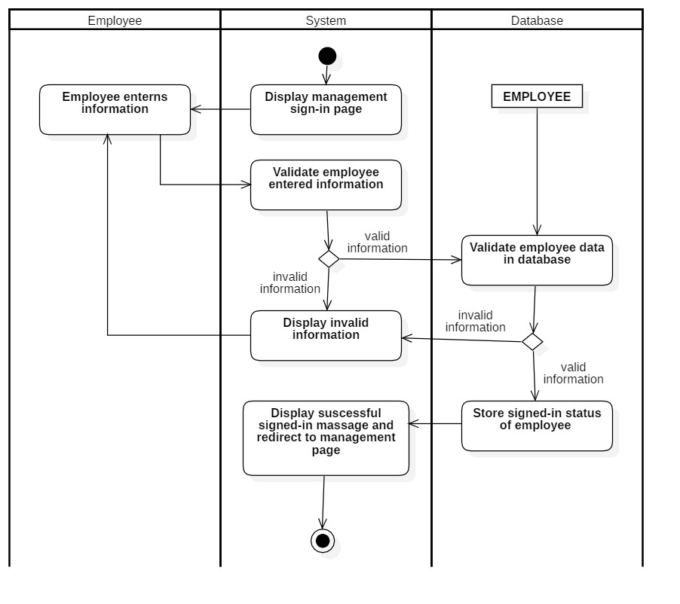

### **2.3 Sign-in (for administrator)**

|  |  |
| --- | --- |
| **Use-case name** | Sign in (for administrator) |
| **Description** | Administrators use their existing management account to sign-in to the system for all monitoring. |
| **Trigger** | Administrators click the button "Sign in" at the management page. |
| **Pre-condition** | Administrators’ devices must connect to the Internet.  Administrators’ accounts existed. |
| **Post-condition** | Administrators are notified when a sign-in is successful.  Administrators is redirected to the administration page. |
| **Basic flow** | 1. Administrators click the "Sign in" button at the management page.  2. The system displays the login management page  3. Administrators enter their email and password.  4. The system validates that the administrator has entered the correct email & password  5. System validates administrators’ data with existed administrator account in the database.  6. The system stores the login status of the administrator according to the session  7. The system displays a successful sign-in and redirects to the management page. |
| **Alternative flow** | 3a. The system displays invalid information due to the wrong format.  Use-cases continue at step 2.  4a. The system displays invalid information due to administrators’ accounts.  The information does not match with existing account information in the database.  Use-cases continue at step 2. |
| **Exception flow** |  |

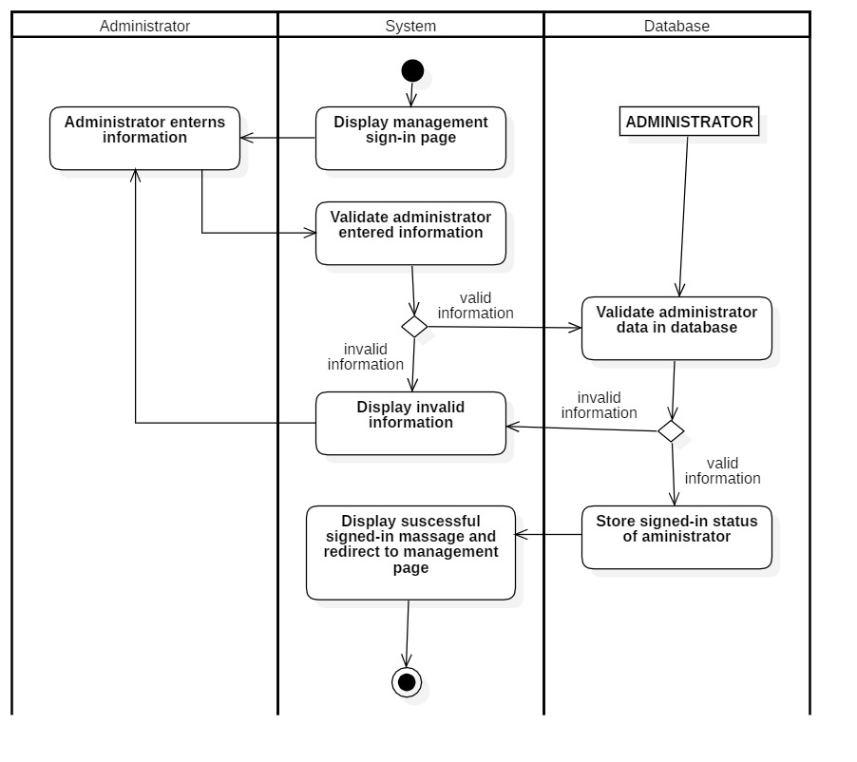

### **2.4 Manage employees**

#### *2.4.1 Insert Employees*

|  |  |
| --- | --- |
| **Use-case name** | Insert Employees (for administrator) |
| **Description** | Administrator can insert Employees to database |
| **Trigger** | Administrators click on “Insert” button |
| **Pre-condition** | Adminsator’s device has to connect internet  Employees have not existed  Administrators’ account existed  Administrator’s status is signed-in |
| **Post-condition** | Employees information data save successfully  Data at manage Employees page are updated |
| **Basic flow** | 1. System display Employees management page with data loaded from database (existed Employees)  2. Click the “Insert” button  3. System display Employees information form  4. Enter Employees information  5. System validates correct Employees information form  6. System validates Employees information in database  7. System store Employees information  8. System display Employees management page with new data |
| **Alternative flow** | 5a. System display not correct form notification  Use-case continue at step 4  6a. System display invalid information because data had been existed in the database.  Use-case continue at step 4 |
| **Exception flow** |  |

#### *2.4.2 Update Employees*

|  |  |
| --- | --- |
| **Use-case name** | Update Employees (for administrator) |
| **Description** | Administrator can update an existed Employees to database |
| **Trigger** | Administrators click on “Update” button |
| **Pre-condition** | Adminsator’s device has to connect internet  Employees have existed  Administrators’ account existed  Administrator’s status is signed-in |
| **Post-condition** | Employees information data save successfully  Data at manage Employees page are updated |
| **Basic flow** | 1. System display Employees management page with data loaded from database (existed Employees)  2.Choose Employees to be update  3. Click the “Update” button  4. System display Employees information form  5. Enter Employees information to be update  6. System validates correct Employees information form  7. System validates Employees information in database  8. System store Employees information  9. System display Employees management page with new data |
| **Alternative flow** | 6a. System display not correct form notification  Use-case continue at step 5  7a. System display invalid information because data had been existed in the database.  Use-case continue at step 5 |
| **Exception flow** |  |

#### *2.4.3 Delete Employees*

|  |  |
| --- | --- |
| **Use-case name** | Delete Employees (for administrator) |
| **Description** | Administrator can delete an existed Employees to database |
| **Trigger** | Administrators click on “Delete” button |
| **Pre-condition** | Adminsator’s device has to connect internet  Employees have existed  Administrators’ account existed  Administrator’s status is signed-in  No external data involved (showtime, ...) |
| **Post-condition** | Employees information data save successfully  Data at manage Employees page are updated |
| **Basic flow** | 1. System display Employees management page with data loaded from database (existed Employees)  2.Choose Employees need to be deleted  3. Click the “Delete” button  4.System display confirm delete  5.System processes delete request  6. System validates no external data required Employees information and Employees existed in database  7.System deletes Employees information in the database  8.System display Employees management page with new data |
| **Alternative flow** | 6a. System display error notification because external data had required that Employees information (showtime) or no Employees existed  Use-case stop |
| **Exception flow** |  |

#### *2.4.4 Search Employees*

|  |  |
| --- | --- |
| **Use-case name** | Search Employees (for administrator) |
| **Description** | Administrator can search an existed Employees in the database |
| **Trigger** | Administrators click on “Search” button |
| **Pre-condition** | Adminsator’s device has to connect internet  Administrators’ account existed  Administrator’s status is signed-in |
| **Post-condition** | Data at management page is filtered by keywords |
| **Basic flow** | 1. System display Employees management page with data loaded from database (existed Employees)  3. Click the “Search” button  4. Enter Employees need to be search  5.System processes search request  6. System queries data based on keywords in the database  7.System updates data at Employees management page (data related to keyword is retained) |
| **Alternative flow** | 6a. System displays not found result notification  Use-case stop |
| **Exception flow** |  |

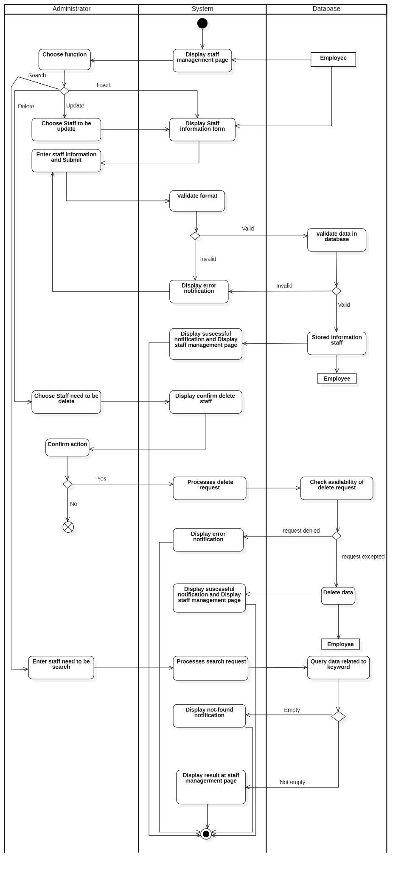

### **2.5 Payment cost (for administrator and employees)**

#### *2.5.1 Insert invoice*

|  |  |
| --- | --- |
| **Use-case name** | Insert invoice (for administrator and Employees) |
| **Description** | Administrators and Employees can insert invoices for rooms in the database |
| **Trigger** | Administrator and Employees click on “insert invoice” button |
| **Pre-condition** | Administrators and Employees device has to connect internet  Administrators and Employees account existed  Administrator’s and Employees status is signed-in |
| **Post-condition** | Invoice information data save successfully  Data at payment cost page are updated |
| **Basic flow** | 1. System display payment cost page with data loaded from database  2. Click the “Insert invoice” button  3. System display invoice information form  4. Enter invoice information  5. System validates correct invoice information form  6. System validates invoice information in database  7. System store invoice information  8. System display payment cost page with new data |
| **Alternative flow** | 5a. System display not correct form notification  Use-case continue at step 4  6a. System display invalid information in the database.  Use-case continue at step 4 |
| **Exception flow** |  |

#### *2.5.2 Update invoice*

|  |  |
| --- | --- |
| **Use-case name** | Update invoice (for administrator and Employees) |
| **Description** | Administrator and Employees can update invoices for rooms to database |
| **Trigger** | Administrator and Employees click on “Update” button |
| **Pre-condition** | Administrators and Employees device has to connect internet  Rooms have existed  Administrators’ and Employees account existed  Administrator’s and Employees status is signed-in |
| **Post-condition** | Invoice information data save successfully  Data at payment cost page are updated |
| **Basic flow** | 1. System display payment cost page with data loaded from database (existed invoices)  2.Choose the invoice of the room to be update  3. Click the “Update” button  4. System display invoice information form  5. Enter invoice information to be update  6. System validates correct invoice information form  7. System validates invoice information in database  8. System store invoice information  9. System display payment cost page with new data |
| **Alternative flow** | 6a. System display not correct form notification  Use-case continue at step 5  7a. System display invalid information in the database.  Use-case continue at step 5 |
| **Exception flow** |  |

#### *2.5.3 Delete invoice*

|  |  |
| --- | --- |
| **Use-case name** | Delete invoice (for administrator and Employees) |
| **Description** | Administrator and Employees can delete invoices for rooms to database |
| **Trigger** | Administrator and Employees click on “Delete” button |
| **Pre-condition** | Administrators and Employees device has to connect internet  Rooms have existed  Administrators’ and Employees account existed  Administrator’s and Employees status is signed-in |
| **Post-condition** | Invoice information data save successfully  Data at payment cost page are updated |
| **Basic flow** | 1. System display payment cost page with data loaded from database (existed invoices)  2.Choose the invoice of the room need to be delete  3. Click the “Delete” button  5.System processes delete request  7.System deletes invoice information in the database  8.System display payment cost page with new data |
| **Alternative flow** |  |
| **Exception flow** |  |

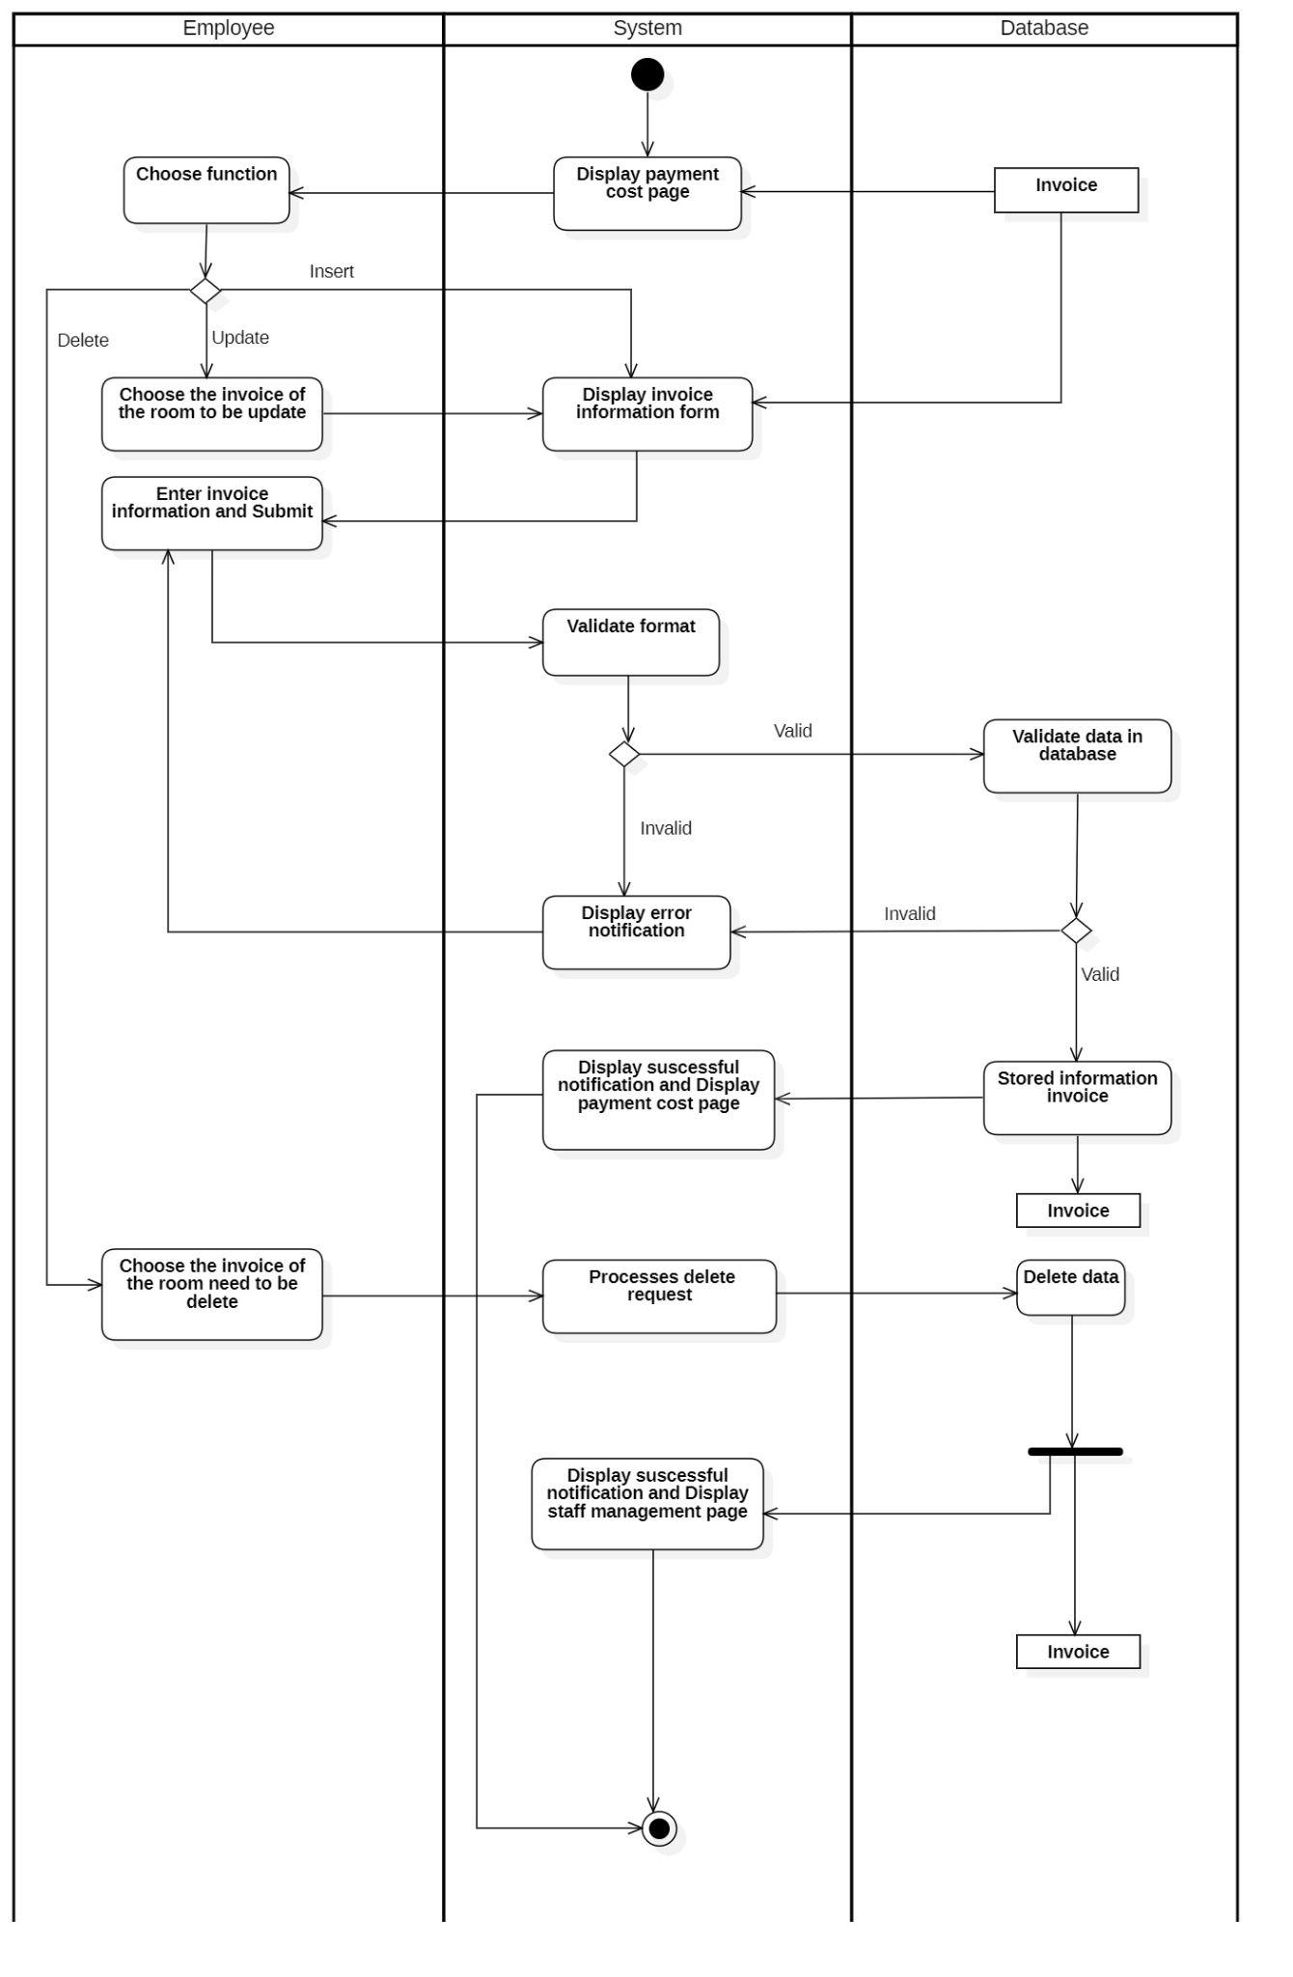

### **2.6 Payment cost (for student)**

#### *2.6.1 View payment information*

|  |  |
| --- | --- |
| **Use-case name** | View payment information(for student) |
| **Description** | Students view their payment information |
| **Trigger** | Students click on “Invoice” button |
| **Pre-condition** | Student device has to connect the Internet |
| **Post-condition** | Students get payment information |
| **Basic flow** | 1. Click on the “Invoice” button  2.System displays payment cost page with data loaded from database (existed invoices) |
| **Alternative flow** |  |
| **Exception flow** |  |

#### *2.6.2 Make a payment*

|  |  |
| --- | --- |
| **Use-case name** | Make a payment (for student) |
| **Description** | Students can make the payment for accommodation and electricity and water |
| **Trigger** | Students click on “pay” button |
| **Pre-condition** | Student device has to connect internet |
| **Post-condition** | Update the status of successful payments |
| **Basic flow** | 1. System display payment cost page with data loaded from database (existed invoices)  2.Choose the invoice of the room need to be payment  3. Click the “pay” button  4.System display payment information form  5.Enter payment information  6.System display confirm payment information  7.System processes payment request  8. System validates payment information in database  9.System updates the payment status in the database  10.System display payment cost page with new data |
| **Alternative flow** | 8a. System displays invalid information in the database.  Use-case continue at step 5 |
| **Exception flow** |  |

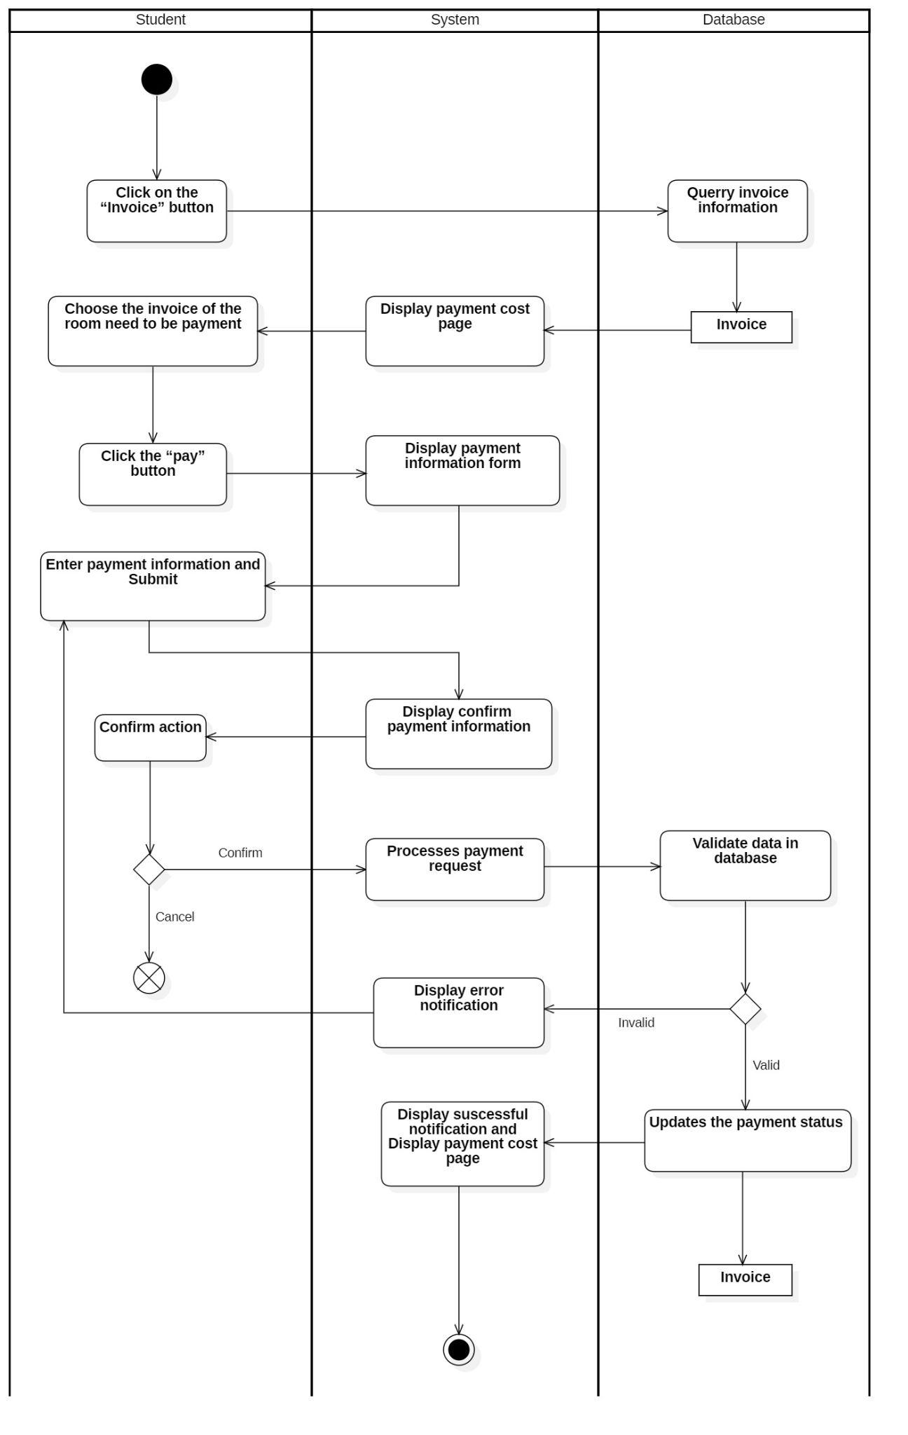

### **2.7 Arrange room**

#### *2.7.1 Register room*

|  |  |
| --- | --- |
| **Use-case name** | Register Room (For admin and Employees) |
| **Description** | Administrator or Employees can register room for student |
| **Trigger** | Administrator or Employees click on “Register room” button |
| **Pre-condition** | Administrator's or Employee's device has to connect internet  Students have existed  Students have not registered room  Room has to existed  Room not full |
| **Post-condition** | Room register data save successfully  Data at room page and register room page are updated |
| **Basic flow** | 1. System display register room page  2. Click the “register room” button  3. System display register room form  4. Enter register room information  5. System validates correct register room form  6. System validates registered room information in database  7. System store register room information  8. System display register room page with new data |
| **Alternative flow** | 5a. System display not correct form notification  Use-case continue at step 4  6a. System display not success notification  Use-case continue at step 4 |
| **Exception flow** |  |

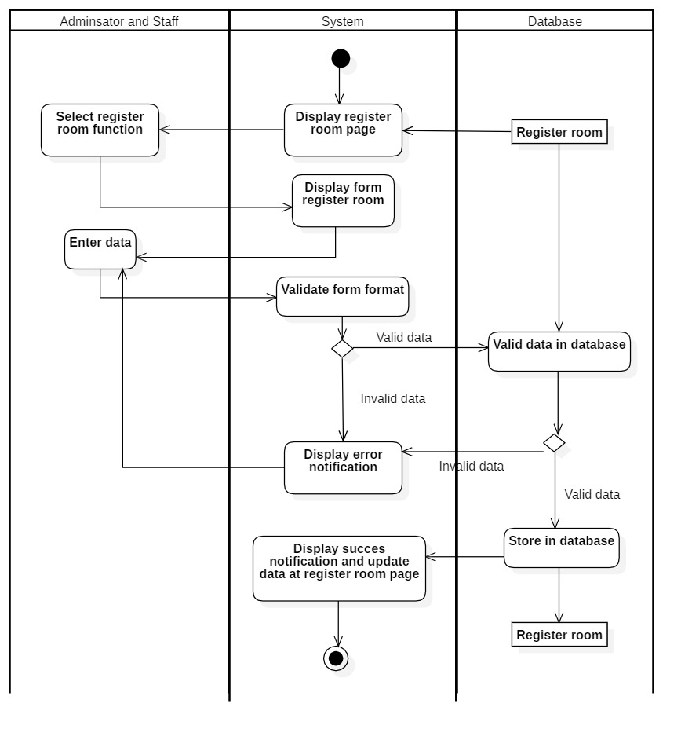

#### *2.7.2 Change room*

|  |  |
| --- | --- |
| **Use-case name** | Change Room |
| **Description** | Administrator or Employees can change room for student |
| **Trigger** | Administrator or Employees click on “update register room” button |
| **Pre-condition** | Administrator's or Employee's device has to connect internet  Students have existed  Students have registered room  Room have to existed  Room not full |
| **Post-condition** | Room register data save successfully  Data at room page and register room page are updated |
| **Basic flow** | 1. System display register room page 2. Select item and click the “update register room” button 3. System display update register room form 4. Enter update register room information 5. System validates correct update register room form 6. System validates updated registered room information in database 7. System store update register room information 8. System display register room page with new data |
| **Alternative flow** | 5a. System display not correct form notification  Use-case continue at step 4  6a. System display not success notification  Use-case continue at step 4 |
| **Exception flow** |  |



#### *2.7.3 Cancel room*

|  |  |
| --- | --- |
| Use-case name | Cancel Room |
| Description | Administrator or Employees cancel change room for student |
| Trigger | Administrator or Employees click on “cancel register room” button |
| Pre-condition | Adminsator’s or Employees’s device has to connect internet  Students have registered room |
| Post-condition | Room register data save successfully  Data at room page and register room page are updated |
| Basic flow | 1. System display register room page  2. Select item Click the “cancel register room” button  3. System store update register room information  4. System display success notification and register room page with new data |
| Alternative flow |  |
| Exception flow |  |

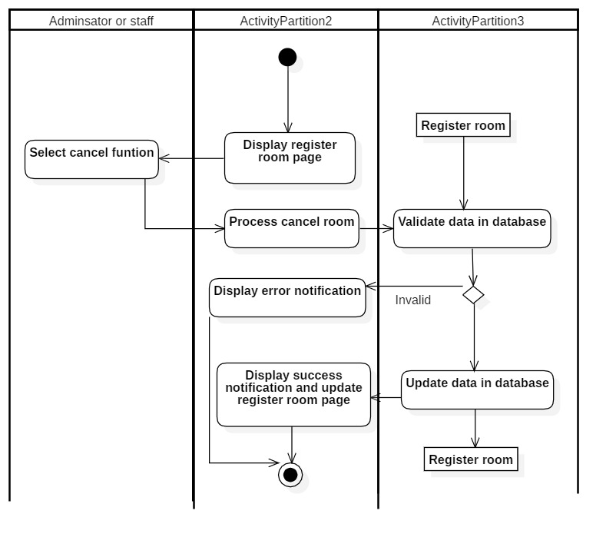

### **2.8 View profile**

|  |  |
| --- | --- |
| **Use-case name** | View profile (For student, Employees) |
| **Description** | Student or Employees view pers profile |
| **Trigger** | Student or Employees click on “profile” button |
| **Pre-condition** | Student or Employees device has to connect internet |
| **Post-condition** | Student or Employees get profile information |
| **Basic flow** | 1. Click on the “profile” button  2. System query personal profile information  3. System displays personal information |
| **Alternative flow** |  |
| **Exception flow** |  |

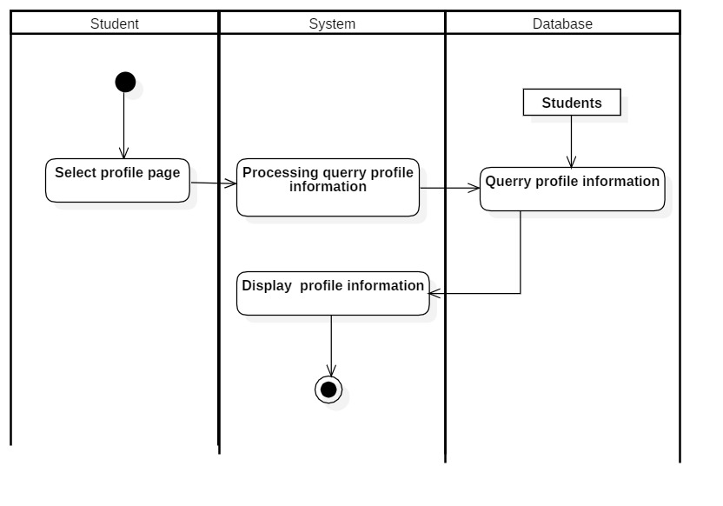

### **2.9 View stay history**

|  |  |
| --- | --- |
| **Use-case name** | View stay history (For student) |
| **Description** | Student view stay history |
| **Trigger** | Student click on “Stay history” button |
| **Pre-condition** | Student device has to connect internet |
| **Post-condition** | Student or Employees gets list stay history |
| **Basic flow** | 1. Click on the “stay history” button  2. System query stays history information  3. System displays history information |
| **Alternative flow** |  |
| **Exception flow** |  |

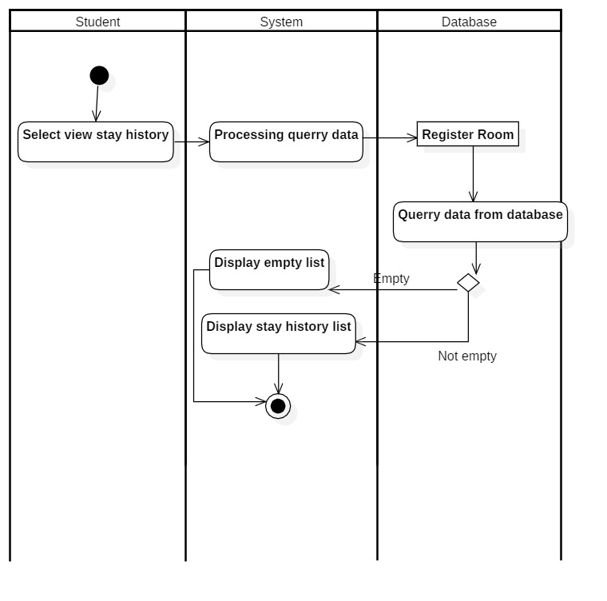

### **2.10 Manage student**

#### *2.10.1 Insert student*

|  |  |
| --- | --- |
| **Use-case name** | Insert student (for Employee) |
| **Description** | Employee can insert a student to database |
| **Trigger** | Employees click on “Insert” button |
| **Pre-condition** | Employee’s device has to connect internet  Student have not existed  Employee’s account existed  EmployeeAdministrator’s status is signed-in |
| **Post-condition** | Student information data save successfully  Data at manage Employees page are updated |
| **Basic flow** | 1. System display student management page with data loaded from database (existed Employees)  2. Click the “Insert” button  3. System display student information form  4. Enter student information  5. System validates correct student information form  6. System validates student information in database  7. System store student information  8. System display student management page with new data |
| **Alternative flow** | 5a. System display not correct form notification  Use-case continue at step 4  6a. System display invalid information because data had been existed in the database.  Use-case continue at step 4 |
| **Exception flow** |  |

#### *2.10.2 Update student*

|  |  |
| --- | --- |
| **Use-case name** | Update student (Employee) |
| **Description** | Employee can update an existed student to database |
| **Trigger** | Employees click on “Update” button |
| **Pre-condition** | Employee’s device has to connect internet  Employees have existed  Employee’s account existed  Employee’s status is signed-in |
| **Post-condition** | Employees information data save successfully  Data at manage student page are updated |
| **Basic flow** | 1. System display student management page with data loaded from database (existed Employees)  2.Choose student to be update  3. Click the “Update” button  4. System display student information form  5. Enter student information to be update  6. System validates correct student information form  7. System validates student information in database  8. System store student information  9. System display student management page with new data |
| **Alternative flow** | 6a. System display not correct form notification  Use-case continue at step 5  7a. System display invalid information because data had been existed in the database.  Use-case continue at step 5 |
| **Exception flow** |  |

#### *2.10.3 Delete student*

|  |  |
| --- | --- |
| **Use-case name** | Delete student (for Employee) |
| **Description** | Employee can delete an existed student to database |
| **Trigger** | Employeeclick on “Delete” button |
| **Pre-condition** | Employee’s device has to connect internet  Employees have existed  Employee’s account existed  Employee’s status is signed-in  No external data involved (showtime, ...) |
| **Post-condition** | Employees information data save successfully  Data at manage studentpage are updated |
| **Basic flow** | 1. System display student management page with data loaded from database (existed Employees)  2.Choose student need to be delete  3. Click the “Delete” button  4.System display confirm delete  5.System processes delete request  6. System validates no external data required student  information and Employees existed in database  7.System deletes student information in the database  8.System display student management page with new data |
| **Alternative flow** | 6a. System display error notification because external data had required that Employees information (showtime) or no Employees existed  Use-case stop |
| **Exception flow** |  |

#### *2.10.4 Search student*

|  |  |
| --- | --- |
| **Use-case name** | Search student (for Employee) |
| **Description** | Employee can search an existed student the database |
| **Trigger** | Employees click on “Search” button |
| **Pre-condition** | Employee’s device has to connect internet  Employee’s account existed  Employee’s status is signed-in |
| **Post-condition** | Data at management page is filtered by keywords |
| **Basic flow** | 1. System display student management page with data loaded from database (existed Employees)  3. Click the “Search” button  4. Enter student need to be search  5.System processes search request  6. System queries data based on keywords in the database  7.System updates data at student management page (data related to keyword is retained) |
| **Alternative flow** | 6a. System displays not found result notification  Use-case stop |
| **Exception flow** |  |

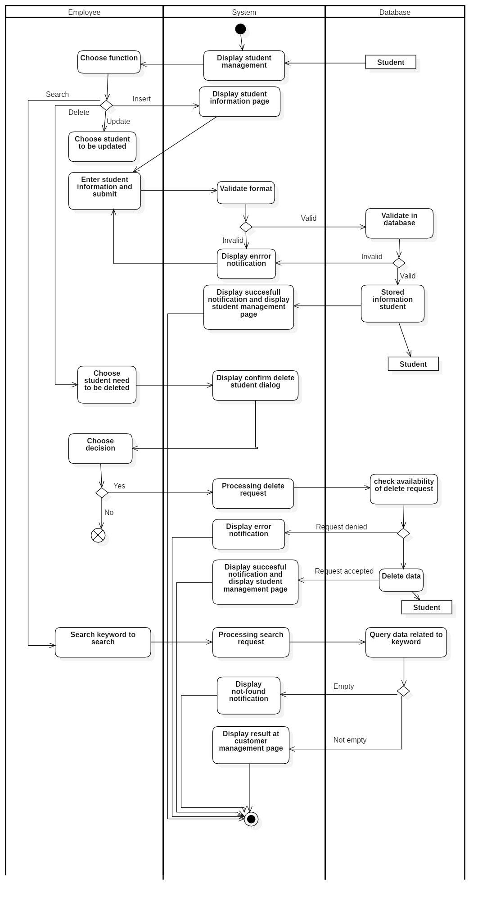

### **2.11 Manage dorm room**

#### *2.11.1 Insert room*

|  |  |
| --- | --- |
| **Use-case name** | Insert dorm room (for administrator) |
| **Description** | The administrator can insert a dorm room into the database |
| **Trigger** | Administrators click the "Insert" button on the dorm room management page. |
| **Pre-condition** | Administrators’ devices must connect to the Internet.  Administrators’ accounts existed.  The administrator’s status is signed in. |
| **Post-condition** | Dorm room data was successfully inserted into the database.  Data on the management page is updated (with a new dorm room). |
| **Basic flow** | 1. The system displays the dorm room management page with data loaded from (existing dorm rooms, employees, etc.) database  2. Administrators select the insert function.  3. The system displays a form with dorm room information.  4. Administrators enter dorm room information.  5. System: validate dorm room information in the correct format.  6. The system validates dorm room information with existing data in the database.  7. The system stores dorm room information in a database.  8. The system updates data on the dorm room management page with inserted information data (new data) |
| **Alternative flow** | 5a. The system displays invalid information due to the wrong format.  Use-cases continue at step 4.  6b. The system displays invalid information because data had been present in the database.  Use-cases continue at step 4. |
| **Exception flow** |  |

#### *2.11.2 Update room*

|  |  |
| --- | --- |
| **Use-case name** | Update dorm room (for administrator) |
| **Description** | Administrators can update an existing dorm room in the database. |
| **Trigger** | Administrators click the button "Update" at the dorm room management page. |
| **Pre-condition** | Administrators’ devices must connect to the Internet.  Administrators’ accounts existed.  The administrator’s status is signed in.  Before updating, dorm room information must be present in the database. |
| **Post-condition** | Management data is being updated |
| **Basic flow** | 1. The system displays the dorm room management page with data loaded from database  2. Administrators select the update function and the item to be updated.  3. The system displays the dorm room information form with the current data.  4. Administrators modify dorm room information.  5. System: validate dorm room information in the correct format.  6. The system validates dorm room information with existing data in the database.  7. System updates: Dorm Room Information in the Database  8. The system updates data at the dorm room management page with updated data at the selected item. |
| **Alternative flow** | 5a. The system displays invalid information due to the wrong format.  Use-cases continue at step 4.  6b. The system displays invalid information because selected data hasn’t been existed in the database.  Use-cases continue at step 4. |
| **Exception flow** |  |

#### *2.11.3 Delete room*

|  |  |
| --- | --- |
| **Use-case name** | Delete dorm room (for administrator) |
| **Description** | Administrators can delete an existing dorm room from the database. |
| **Trigger** | Administrators click the button "Delete" at the dorm room management page. |
| **Pre-condition** | Administrators’ devices must connect to the Internet.  Administrators’ accounts existed.  The administrator’s status is signed in.  Before deleting dorm room information, it must first exist in the database. |
| **Post-condition** | Data on the management page is updated (a selected dorm room had been deleted). |
| **Basic flow** | 1. The system displays the dorm room management page, which contains data from the database.  2. Administrators select the delete function and the item to be deleted.  3. System processes delete requests  4. The system verifies that no external data is needed for dorm room information and that the selected item exists in the database.  5. The system deletes dorm room information from the database.  6. The system updates data at the dorm room management page with the selected item deleted. |
| **Alternative flow** |  |
| **Exception flow** | 5a. The system displays an error message because external data required it.  There was either dorm room information or no data.  Use-case stop. |

#### *2.11.4 Search room*

|  |  |
| --- | --- |
| **Use-case name** | Search dorm room (for administrator) |
| **Description** | Administrators can search dorm rooms in the database. |
| **Trigger** | Administrators click on the button "Search" on the dorm room management page. |
| **Pre-condition** | Administrators’ devices must connect to the Internet.  Administrators’ accounts existed.  The administrator’s status is signed in. |
| **Post-condition** | Data on the management page is filtered by keywords. |
| **Basic flow** | 1. The system displays the management page with data from the database.  2 Administrators select the search function and enter keywords.  3. System processes searching for data  4. The system searches for information using keywords.  5. The system updates data on the dorm room page (data related to keyword is retained) |
| **Alternative flow** | 4a. The system displays an empty result notification.  Use-cases continue at step 5 (no data is retained). |
| **Exception flow** |  |

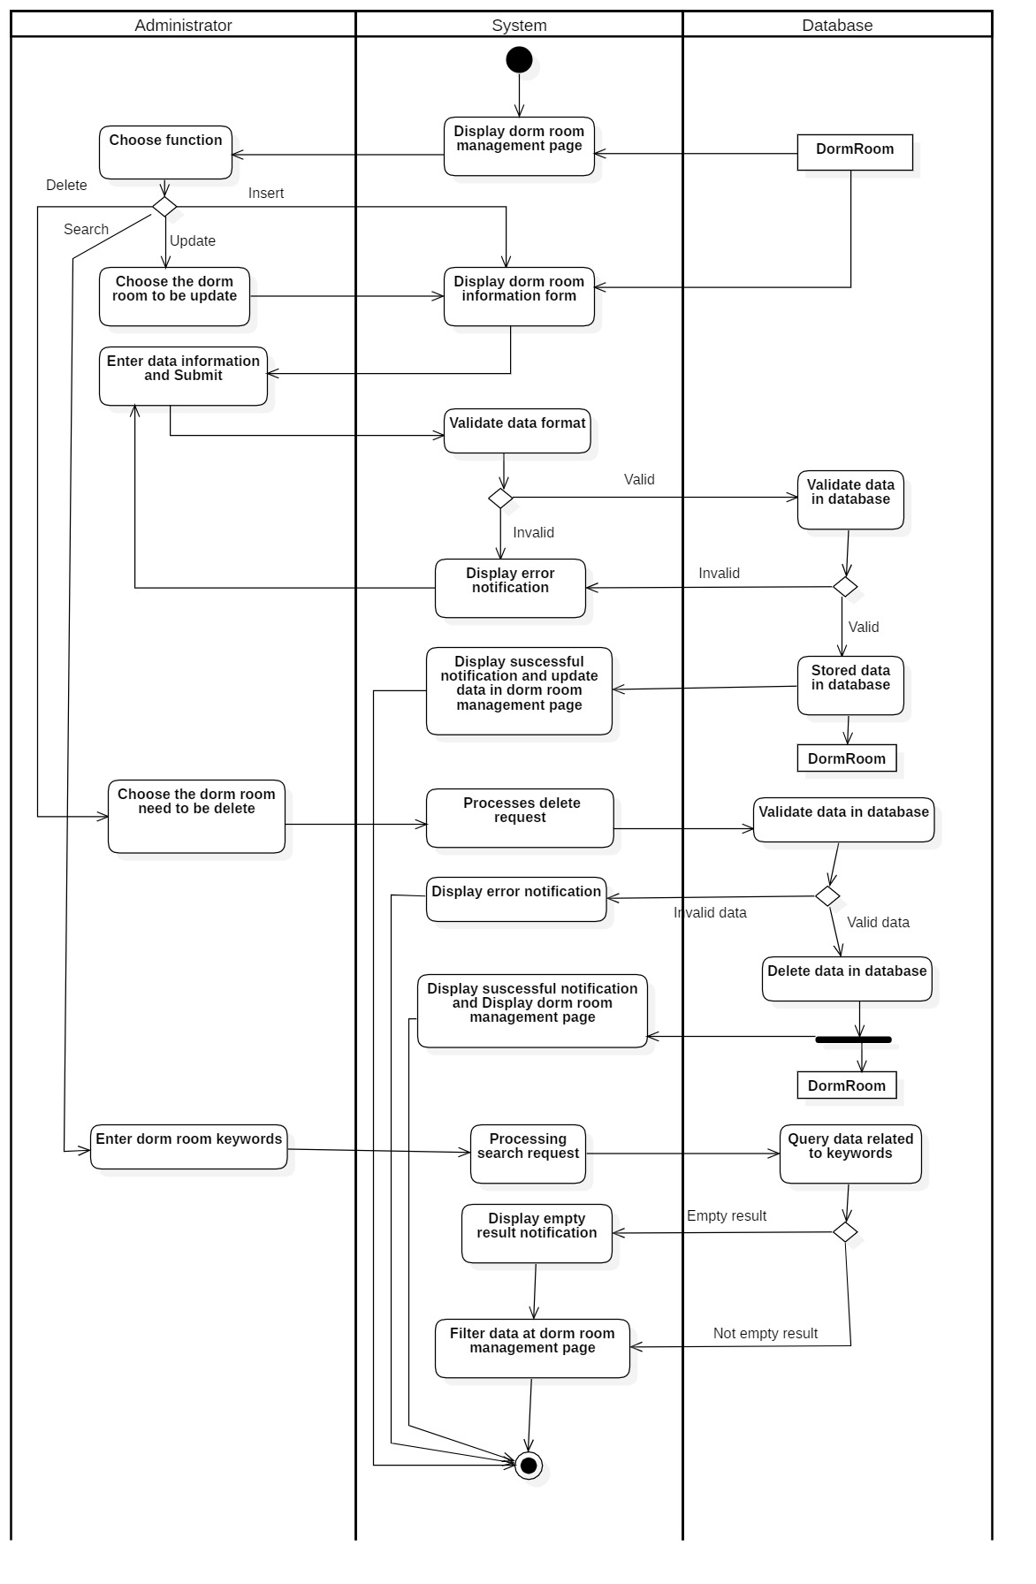

### **2.12 Statistics (for Employee)**

#### *2.12.1 Electricity and water bill owed*

|  |  |
| --- | --- |
| **Use-case name** | Electricity and water bill owed (for Employee) |
| **Description** | Employee can view electricity and water bill owed |
| **Trigger** | Employees click on “Electricity and water bill owed” on Display debt management page |
| **Pre-condition** | Employee ‘s device has to connect internet  Employee ‘s account existed  Employee ‘s status is signed-in |
| **Post-condition** | Employees get successful notification and view electricity and water bill owed on display |
| **Basic flow** | 1. System display debt management page  2. Select item Click the “Electricity and water bill owed”  3. System validate data in database  4. System get data from database  5. System display success notification and electricity and water bill owed on display debt management page |
| **Alternative flow** | 3a. System display invalid data because data is not had in database |
| **Exception flow** |  |

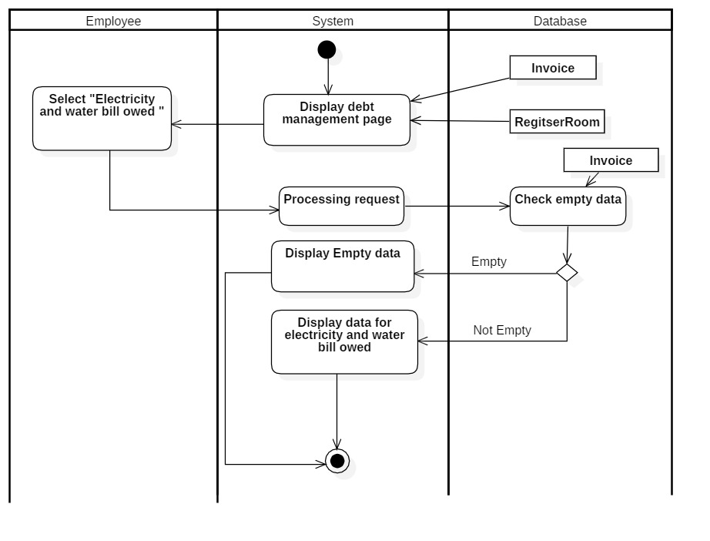

#### *2.12.2 Total amount owed for the room*

|  |  |
| --- | --- |
| **Use-case name** | Total amount owed for the room(for Employee) |
| **Description** | Employee can view Total amount owed for the room |
| **Trigger** | Employees click on “Total amount owed for the room” on Display debt management page |
| **Pre-condition** | Employee’s device has to connect internet  Employee ‘s account existed  Employee ’s status is signed-in |
| **Post-condition** | Employees get successful notification and view electricity and water bill owned on display |
| **Basic flow** | 1. System display debt management page  2. Select item Click the “Total amount owed for the room”  3. System validate data in database  4. System get data from database  5. System display success notification and total amount owed for the room on display debt management page |
| **Alternative flow** | .3a. System display invalid data because data is not have in database |
| **Exception flow** |  |

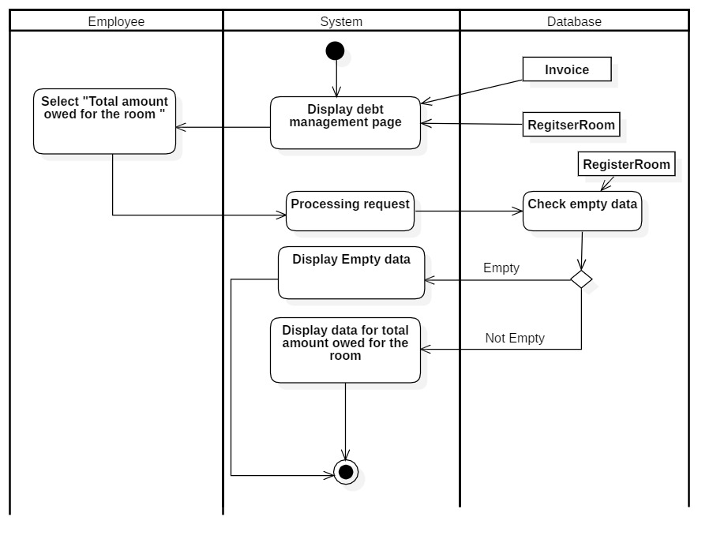

#### *2.12.3 Number of students who have not paid*

|  |  |
| --- | --- |
| **Use-case name** | Number of students who have not paid (for Employee) |
| **Description** | Employee can view Number of students who have not paid |
| **Trigger** | Employees click on “Number of students who have not paid” on Display debt management page |
| **Pre-condition** | Employee’s device has to connect internet  Employee’ s account existed  Employee’s status is signed-in |
| **Post-condition** | Employees get successful notification and view Number of student who have not paid on display |
| **Basic flow** | 1. System display debt management page  2. Select item Click the “Number of students who have not paid”  3. System validate data in database  4. System get data from database  5. System display success notification and Number of students who have not paid for the room on display debt management page |
| **Alternative flow** | .3a. System display invalid data because data is not had in database |
| **Exception flow** |  |

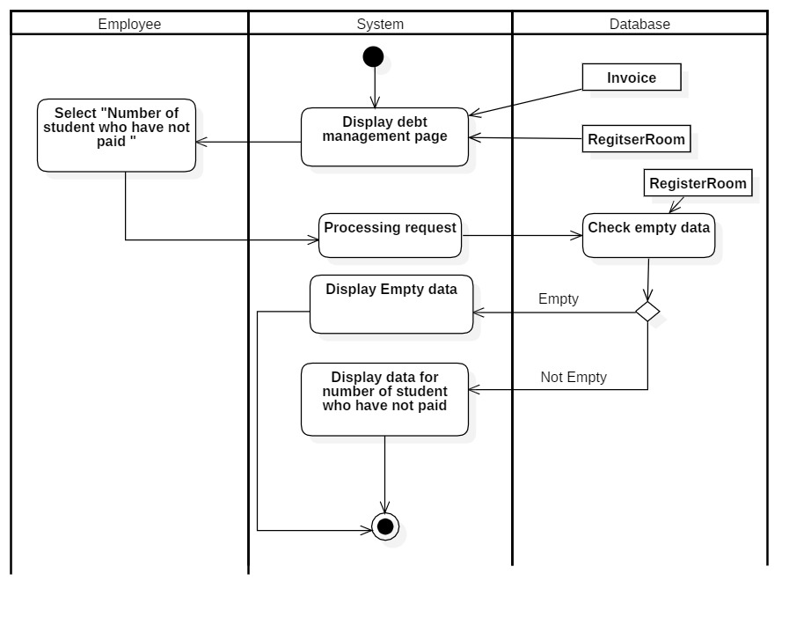

#### *2.12.4 Number of room available*

|  |  |
| --- | --- |
| **Use-case name** | Number of room available (for Employee) |
| **Description** | Employee can view Number of room available |
| **Trigger** | Employees click on “Number of room available” on Display debt management page |
| **Pre-condition** | Employee’s device has to connect internet  Employee’s account existed  Employee’s status is signed-in |
| **Post-condition** | Employees get successful notification and view Number of room available on display |
| **Basic flow** | 1. System display debt management page  2. Select item Click the “Number of room available”  3. System validate data in database  4. System get data from database  5. System display success notification and Number of room available for the room on display debt management page |
| **Alternative flow** | .3a. System display invalid data because data is not had in database |
| **Exception flow** |  |

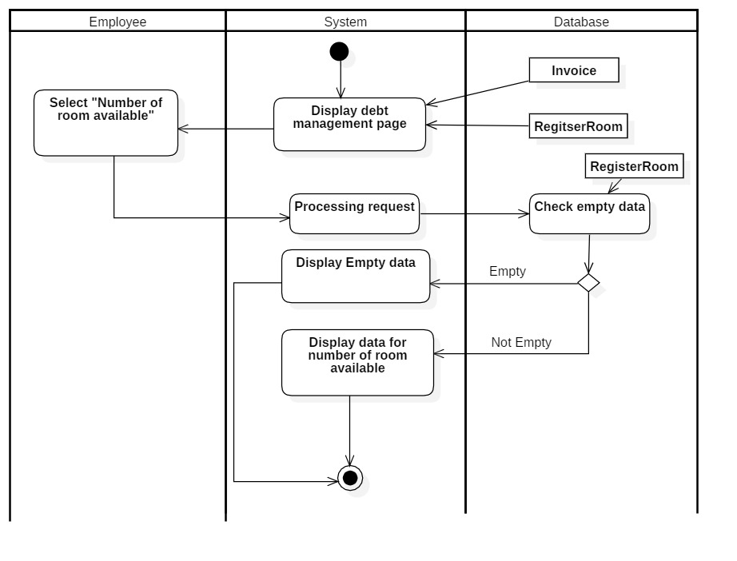

## **3. Sequence diagram and class diagram**

### **3.1 Sign-in**

#### *3.1.1 Sequence diagram*

* For student

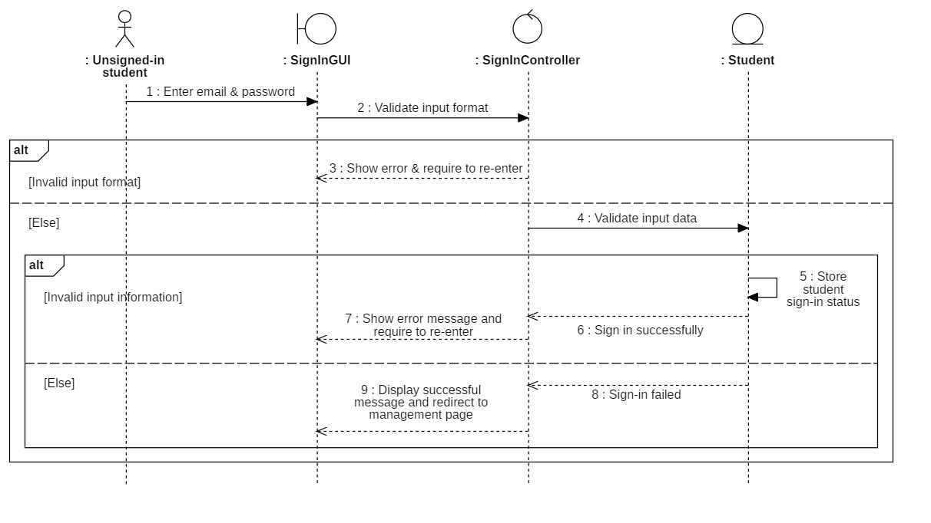

* For employee

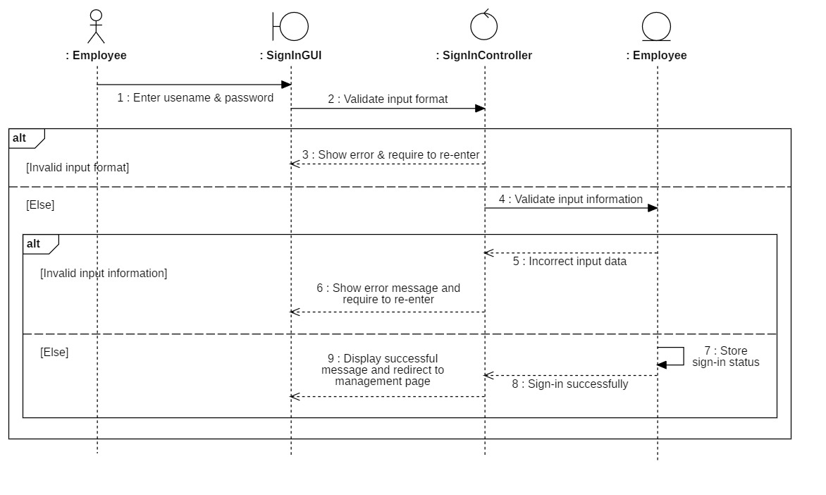

#### *3.1.2 Class diagram*

* For student

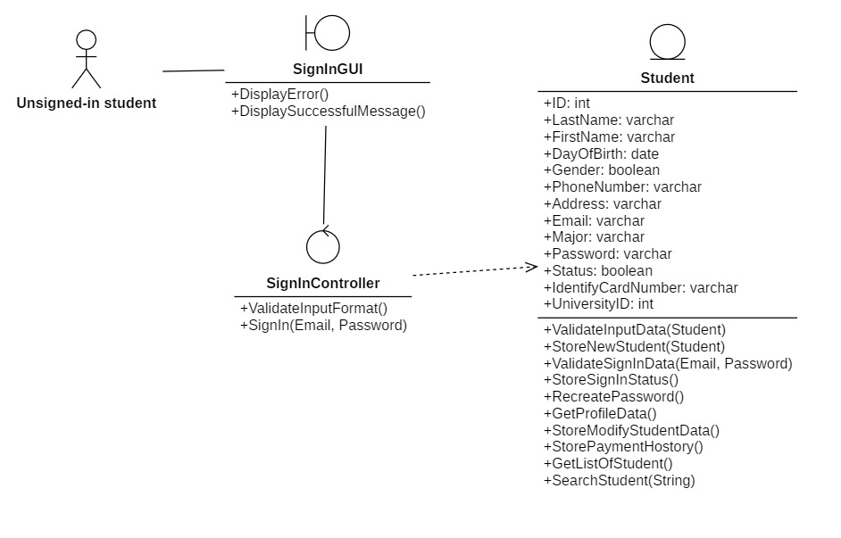

* For employee

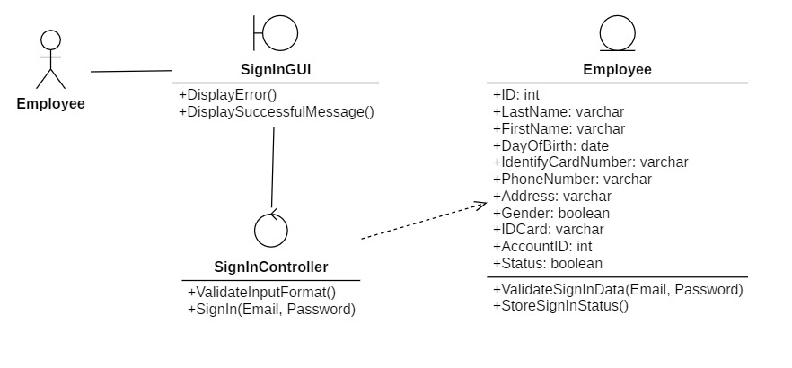

### **3.2 Manage Employees**

#### *3.2.1 Sequence diagram*

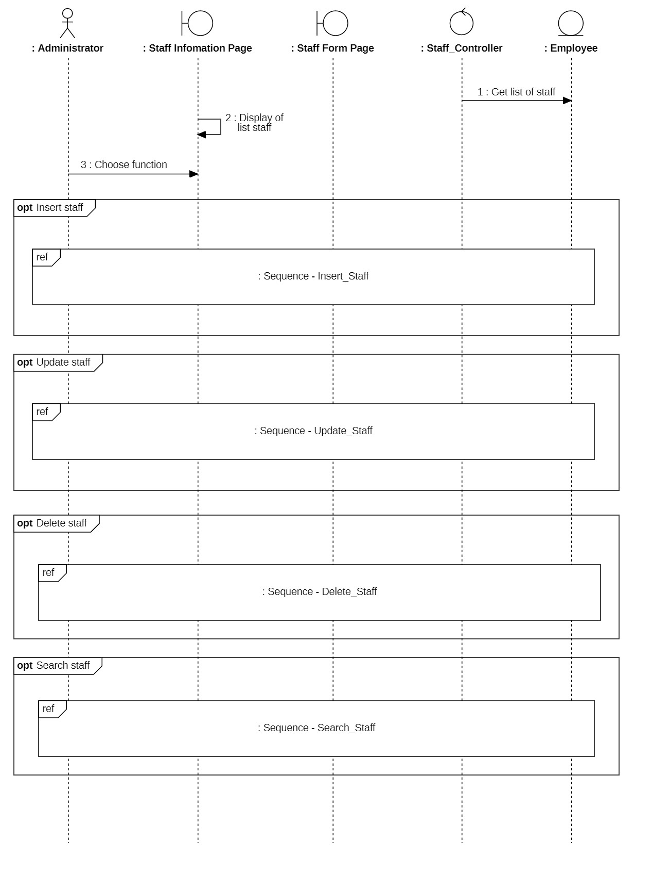

##### 3.2.1.1 Insert employees

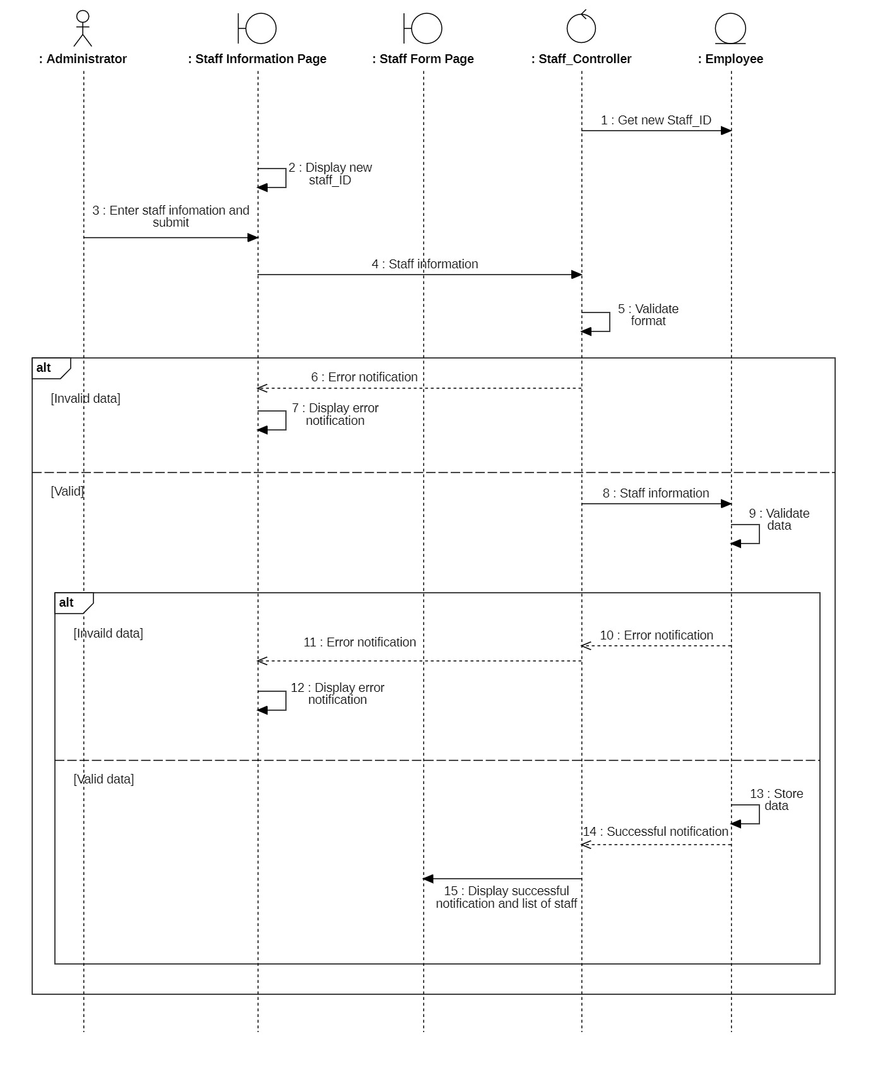

##### 3.2.1.2 Update employees

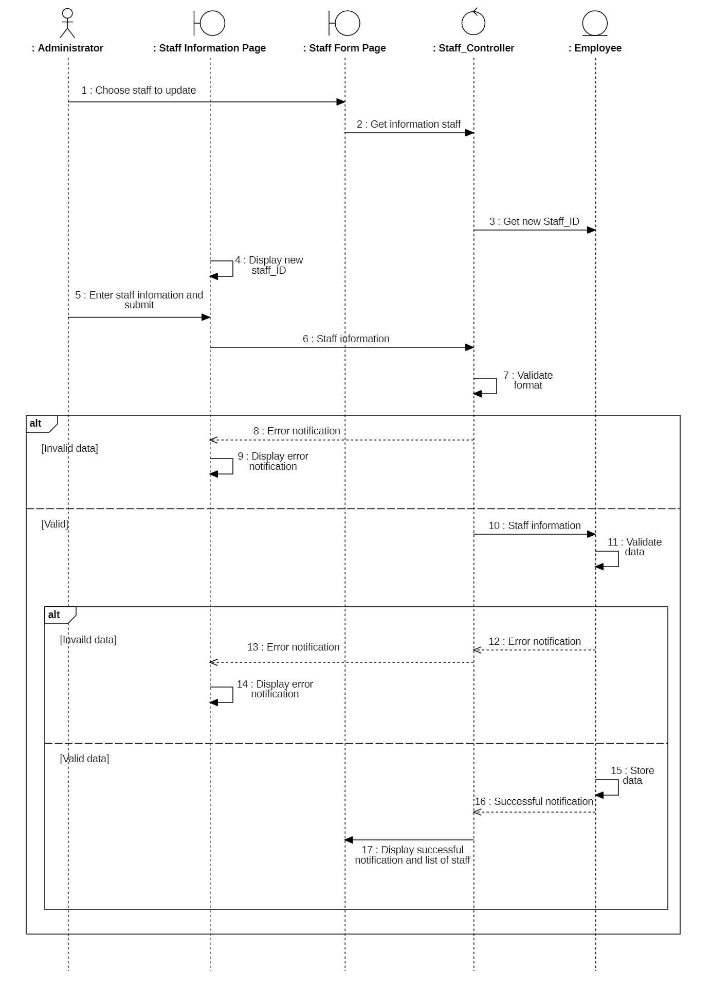

##### 3.2.1.3 Delete employees

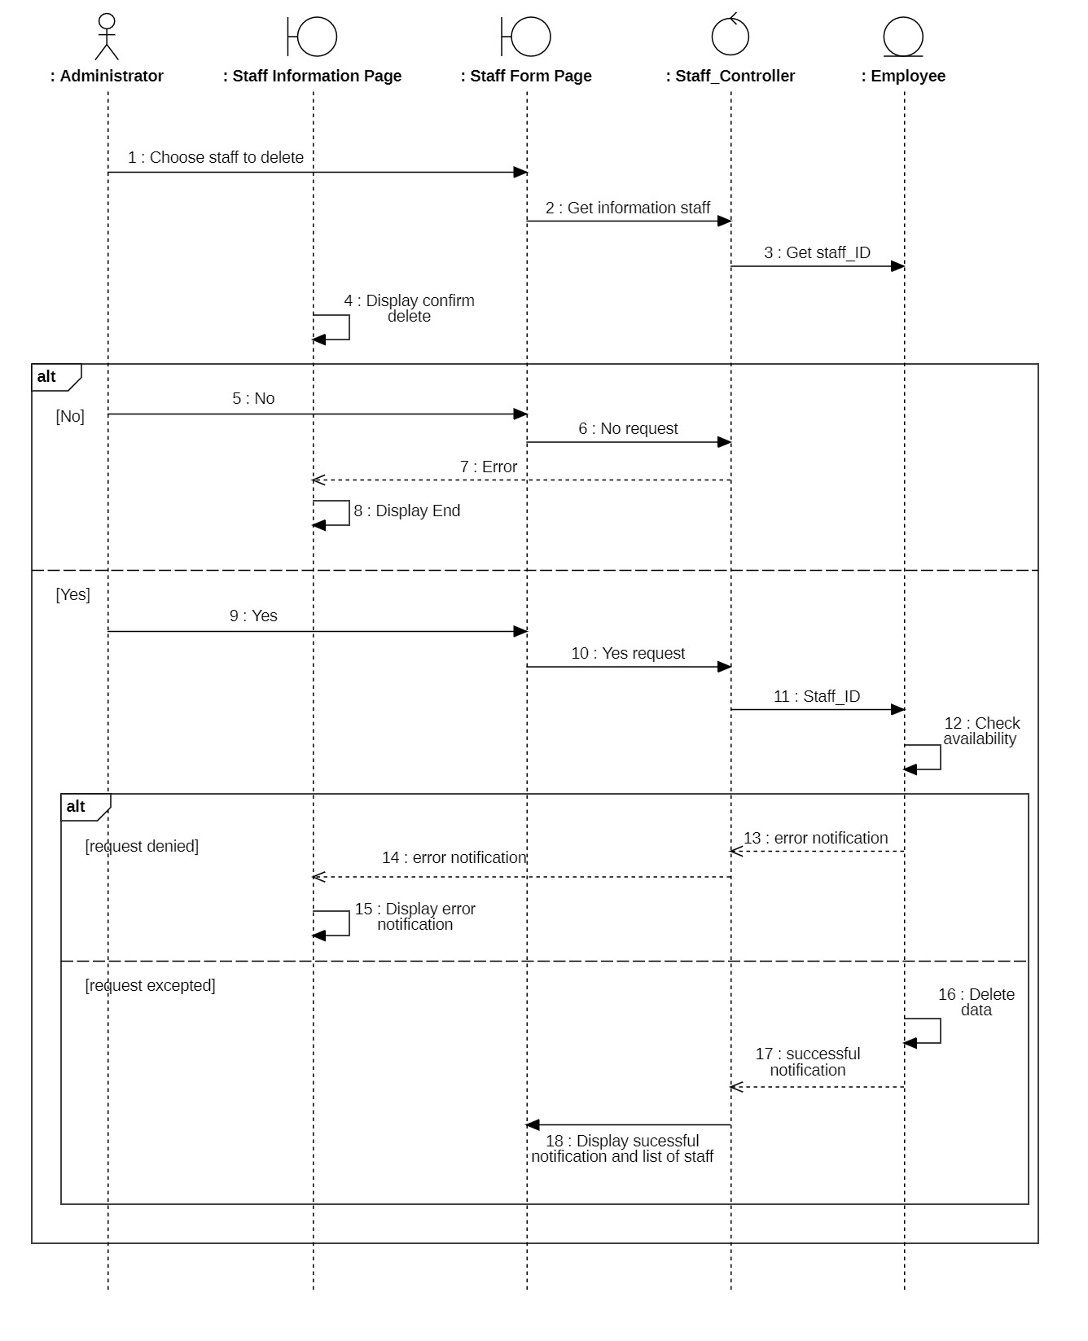

##### 3.2.1.4 Search employees

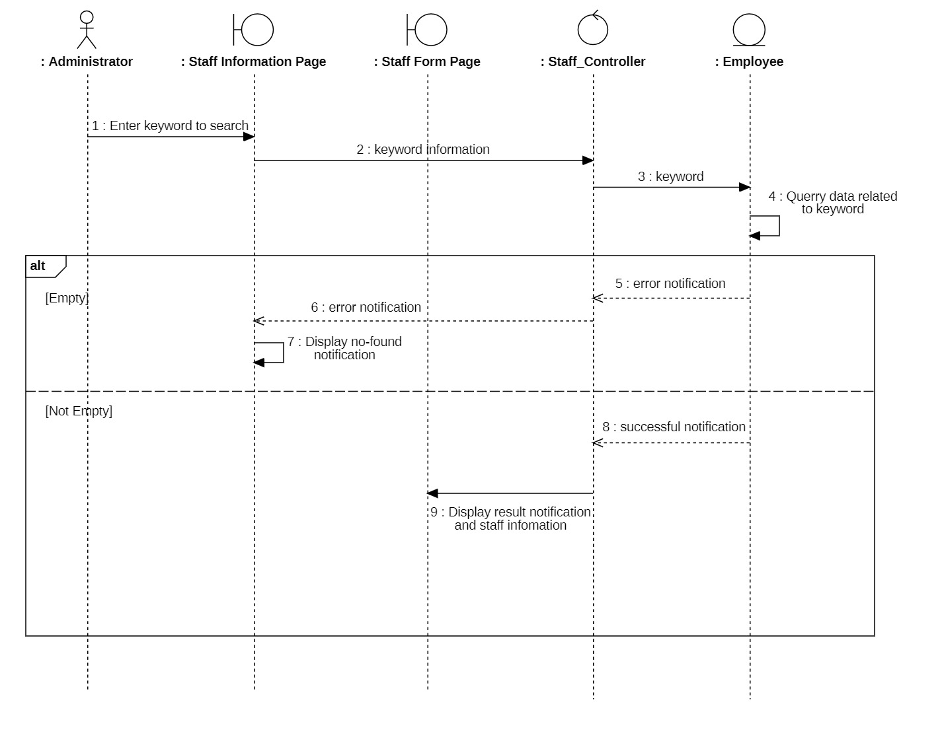

#### *3.2.2 Class diagram*

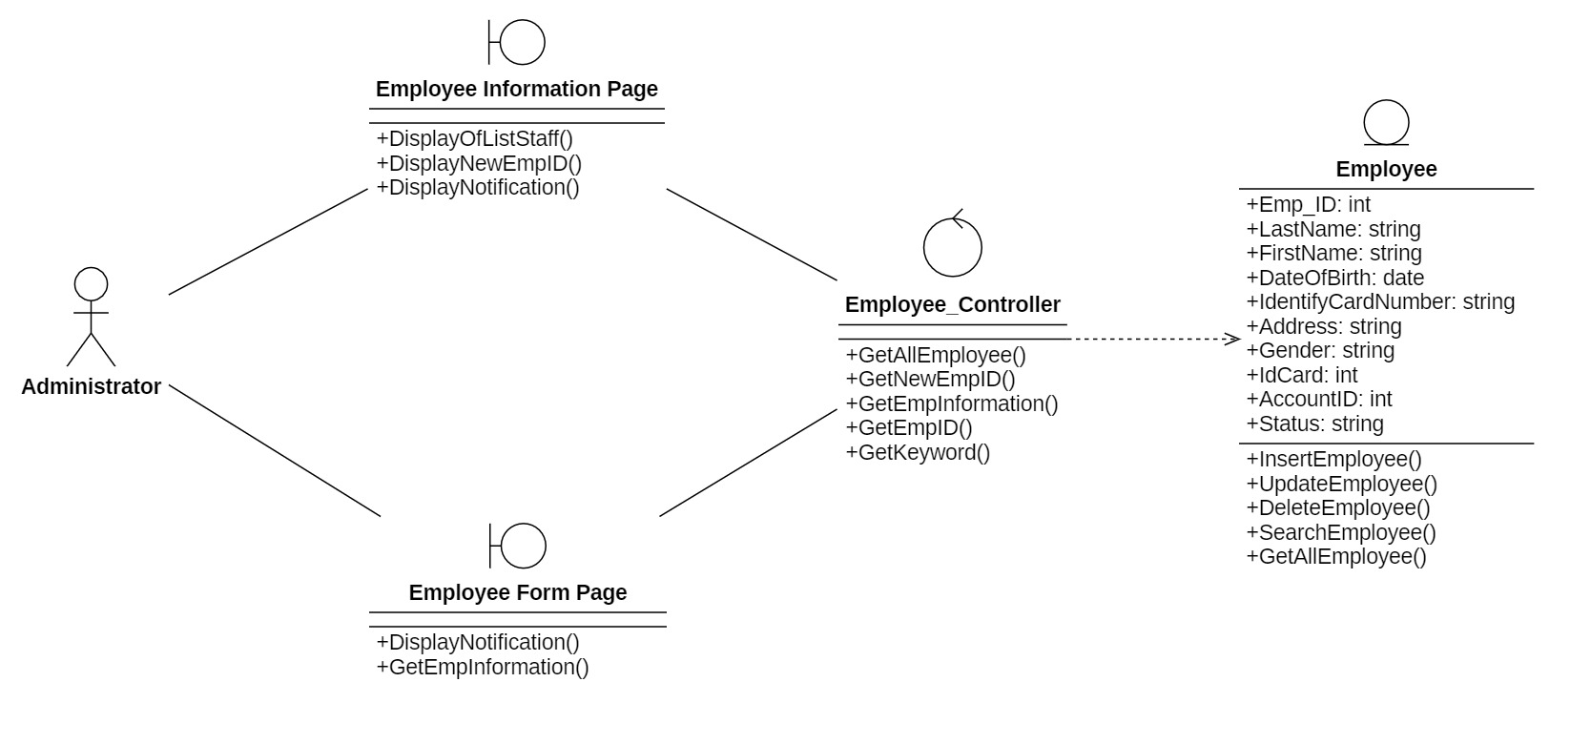

### **3.3 Payment cost (for Administrator and Employees)**

#### *3.3.1 Sequence diagram*

##### 3.3.1.1 Insert invoice

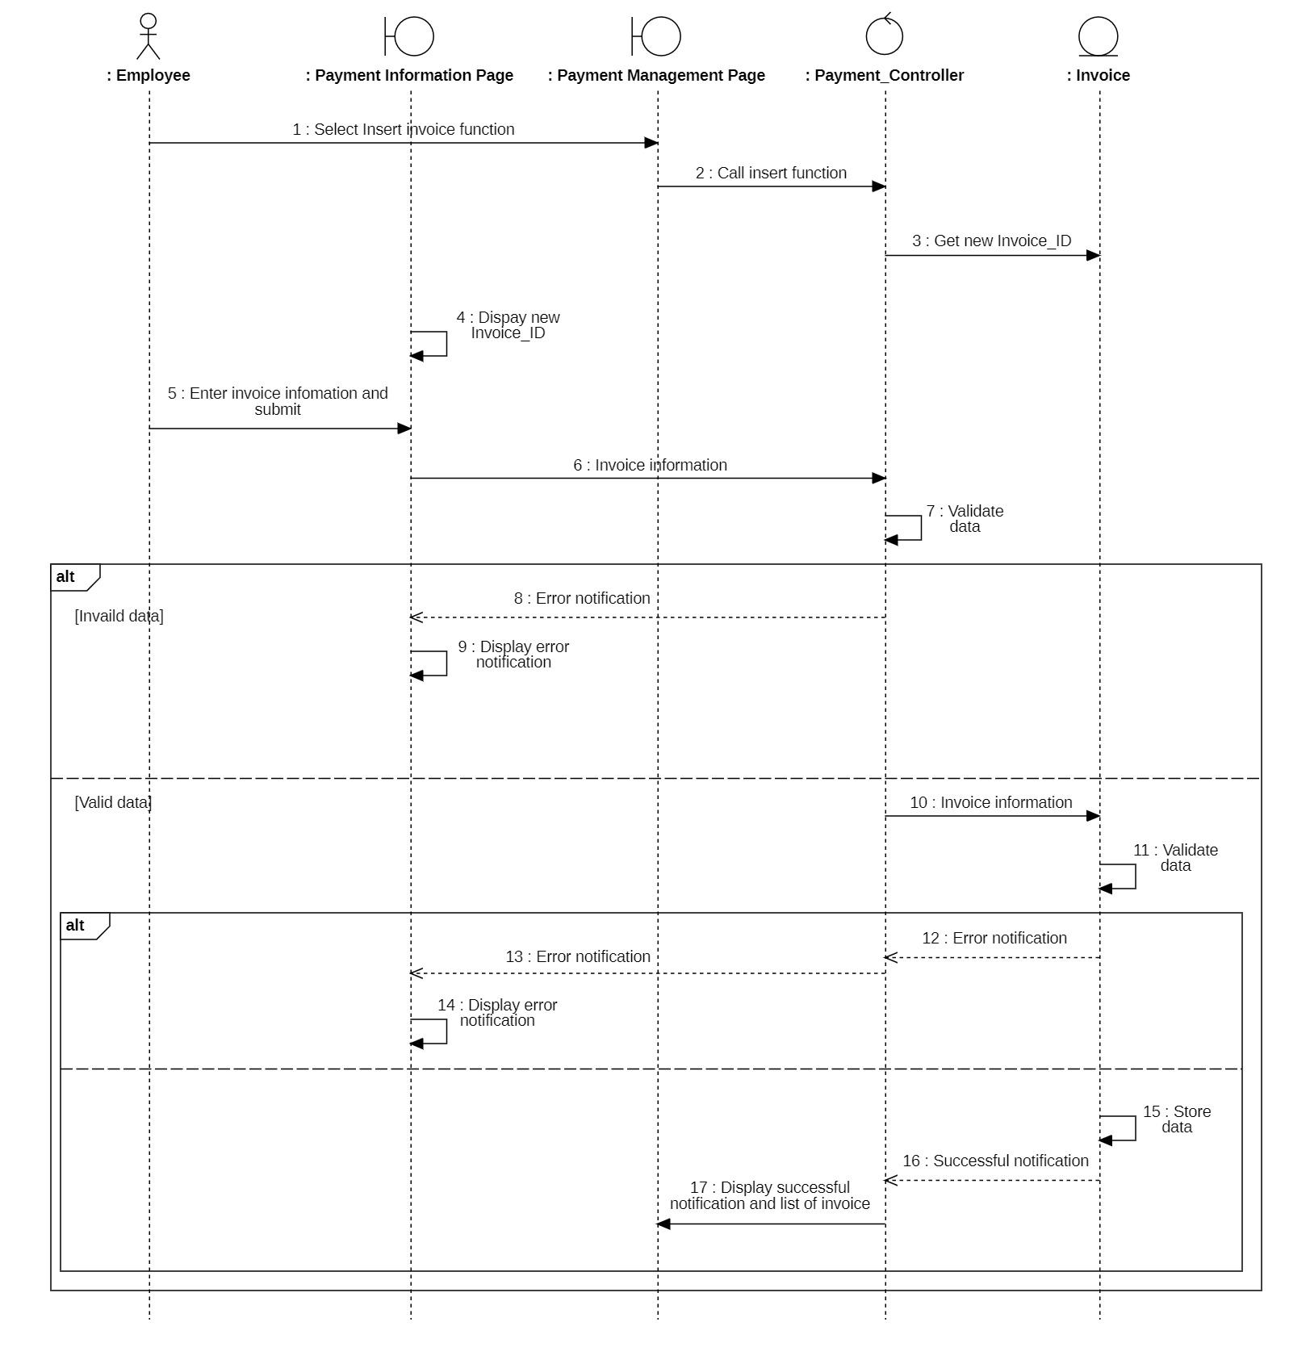

5. Insert invoice for Administrator and Employee

##### 3.3.1.2 Update invoice

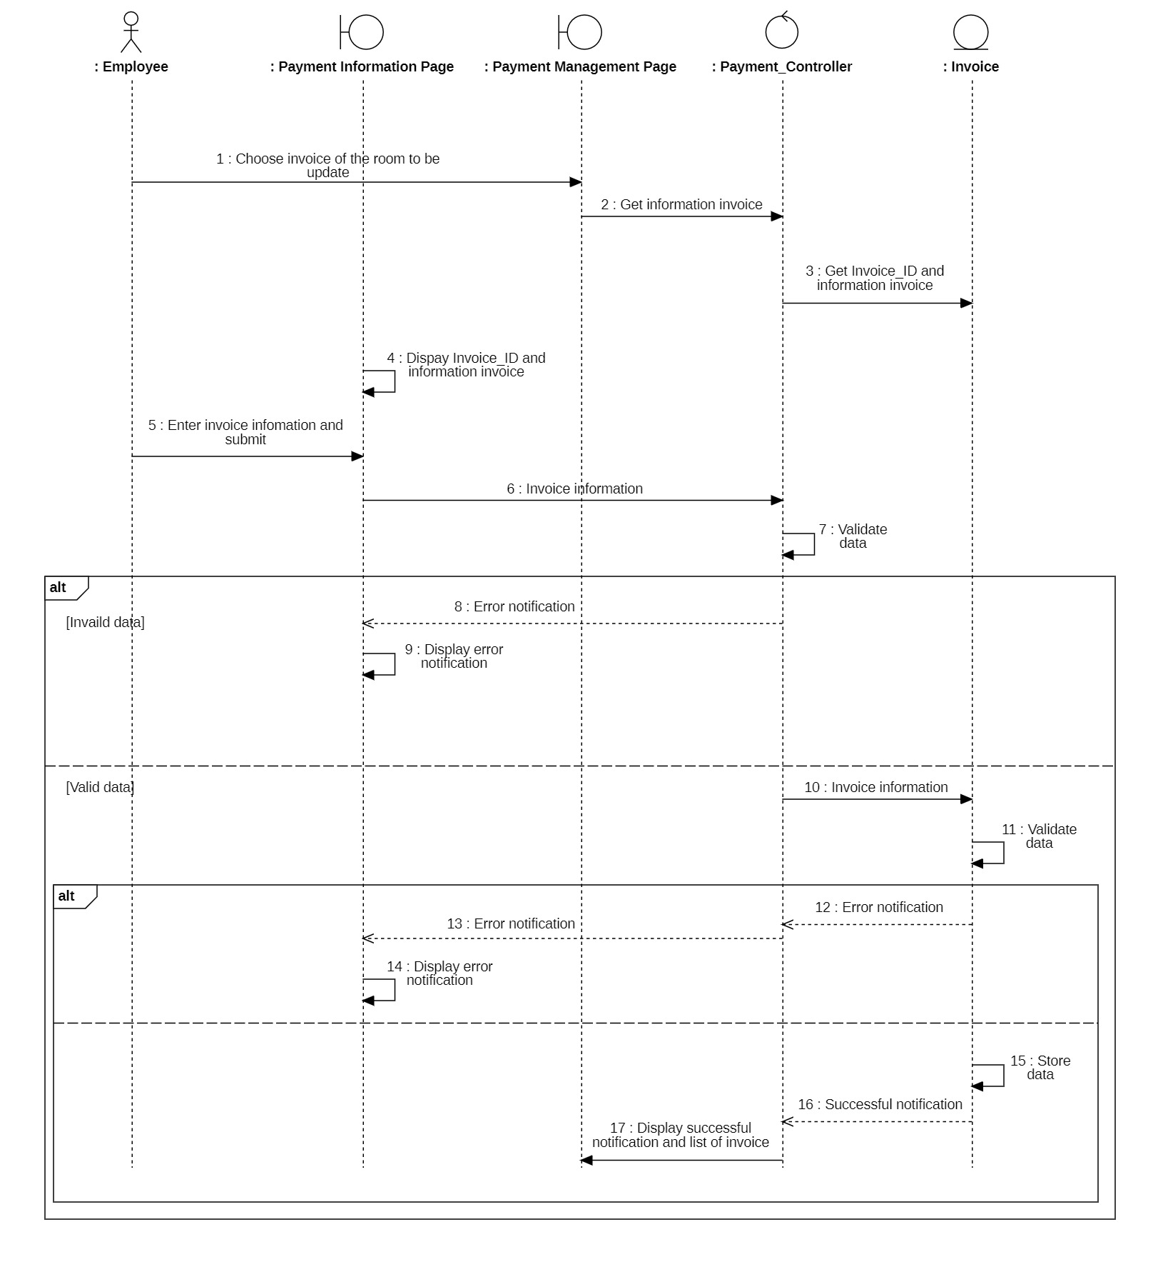

6. Update invoice for Administrator and Employee

##### 3.3.1.3 Delete invoice

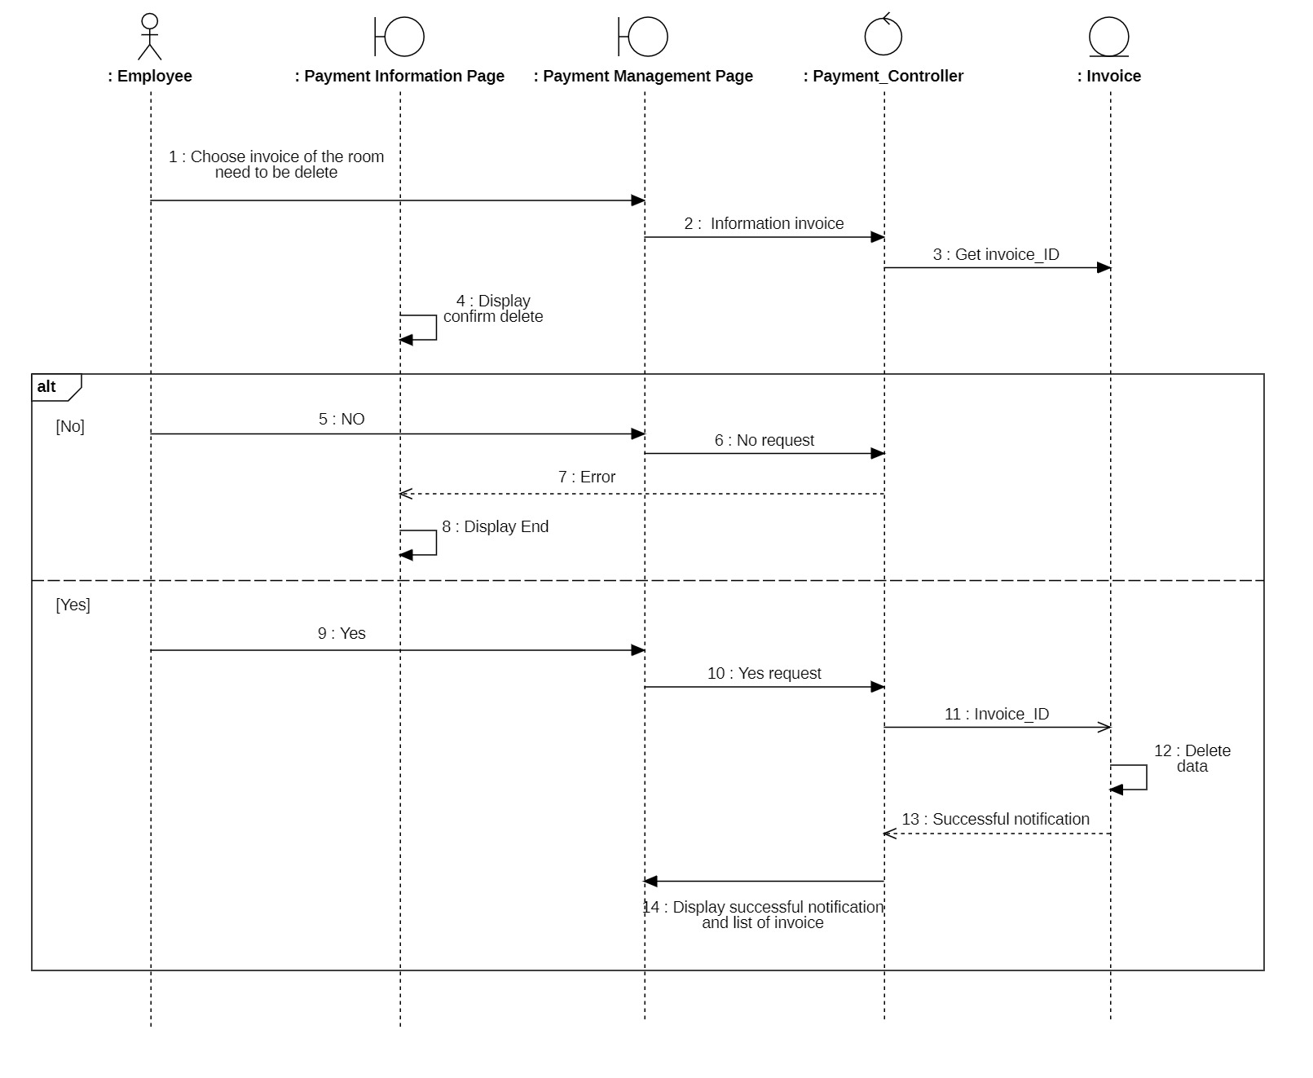

7. Delete invoice for Administrator and Employee

#### *3.3.2 Class diagram*

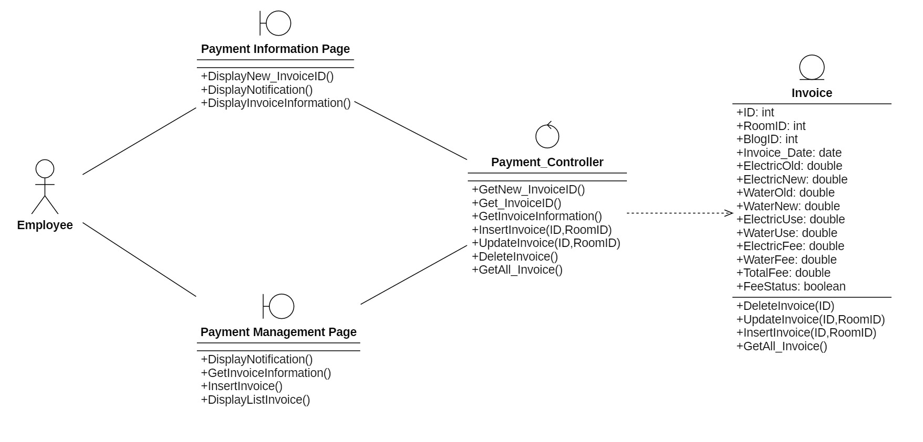

### **3.4 Payment cost (for Student)**

#### *3.4.1 Sequence diagram*

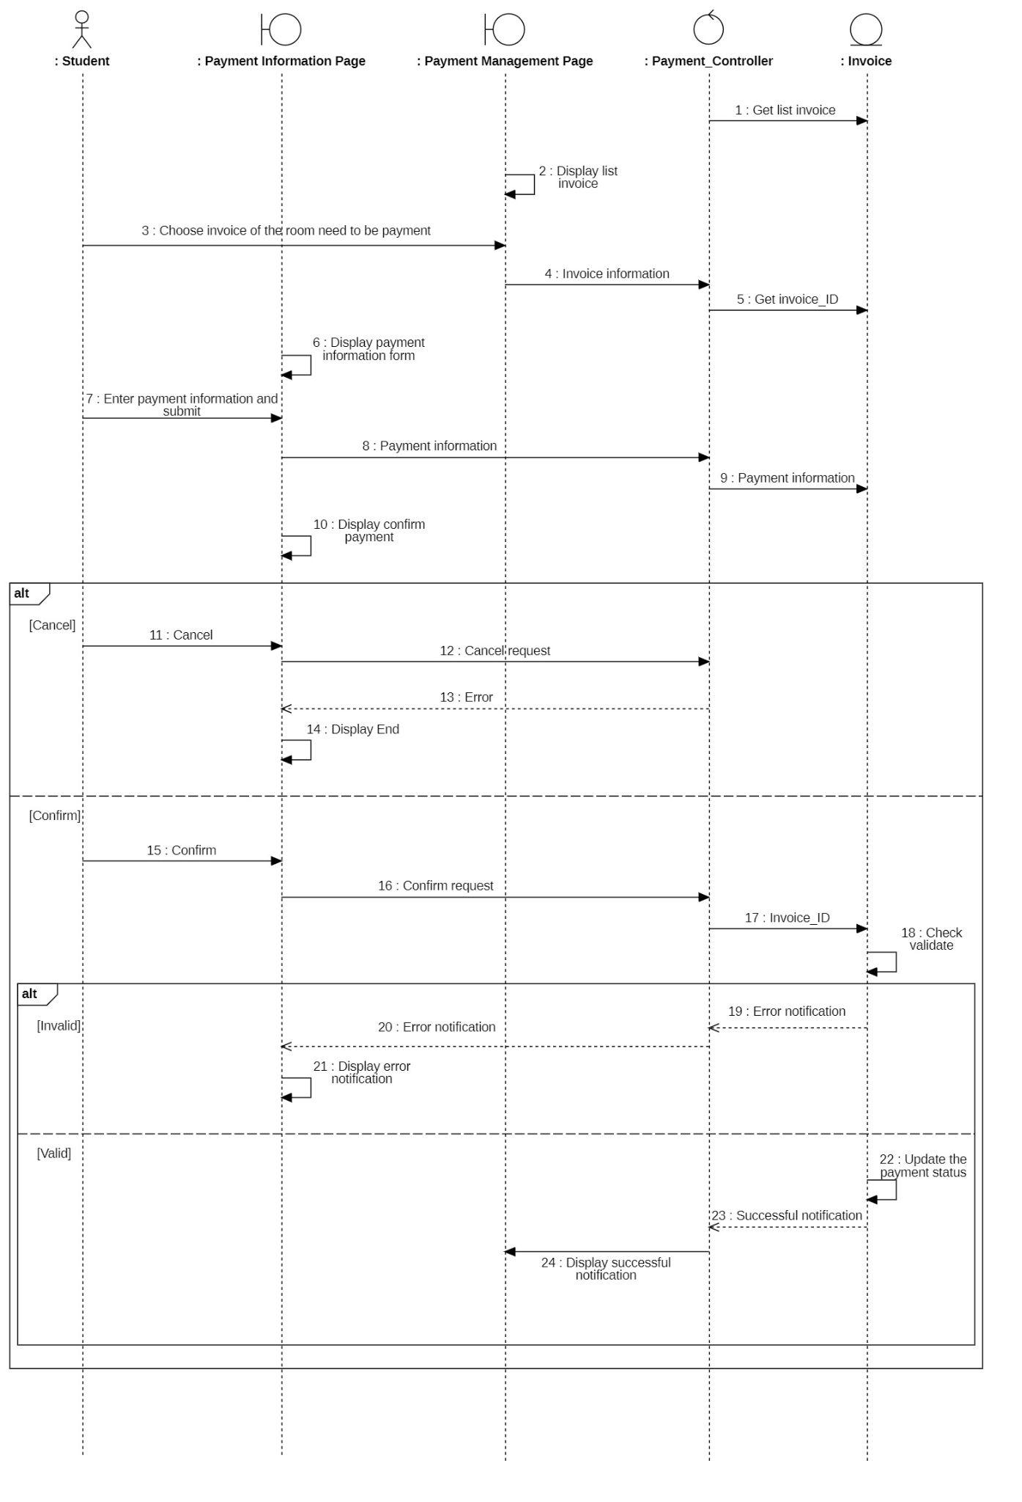

#### *3.4.2 Class diagram*

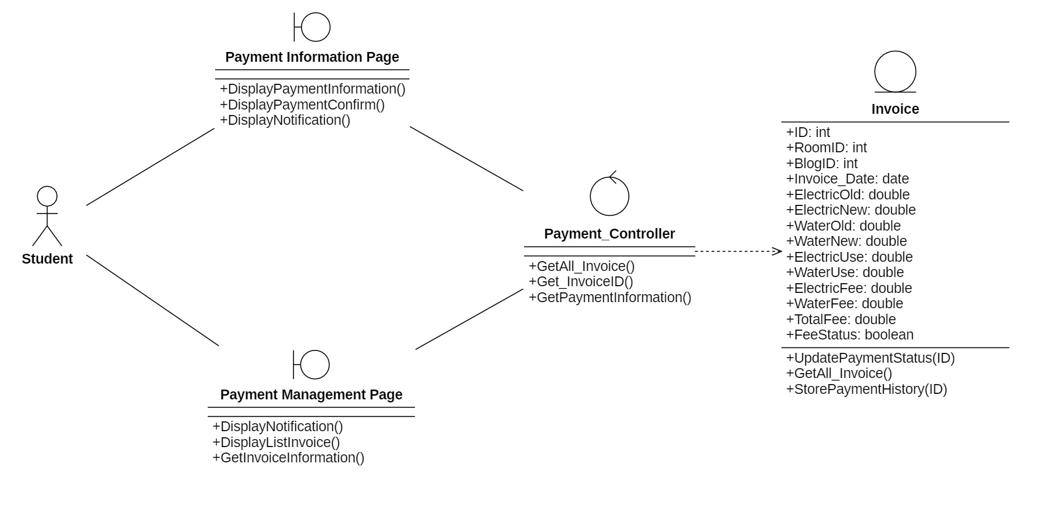

### **3.5 Manage Student**

#### *3.5.1 Sequence diagram*

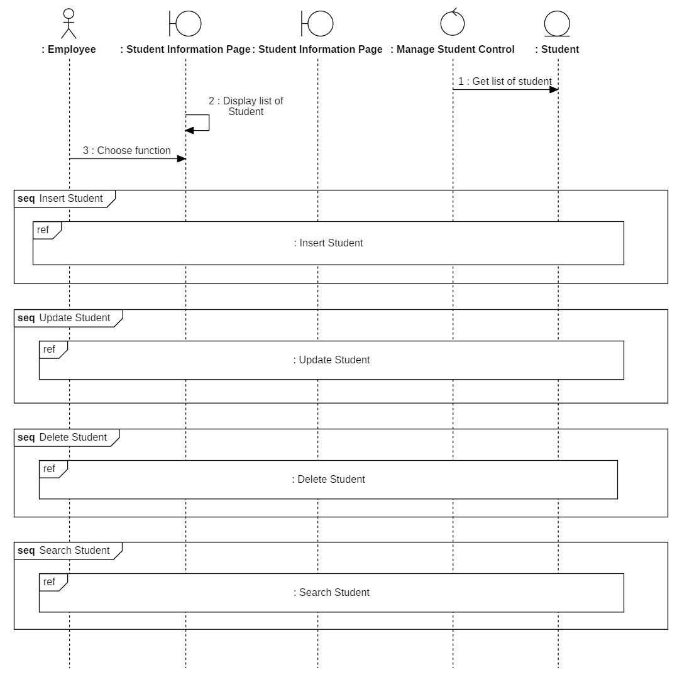

##### 3.5.1.1 Insert student

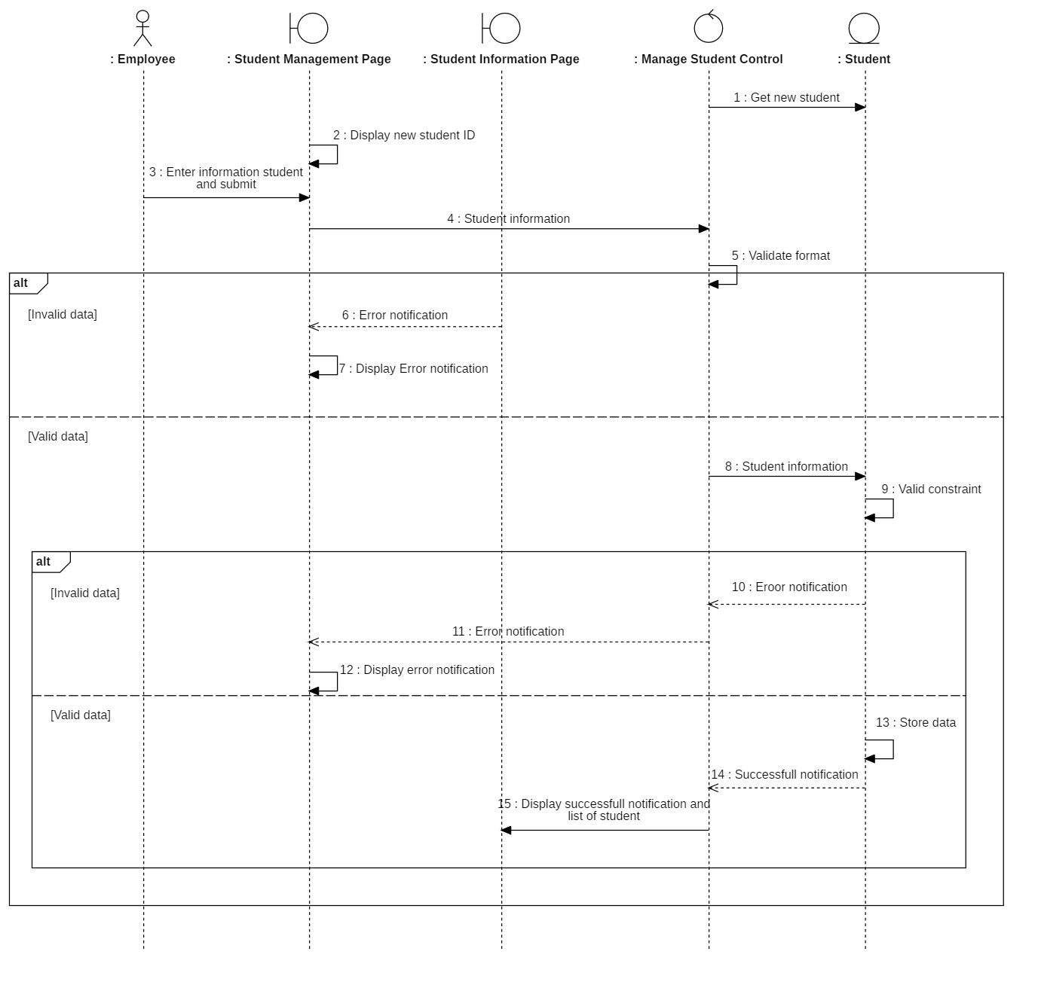

##### 3.5.1.2 Update student

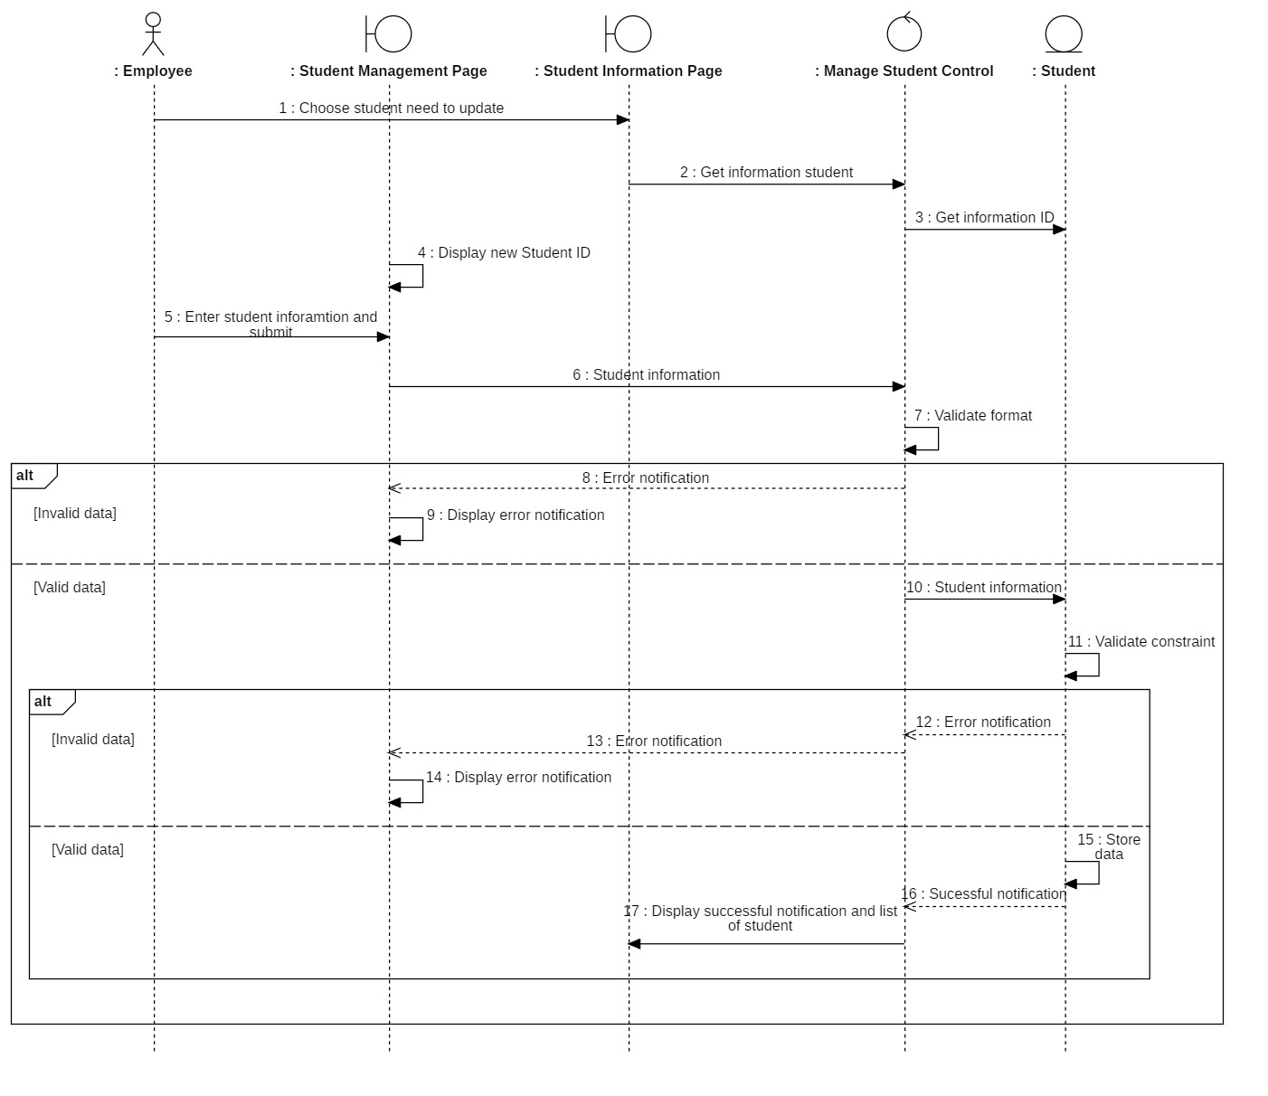

##### 3.5.1.3 Delete student

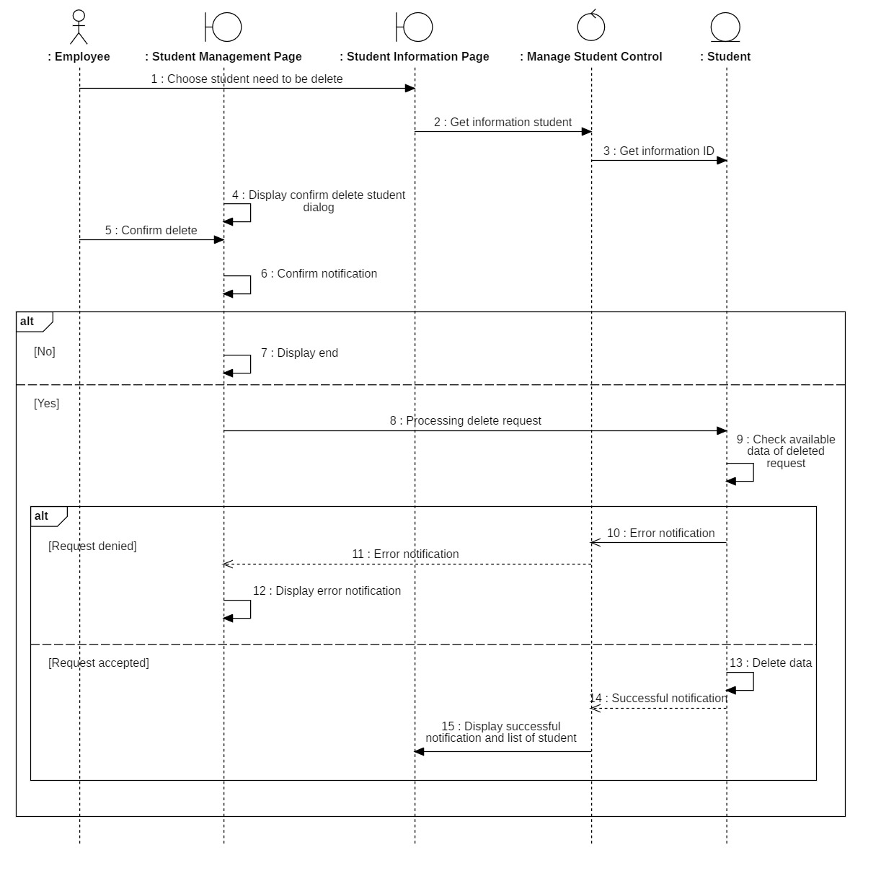

##### 3.5.1.4 Search student

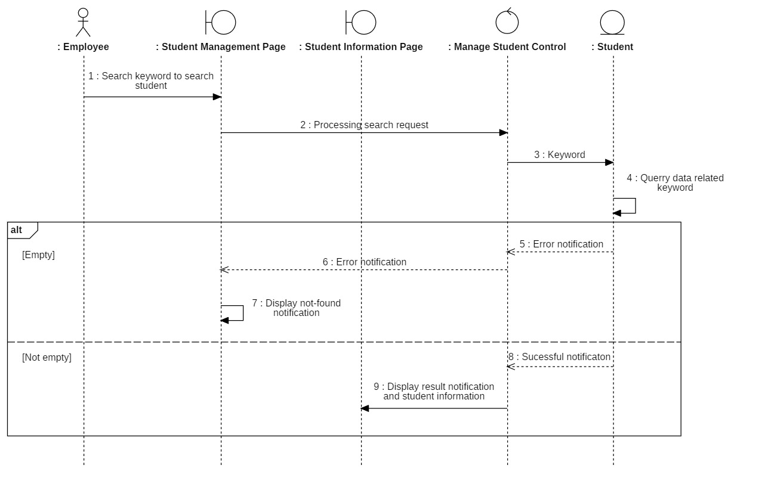

#### *3.5.2 Class diagram*

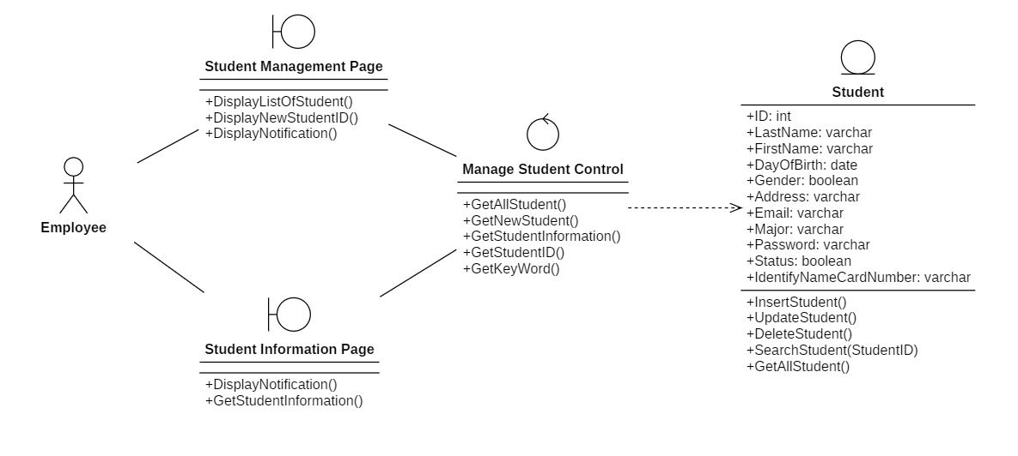

### **3.6 Manage dorm room**

#### *3.6.1 Sequence diagram*

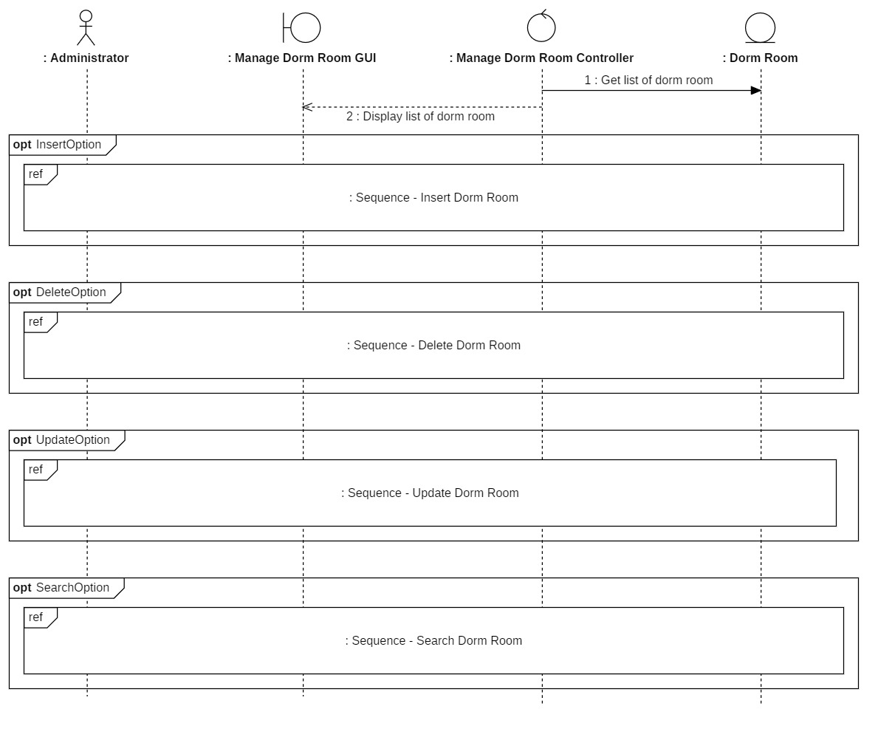

##### 3.6.1.1 Insert dorm room

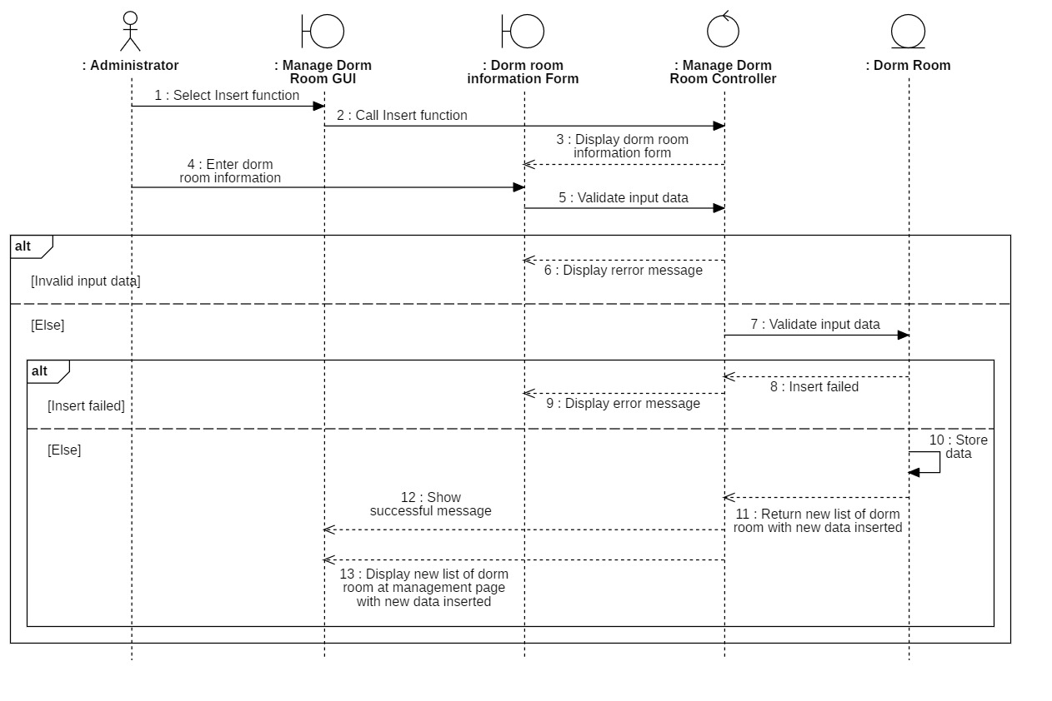

##### 3.6.1.2 Delete dorm room

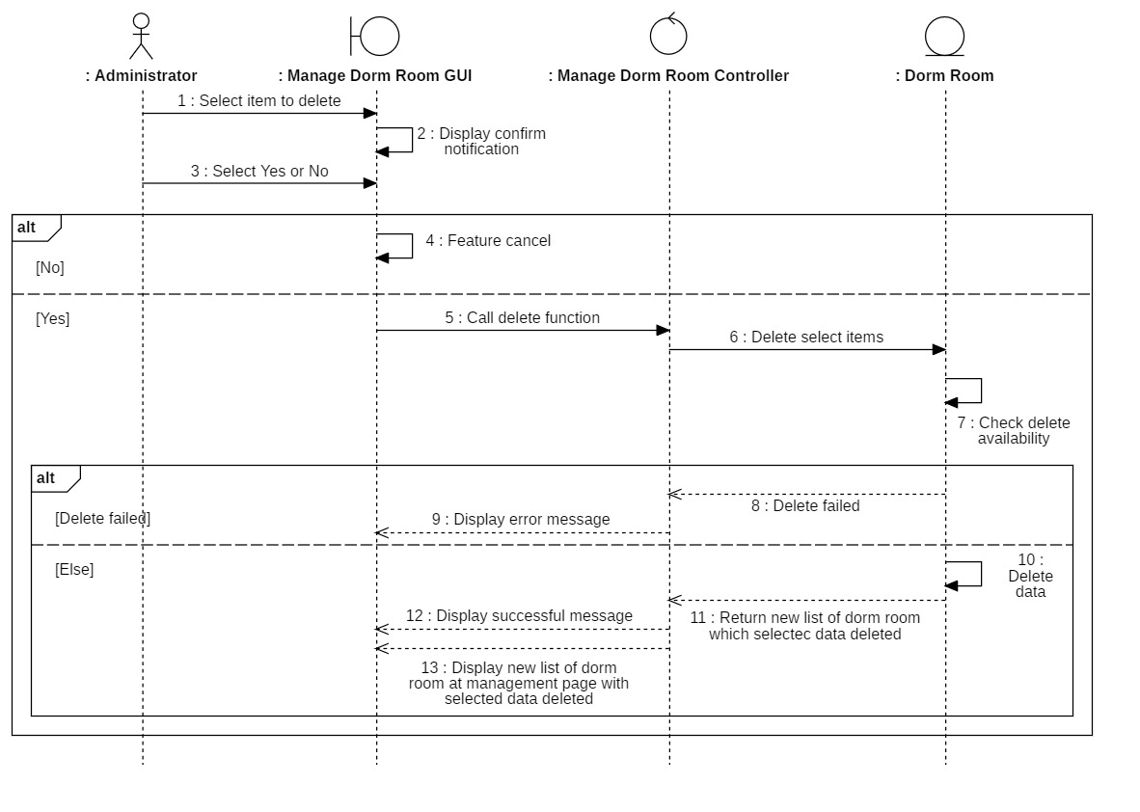

##### 3.6.1.3 Update dorm room

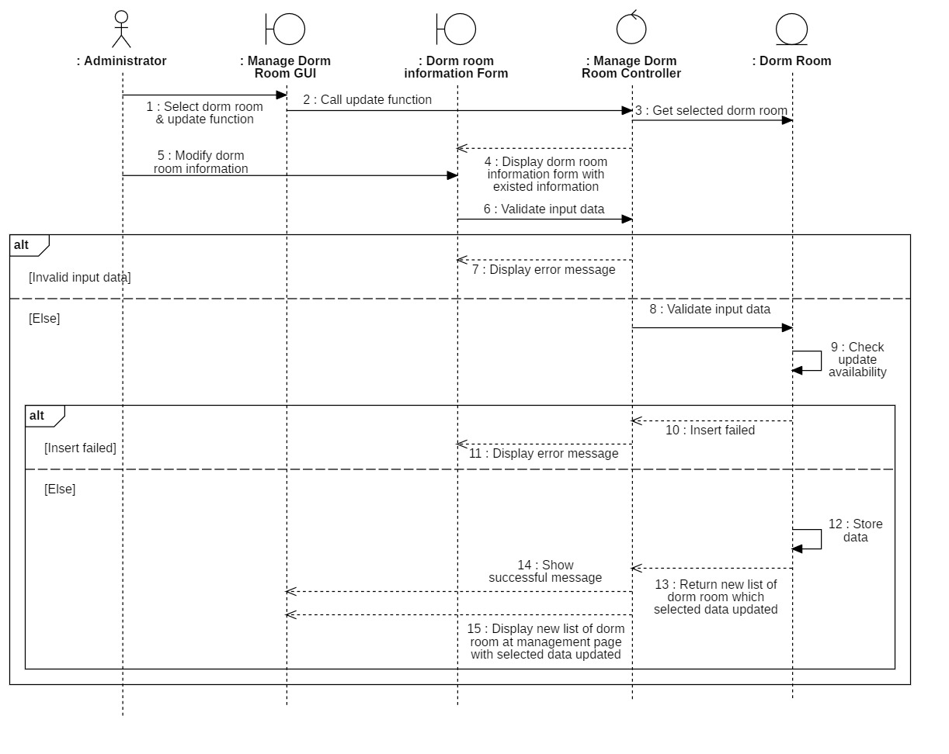

##### 3.6.1.4 Search dorm room

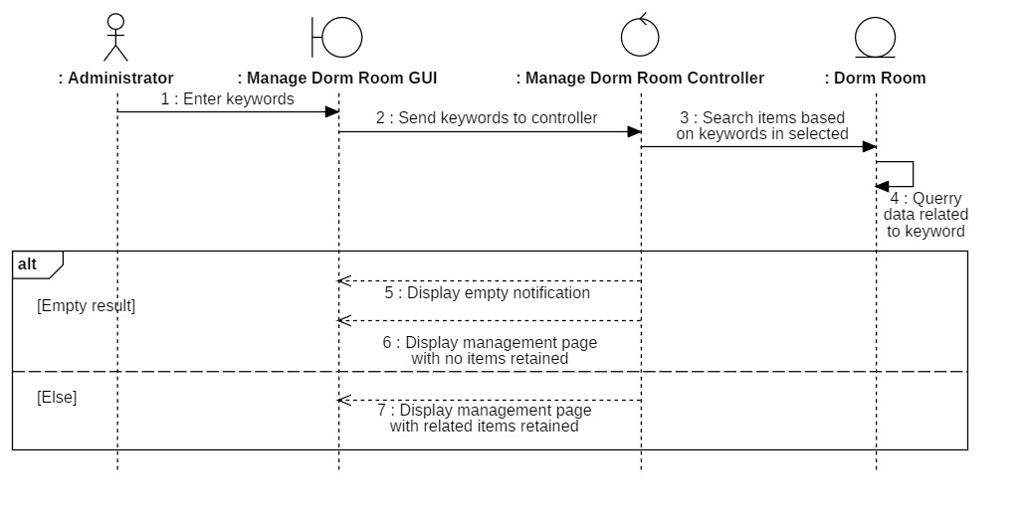

#### *3.6.2 Class diagram*

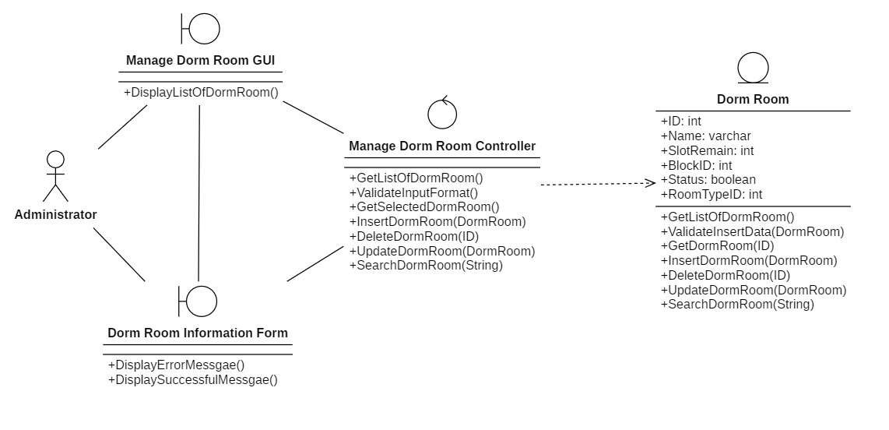

### **3.7 Statistics**

#### *3.7.1 Sequence diagram*

##### 3.7.1.1 Electricity and water bill owed

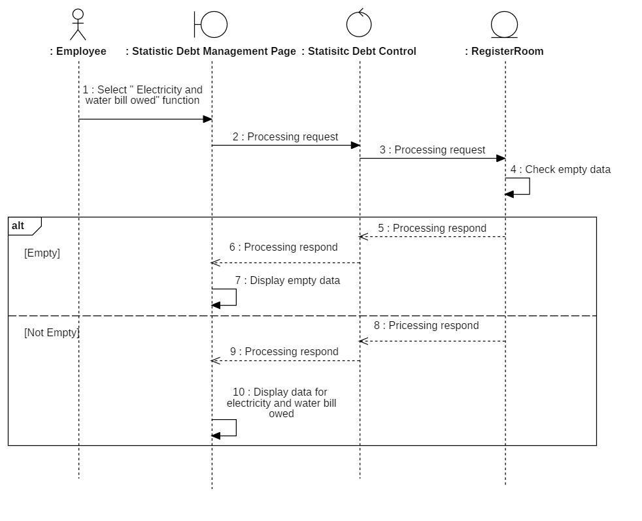

##### 3.7.1.2 Total amount owed for the room

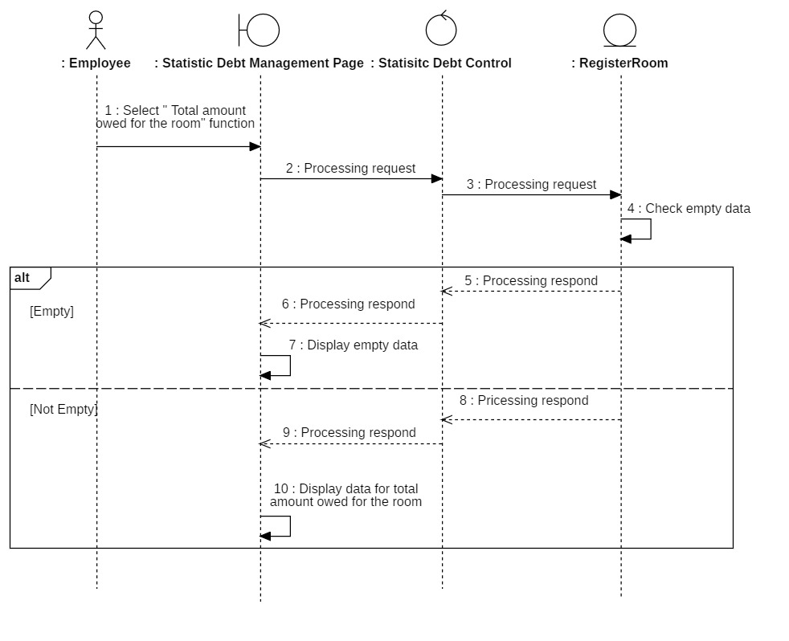

##### 3.7.1.3 Number of students who have not paid

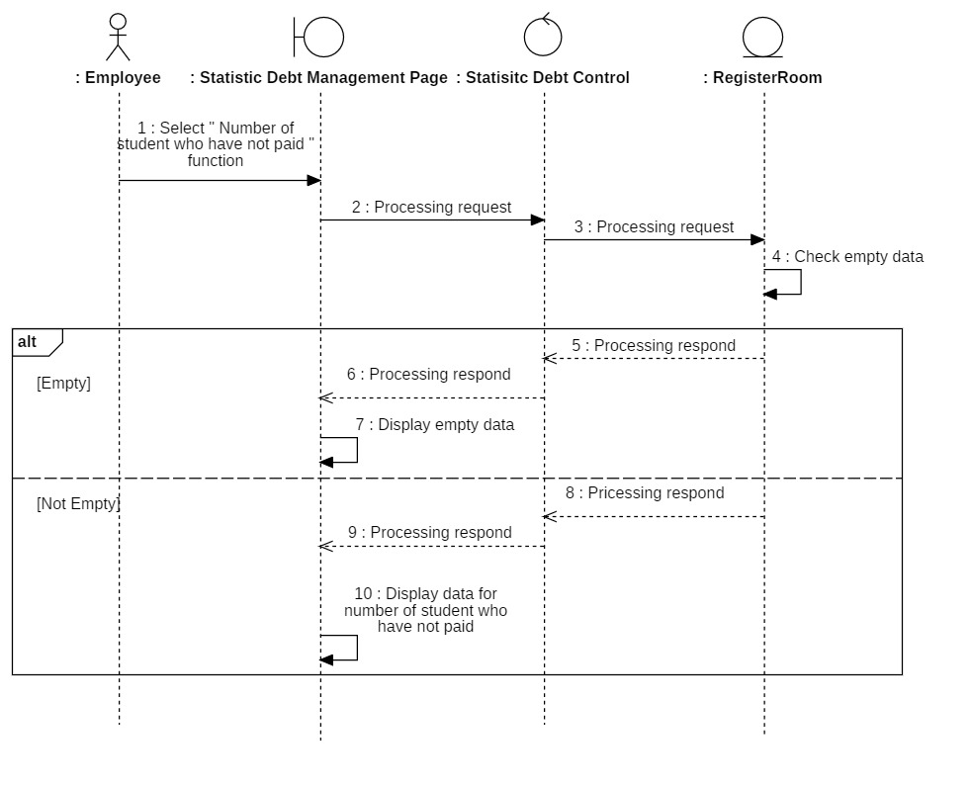

##### 3.7.1.4 Number of room available

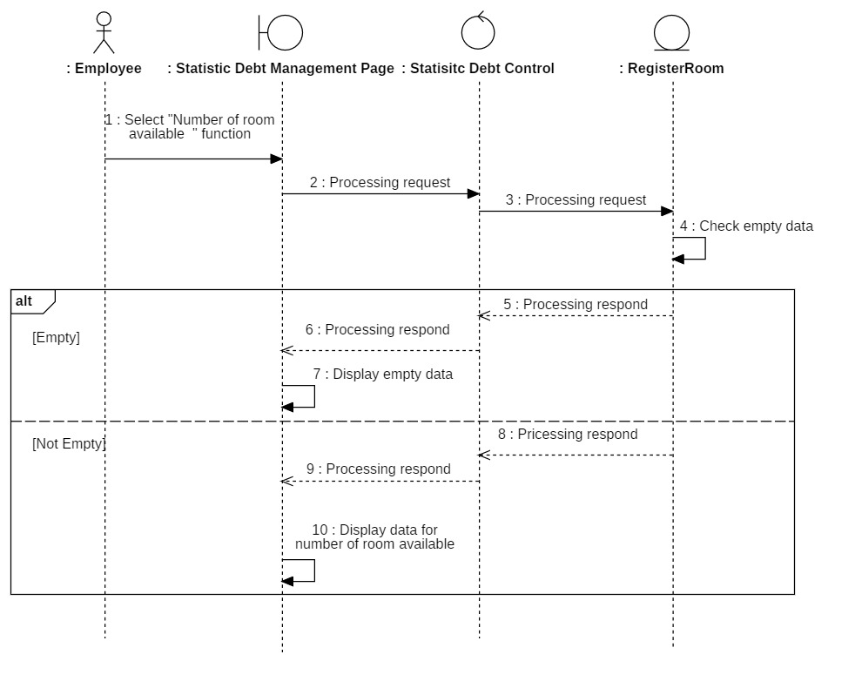

#### *3.7.2 Class diagram*

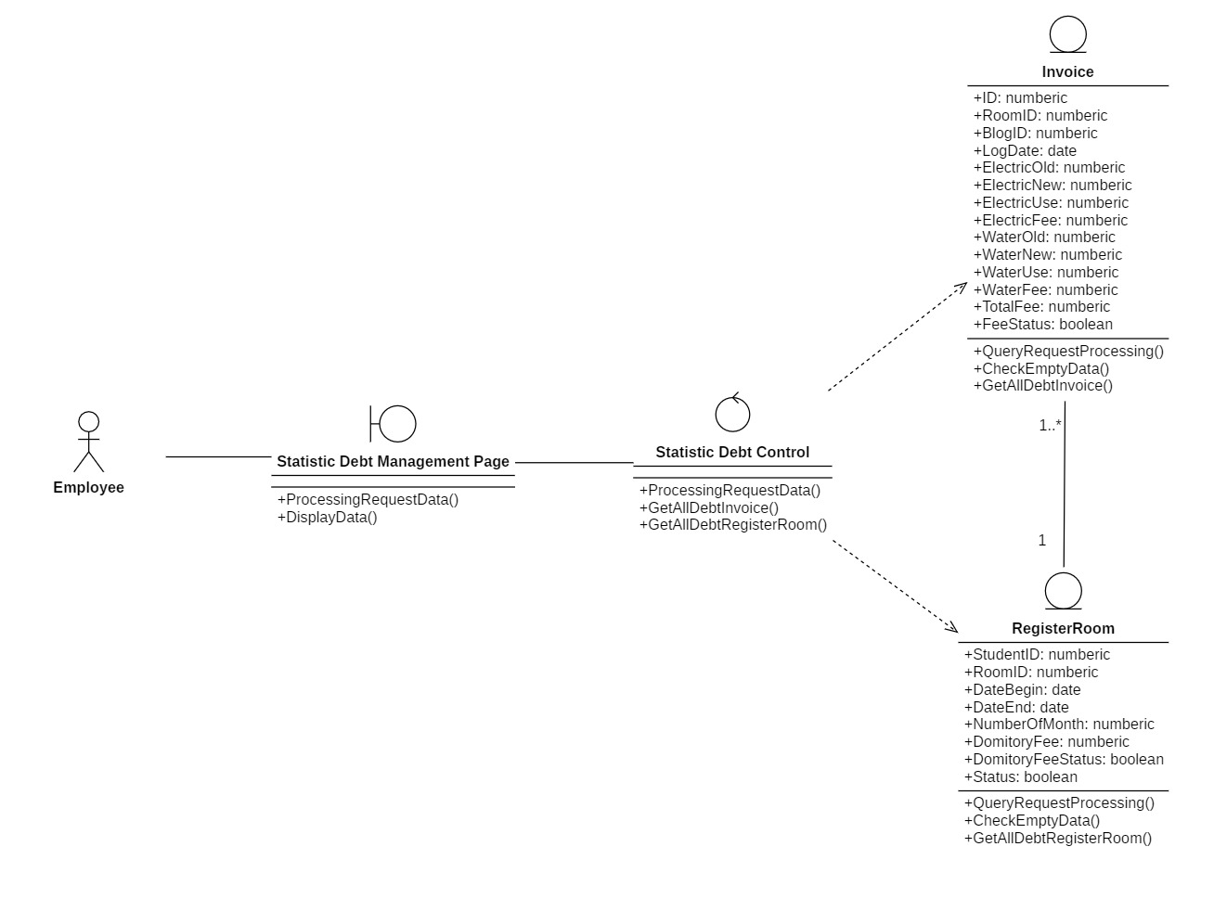

### **3.8 Arrange room**

#### *3.8.1 Sequence diagram*

##### 3.8.1.1 Register Room

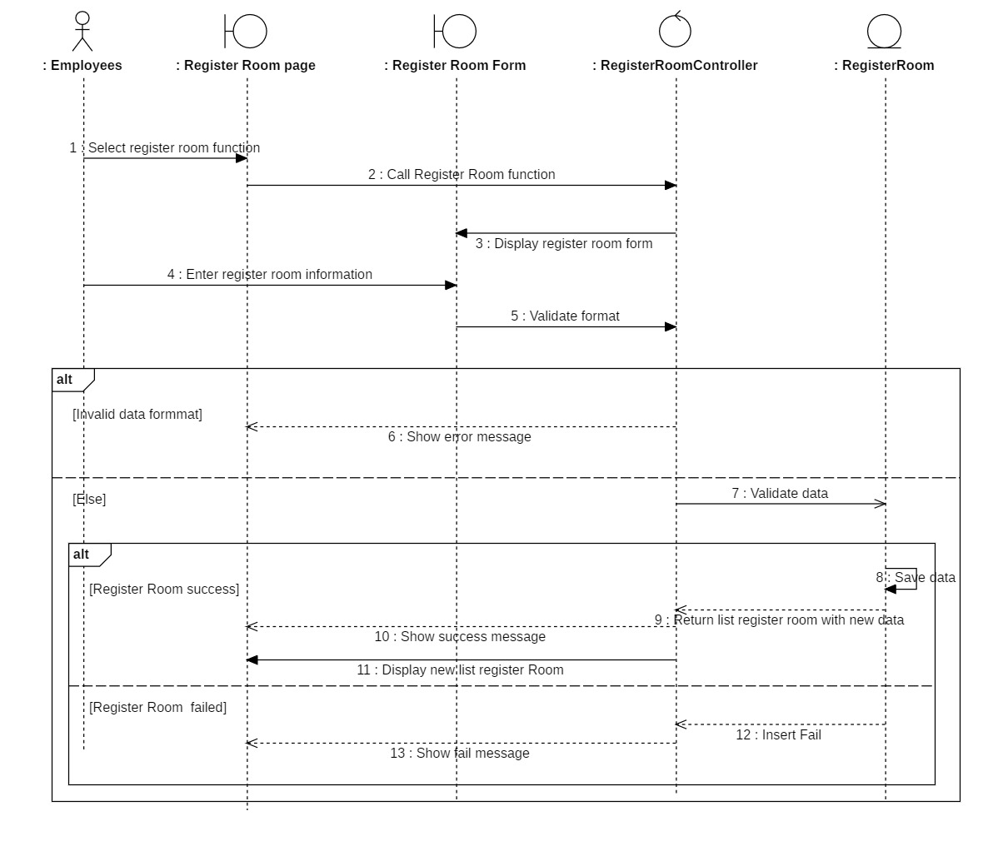

##### 3.8.1.2 Change Room

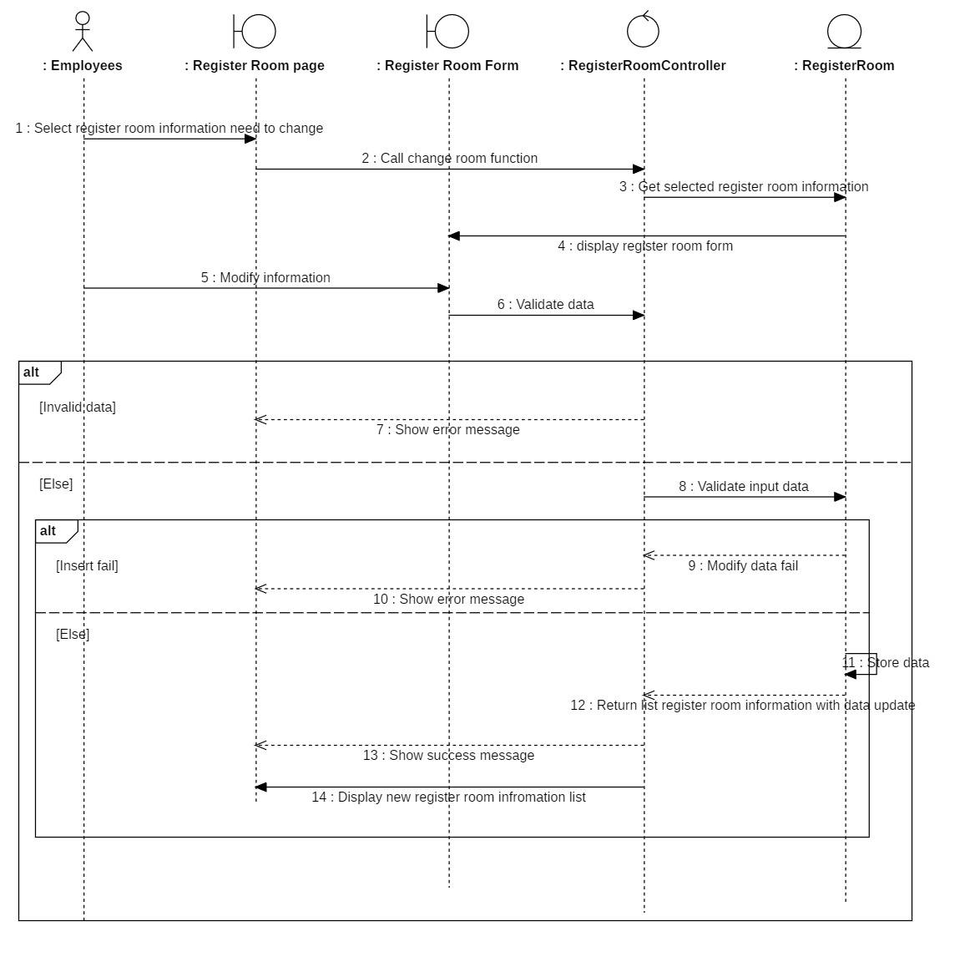

##### 3.8.1.3 Cancel register room

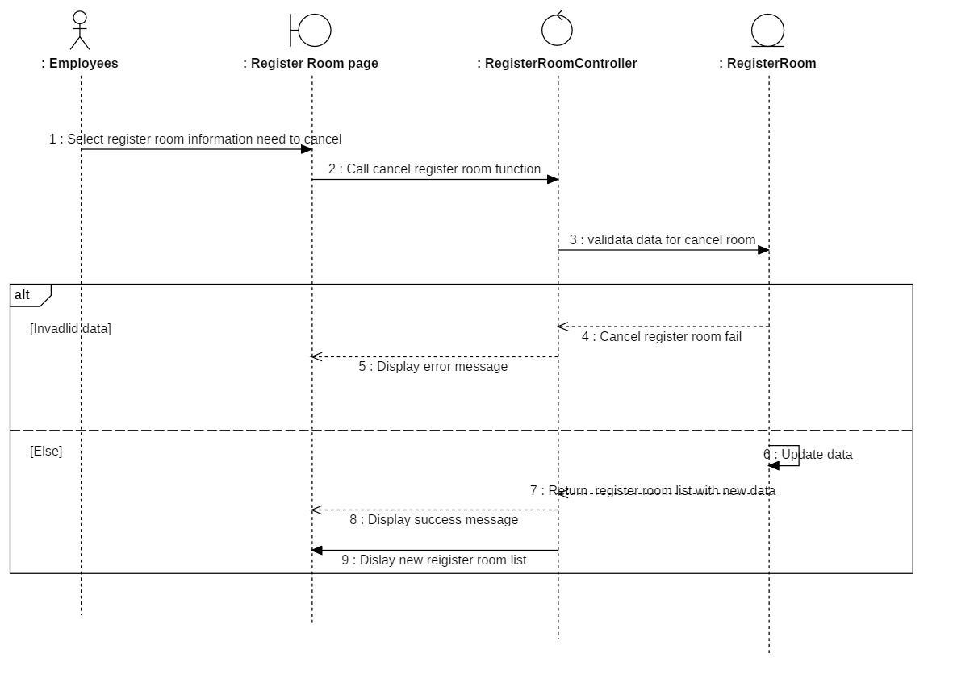

#### *3.8.2 Class diagram*

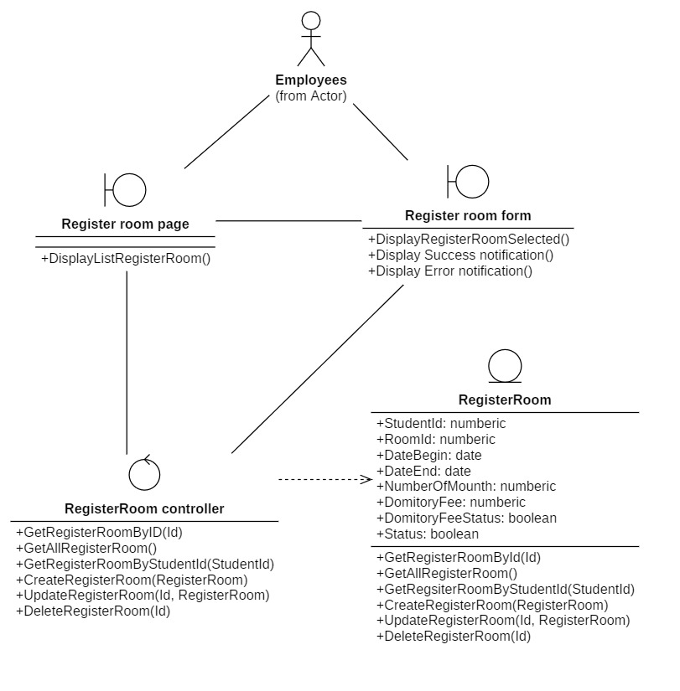

### **3.9 View profile**

#### *3.9.1 Sequence diagram*

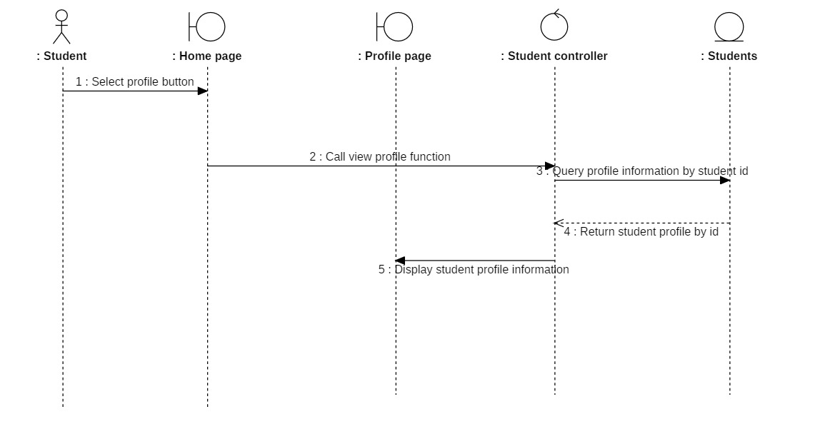

#### *3.9.2 Class diagram*

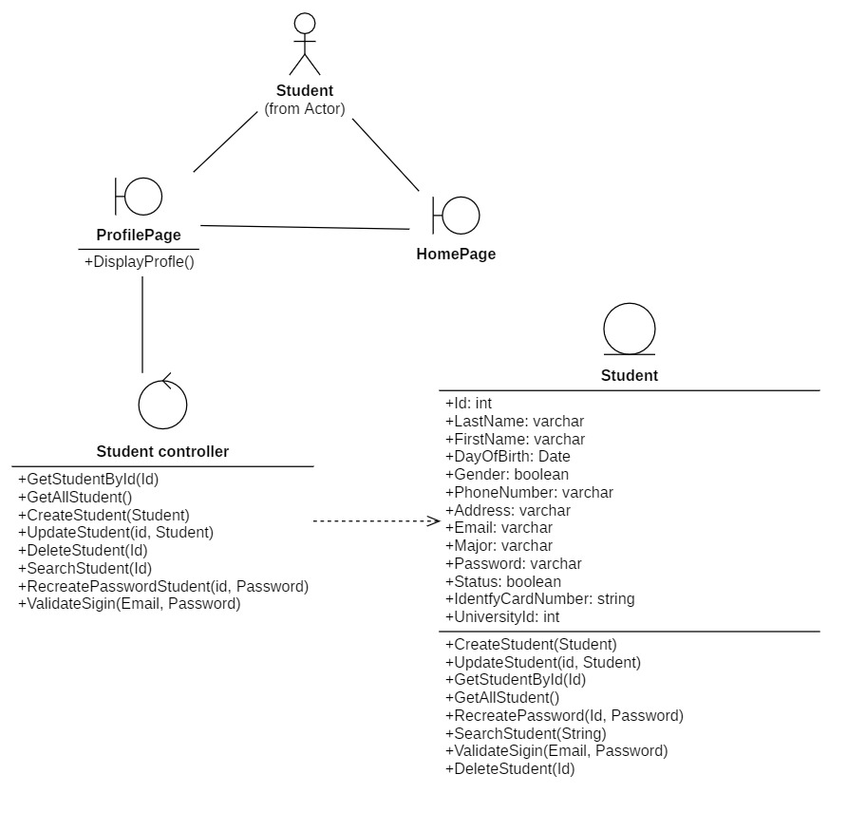

### **3.10 View stay history**

#### *3.10.1 Sequence diagram*

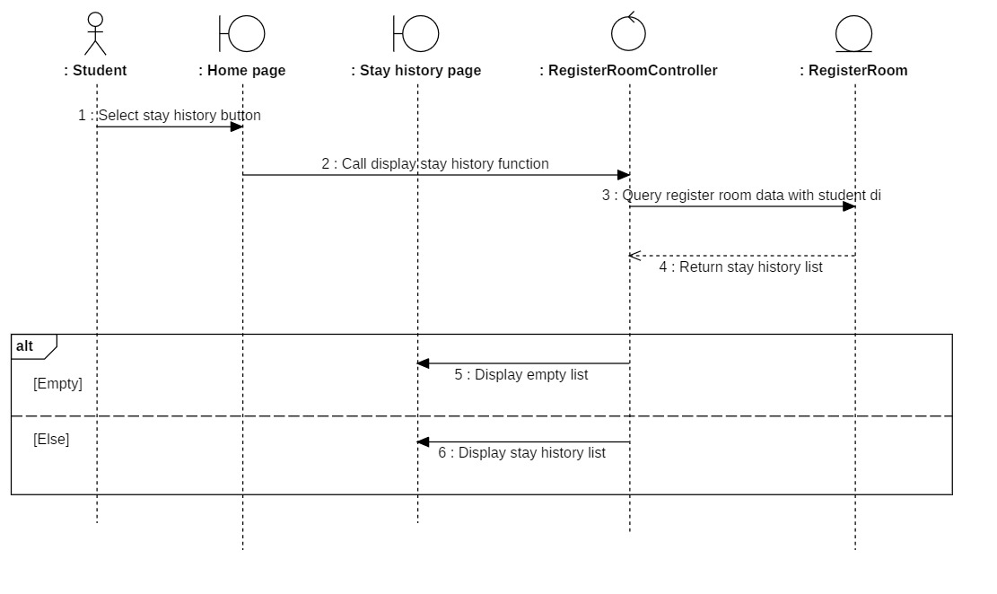

#### *3.10.2 Class diagram*

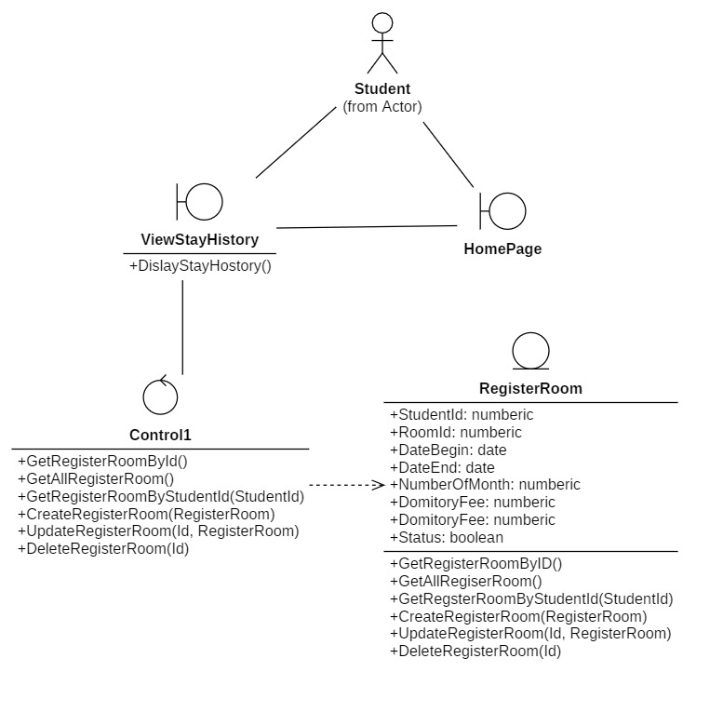

## **4. Class diagram and entity class diagram**

### **4.1 Entity class diagram**

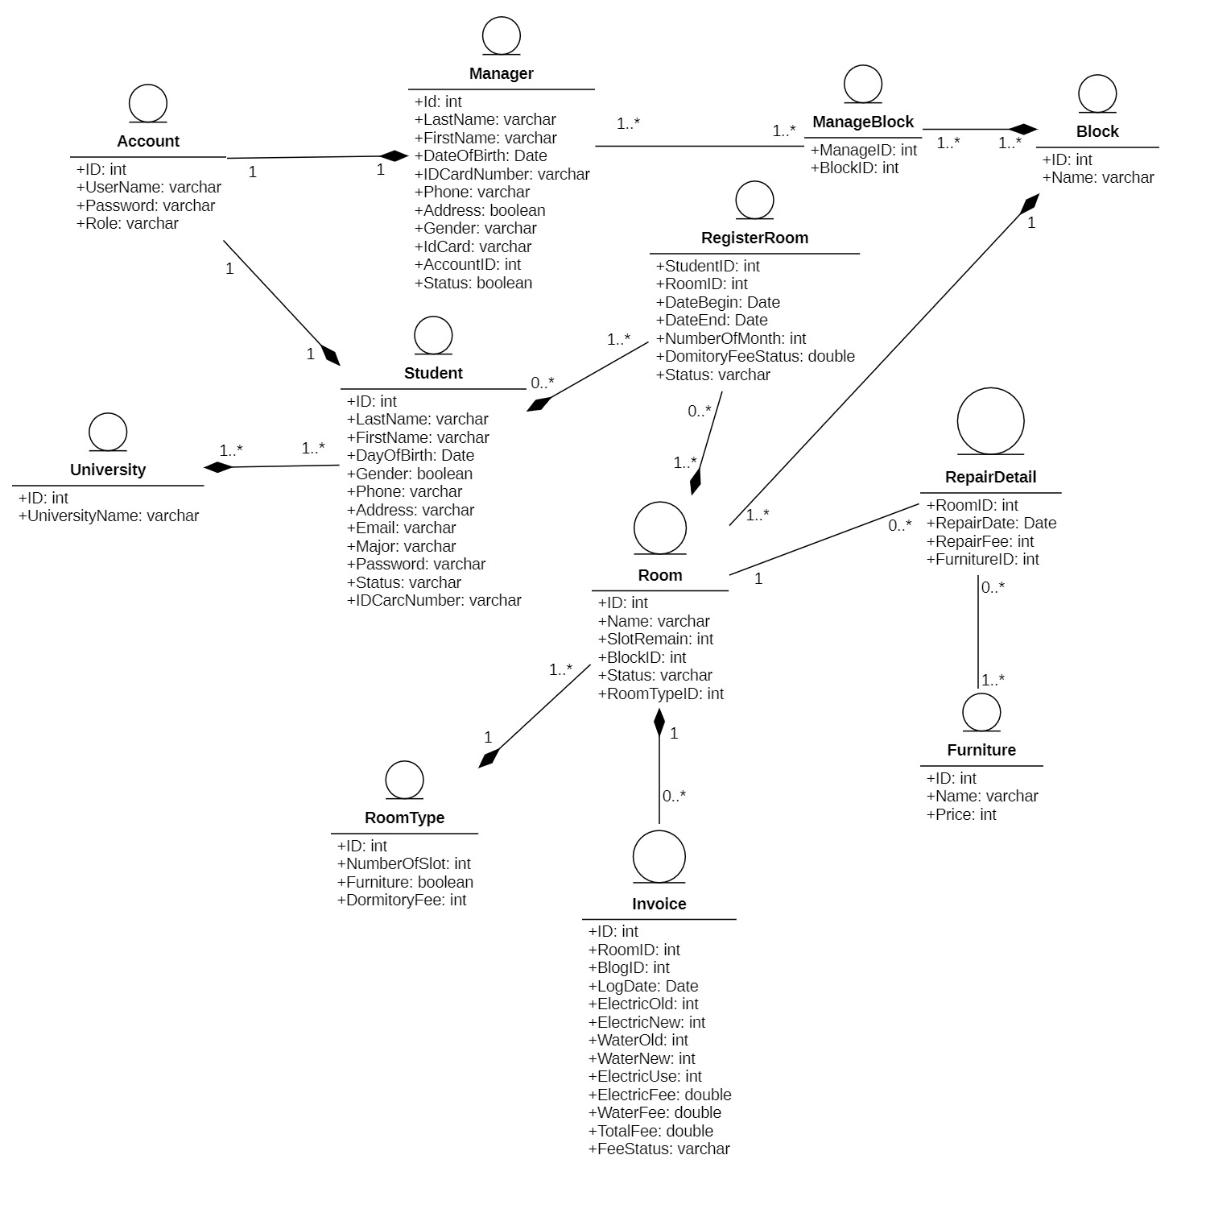

### **4.2 Class diagram specification**

#### *4.2.1 Employee*

|  |  |  |
| --- | --- | --- |
| **Employee** | | |
| **Operation** | **Function** | **Meaning** |
| InsertEmployee() | Store the new employee's information in a database after the information is valid |
| UpdateEmployee() | Update employee information back into the database after changes |
| DeleteEmployee() | Delete employee information after being selected |
| SearchEmployee() | Search employees related to keywords for displaying on the employee management page of administrator. |
| GetAllEmployee() | Get list of employees to perform on the employee management page of administrator |

#### *4.2.2 Invoice*

|  |  |  |
| --- | --- | --- |
| **Invoice** | | |
| **Operation** | **Function** | **Meaning** |
| InsertInvoice() | Store the new invoices information in a database after the information is valid |
| UpdateInvoice() | Update invoice information back into the database after changes |
| DeleteInvoice() | Delete invoice information after being selected |
| UpdatePaymentStatus(ID) | Update the payment status again after the payment has been successful. |
| StorePaymnetHistory(ID) | Store invoice information after successful payment. |
| GetAll_Invoice() | Get a list of invoices to perform on the Payment management page of administrator and employee. |
| QueryRequestProcessing() | Request to query the data in the database to return the required result |
| CheckEmptyData() | Check if the database has data to return or not |
| GetAllDebtInvoice() | Get a list of invoices debt to show on the Statistic debt management page |

#### *4.2.3 Employee_Controller*

|  |  |  |
| --- | --- | --- |
| **Employee_Controller** | | |
| **Operation** | **Function** | **Meaning** |
| GetAllEmployee() | Get list of employees to perform on the employee management page of administrator |
| GetNewEmpID() | Request database to get of new Employee ID |
| GetEmpID() | Database request that returns employee ID after being selected |
| GetEmpInformation() | Send employee information to a database |
| GetKeyword() | Send search keywords to the database |

#### *4.2.4 Payment _Controller*

|  |  |  |
| --- | --- | --- |
| **Payment_Controller** | | |
| **Operation** | **Function** | **Meaning** |
| GetAll_Invoice() | Get a list of invoices to perform on the Payment management page of administrator and employee. |
| GetNew_InvoiceID() | Request database to get of new Invoice ID |
| Get_InvoiceID() | Database request that returns invoice ID after being selected |
| GetInvoiceInformation() | Send invoice information to a database |
| InsertInvoice (ID, RoomID) | Call the invoice insert function below the database |
| UpdateInvoice(ID, RoomID) | Call the invoice update function below the database |
| DeleteInvoice() | Call the invoice delete function below the database |
| GetPaymentInformation() | Send payment information to a database |

#### *4.2.5 Student sign-in controller*

|  |  |  |
| --- | --- | --- |
| **Sign-in controller** | | |
| **Operation** | **Function** | **Meaning** |
| ValidateInputFormat(): Bool | Validate if the input information format is correct |
| SignIn(Email, Password): Bool | Request to sign-in to the database |

#### *4.2.6 Employee sign-in controller*

|  |  |  |
| --- | --- | --- |
| **Sign-in controller** | | |
| **Operation** | **Function** | **Meaning** |
| ValidateInputFormat(): Bool | Validate if the input information format is correct |
| SignIn(Email, Password): Bool | Request to sign-in to the database |

#### *4.2.7 Manage dorm room controller*

|  |  |  |
| --- | --- | --- |
| **Dorm room controller** | | |
| **Operation** | **Function** | **Meaning** |
| GetListODromRoom(): Array | Request database to get list of dorm room filter |
| ValidateInputFormat(): Bool | Validate if the input information format is correct |
| GetSelectedDormRoom(ID): Dorm Room | Request database to get information of a dorm room selected by the user |
| InserDormRoom(DormRoom): Bool | Request database to create a new dorm room. Validation function is prerequisite for this function |
| UpdateDormRoom(DormRoom): Bool | Request database to make a change on an exsisted dorm room. Validation function is prerequisite for this function |
| DeleteDormRoom(ID): Bool | Request database to delete a dorm room selected by the user |
| SearchDormRoom(String): Bool | Request database to get a list of dorm room related to the string parameter |

#### *4.2.8 Student*

|  |  |  |
| --- | --- | --- |
| **Student** | | |
| **Operation** | **Function** | **Meaning** |
| InsertStudent() | Store the new student's information in a database after the information is valid |
| UpdateStudent() | Update student information back into the database after changes |
| DeleteStudent() | Delete student information after being selected |
| SearchEmployee (StudentID) | Search students related to keywords for displaying on the student management page of the administrator. |
| GetAllStudent() | Get list of students to perform on the student management page of administrator |

#### *4.2.9 Manage Student Controller*

|  |  |  |
| --- | --- | --- |
| **Student_Controller** | | |
| **Operation** | **Function** | **Meaning** |
| GetAllStudent() | Get list of student to perform on the student management page of administrator |
| GetNewStudentID() | Request database to get of new Student ID |
| GetStudentID() | Database request that returns student ID after being selected |
| GetStudentInformation() | Send student information to a database |
| GetKeyword() | Send search keywords to the database |

#### *4.2.10 Statistic Debt Controller*

|  |  |  |
| --- | --- | --- |
| **Statistic Debt Control** | | |
| **Operation** | **Function** | **Meaning** |
| ProcessingRequestData() | The control page asks the database to query the data it needs to get |
| GetAllDebtInvoice() | Get a list of invoices debt to show on the Statistic debt management page |
| GetAllDebtRegisterRoom() | Get a list of room bill owed to show on the Statistic debt management page |

#### *4.2.11 Register Room*

|  |  |  |
| --- | --- | --- |
| **Statistic Debt Control** | | |
| **Operation** | **Function** | **Meaning** |
| QueryRequestProcessing() | The control page asks the database to query the data it needs to get |
| CheckEmptyData() | Check if the database has data to return or not |
| GetAllDebtRegisterRoom() | Get a list of room bill owed to show on the Statistic debt management page |

*4.2.12 Register Room Controller*

|  |  |  |
| --- | --- | --- |
| **RegisterRoom_Controller** | | |
| **Operation** | **Function** | **Meaning** |
| GetRegisterRoomById(id) | Get regiser room infromation by Reigster room’s Id |
| GetAllRegisterRoom() | Get list of register room information |
| GetRegisterRoomByStudentId (StudentId) | Get list of register room information by student |
|  | CreateRegisterRoom(RegisterRoom) | Create a new register room with input data from employee or adminsator |
|  | UpdateRegisterRoom(Id,RegisterRoom) | Update data of exist register room information from input data from empoyee or adminsator |
|  | DeleteRegisterRoom(Id) | Disable selected register room |

## **5. State diagram**

### **5.1 Arrangre room**

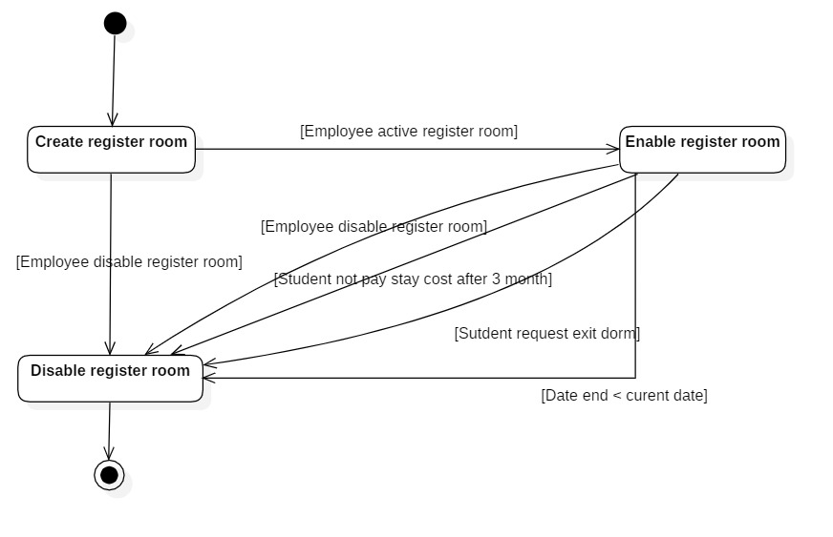

### **5.2 Student**

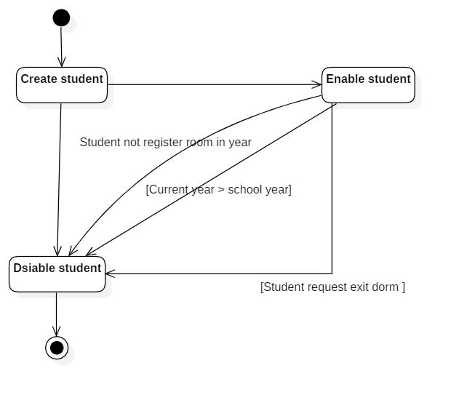

# **CHAPTER IV: IMPLEMENTATION AND TESTING**

## **1. Introduction to the implementation environment**

Operation system: Window 10

Database: SQLServer

Text editor: Visual studio code

Web Client: React

Web Server: ASP.NET.

## **2. User Interface**

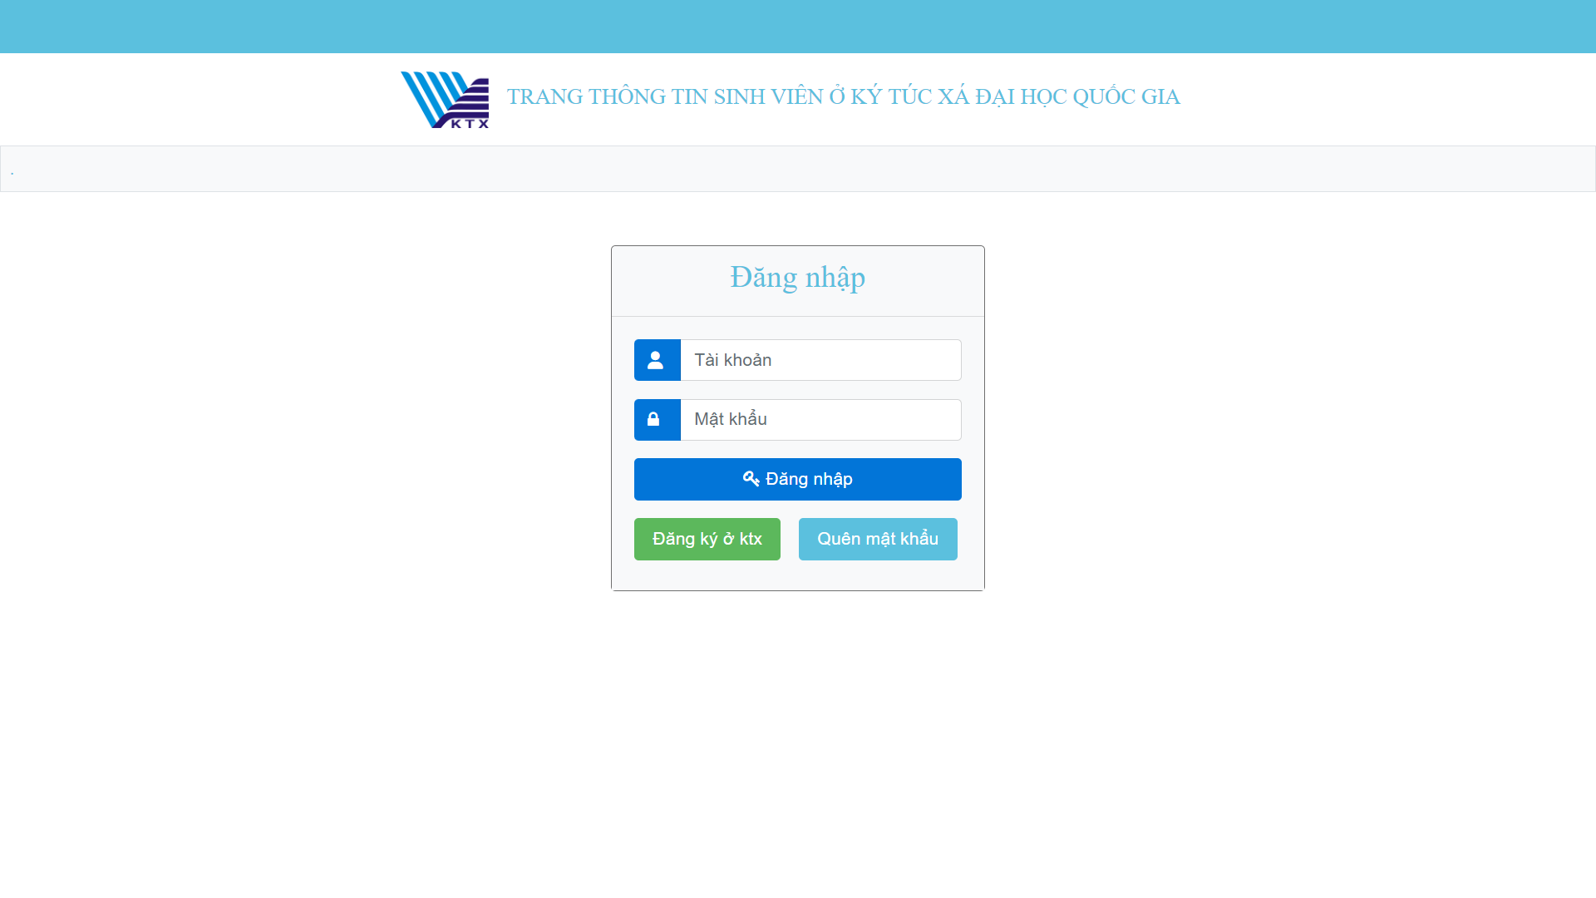

8. Login page

* Admin interface

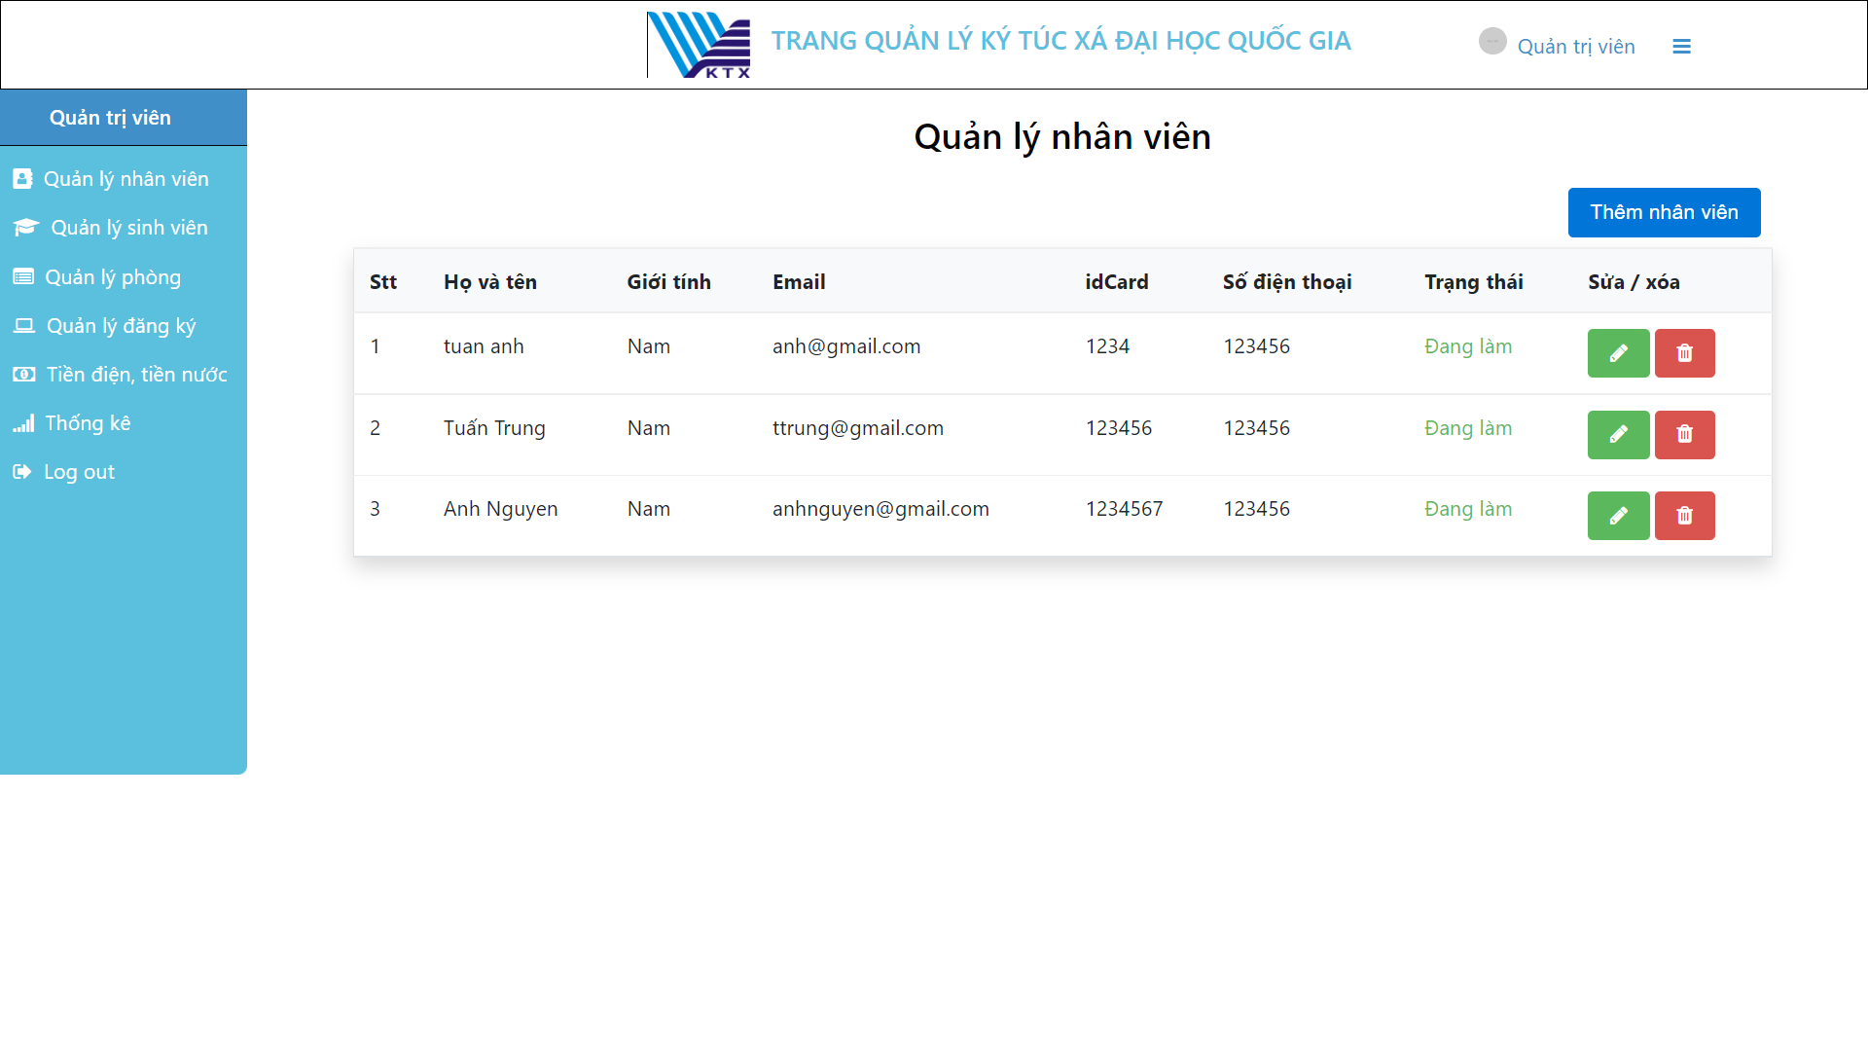

9. Manage employees for adminsator

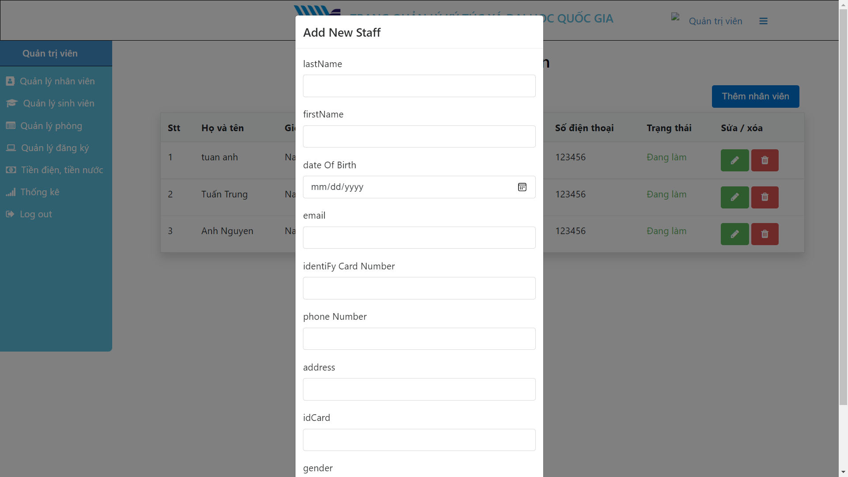

10. Input employee information form

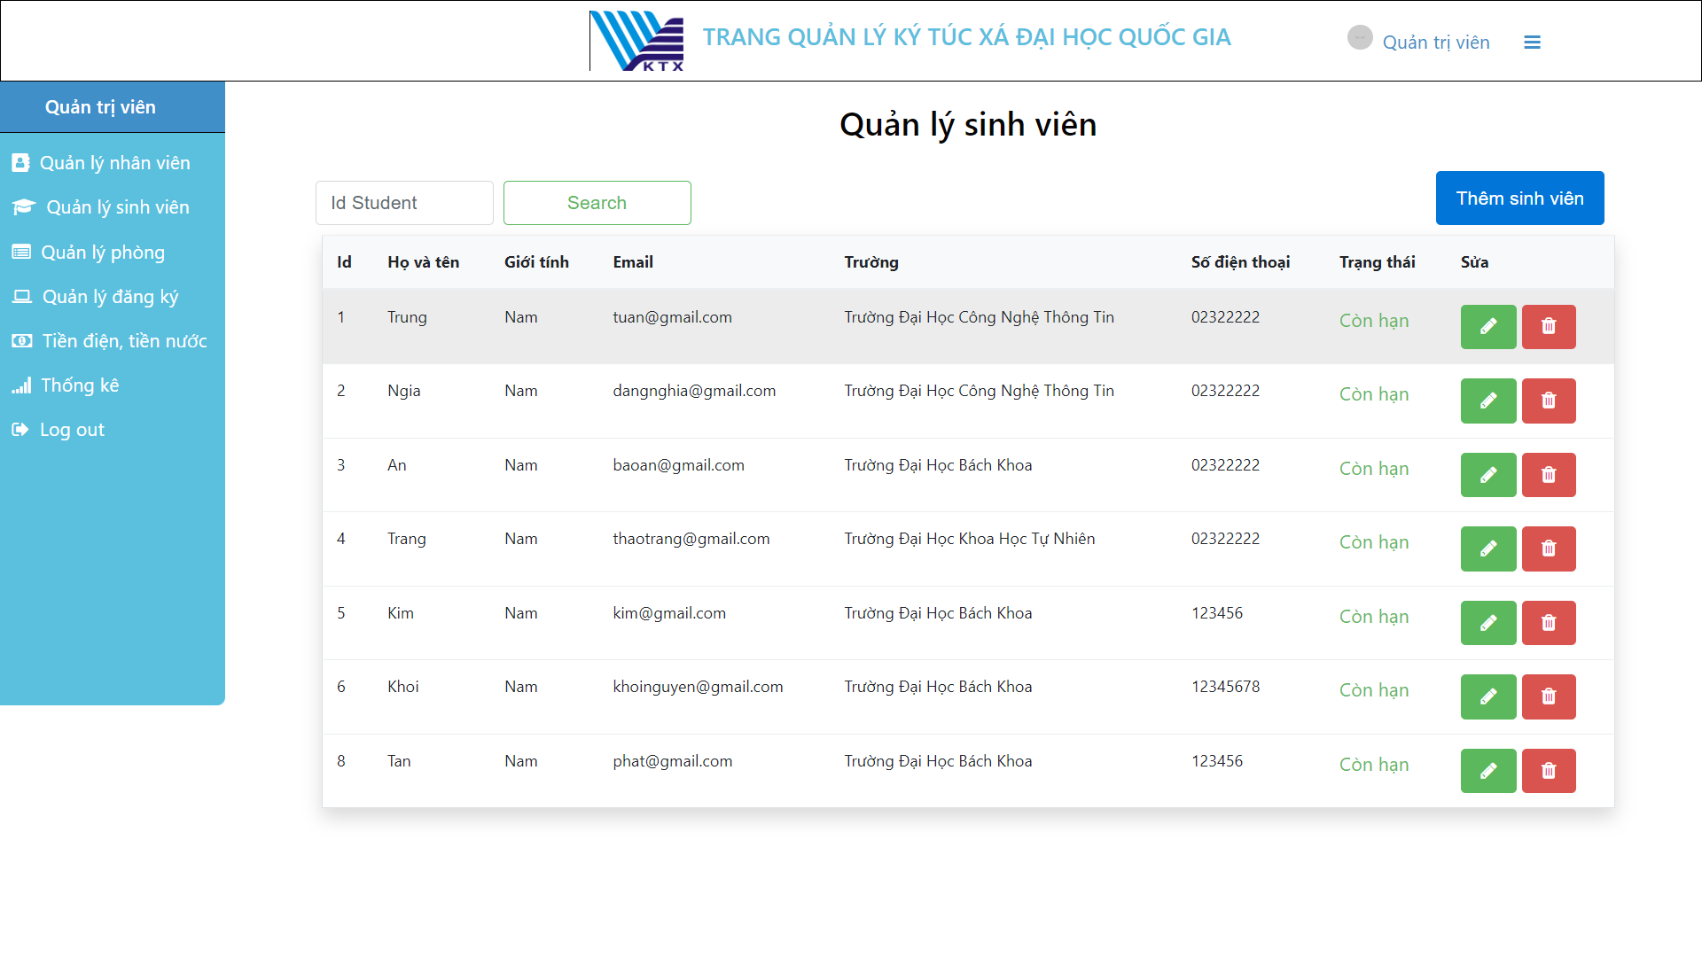

11. Manage student page for employee and adminsator

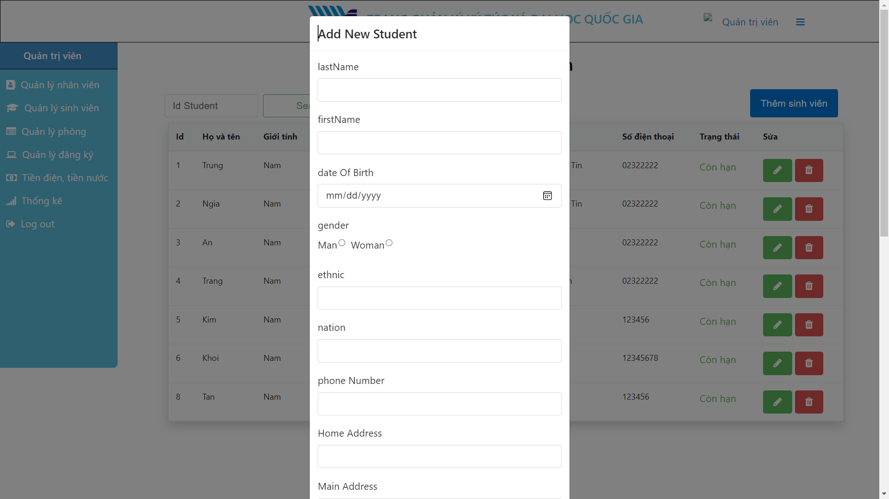

12. Input student information form

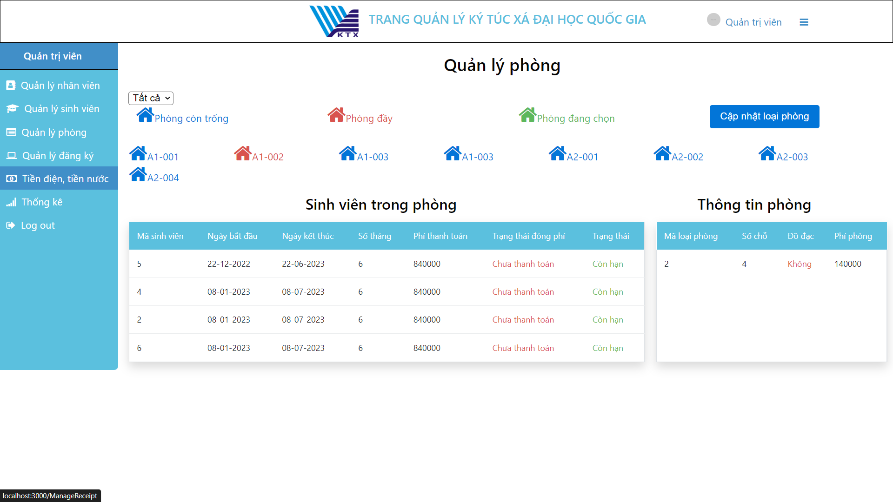

13. Manage rooms page for employee and adminsator

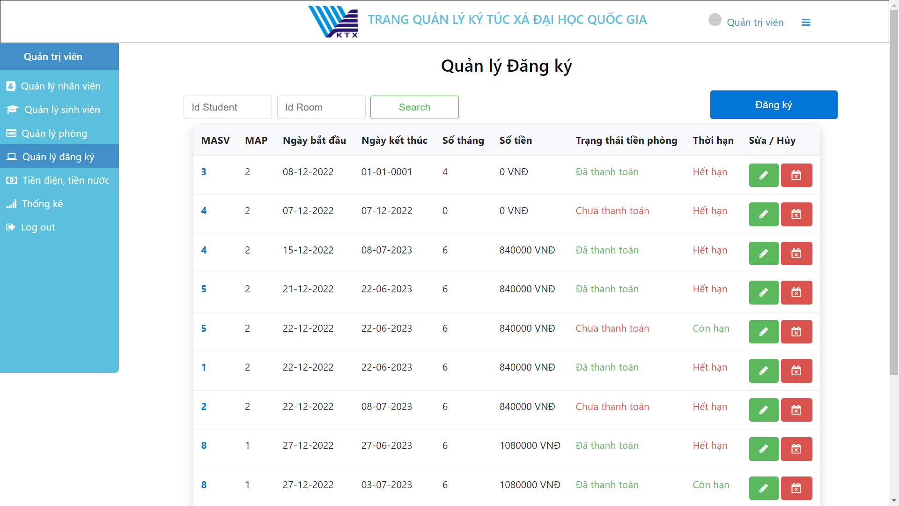

14. Manage register rooms page for employee and adminsator

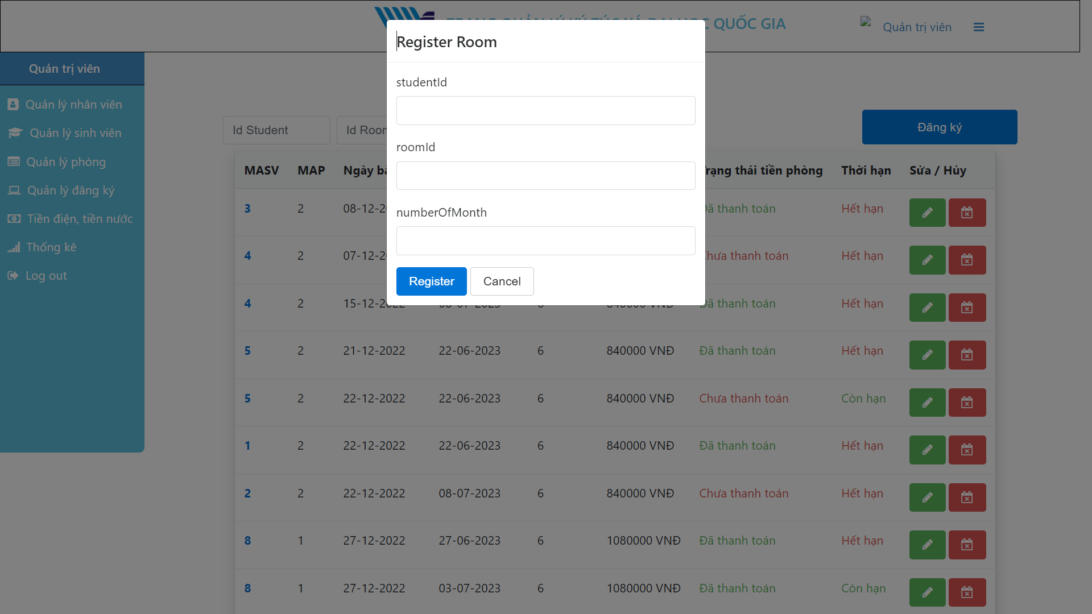

15. Input register room data form

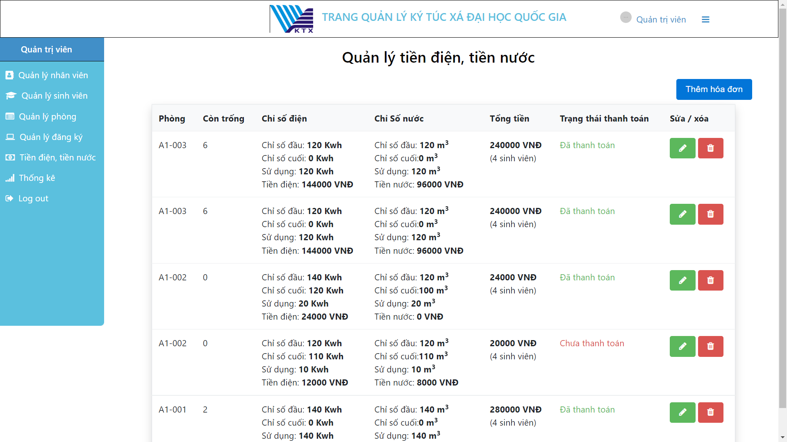

16. Mange electrics waterlog page for employee and adminsator

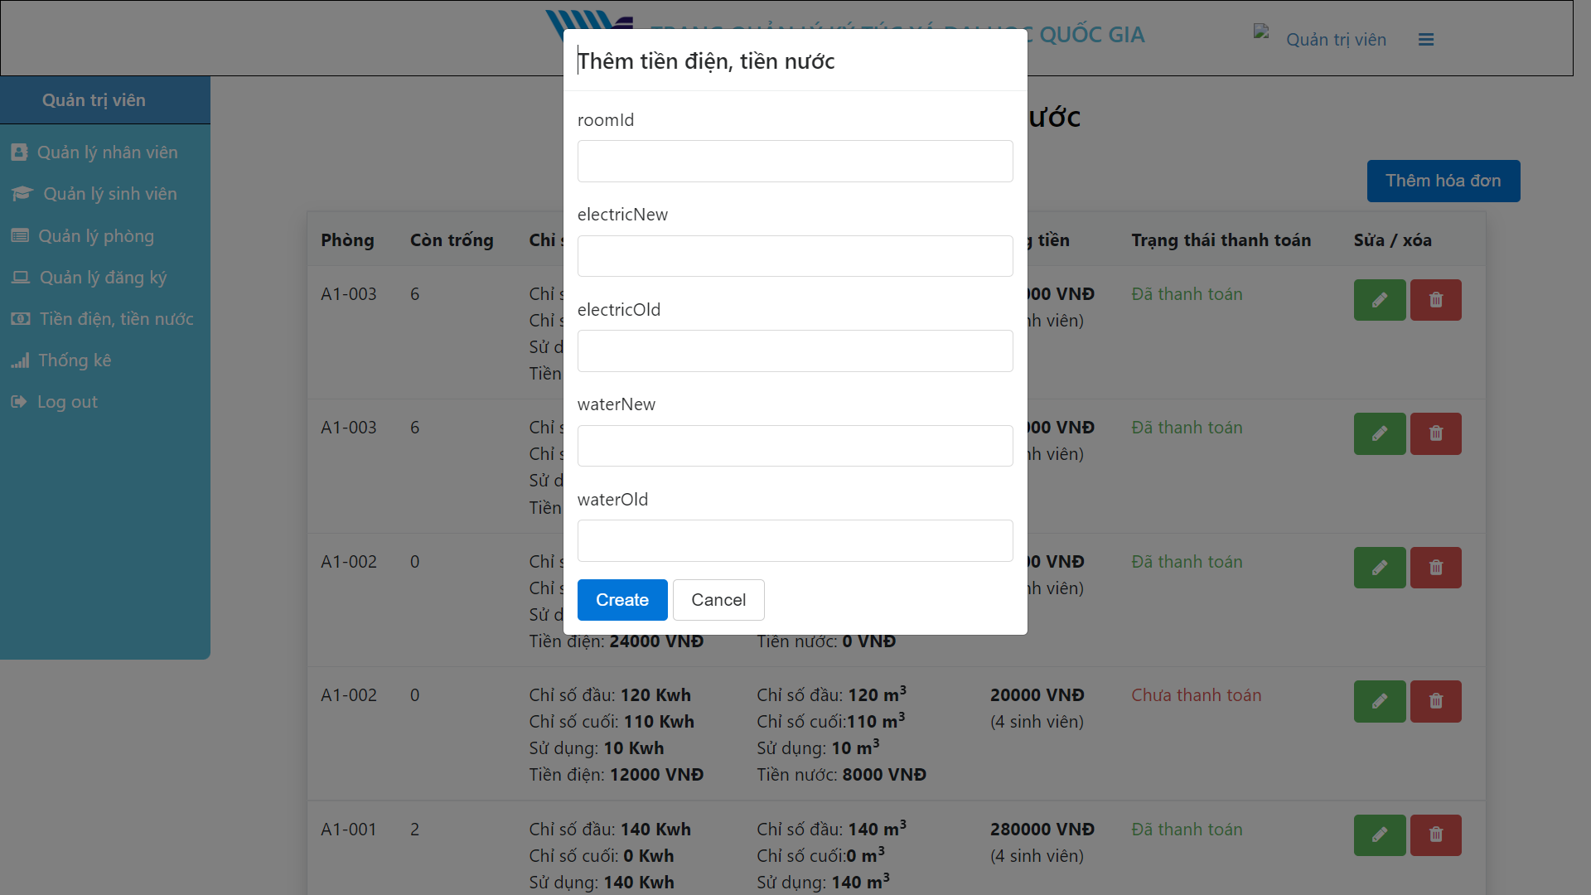

17. Input electrics waterlog data form

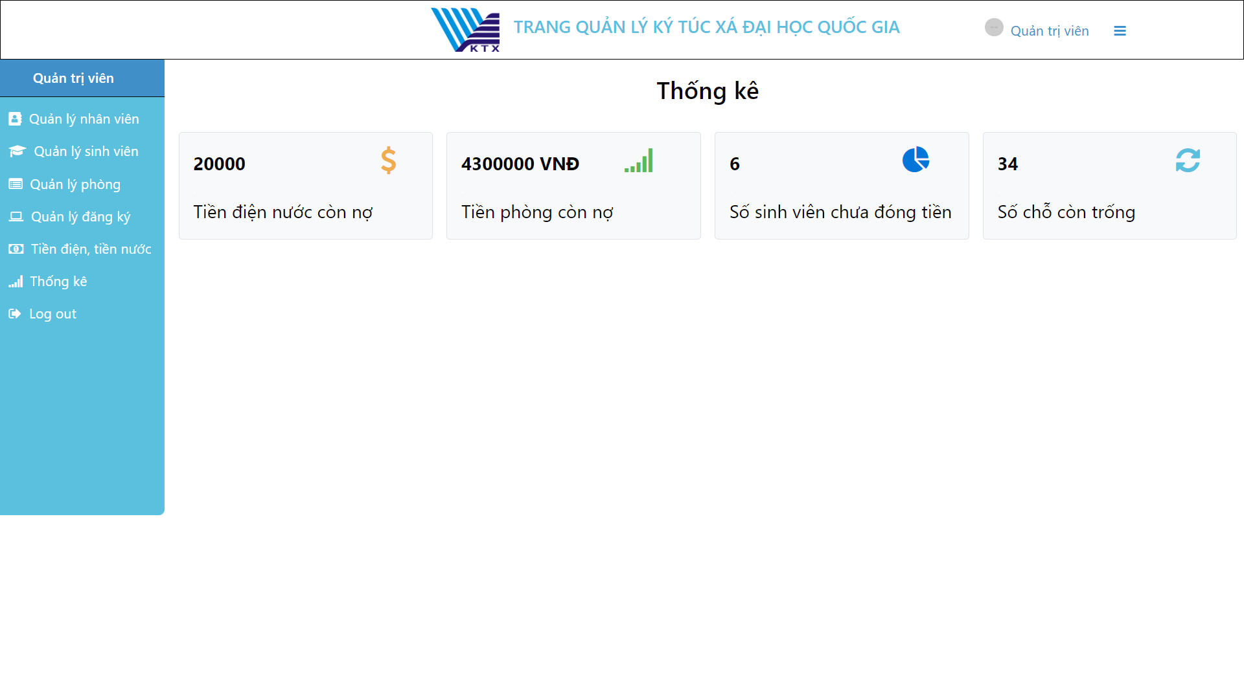

* Student interface

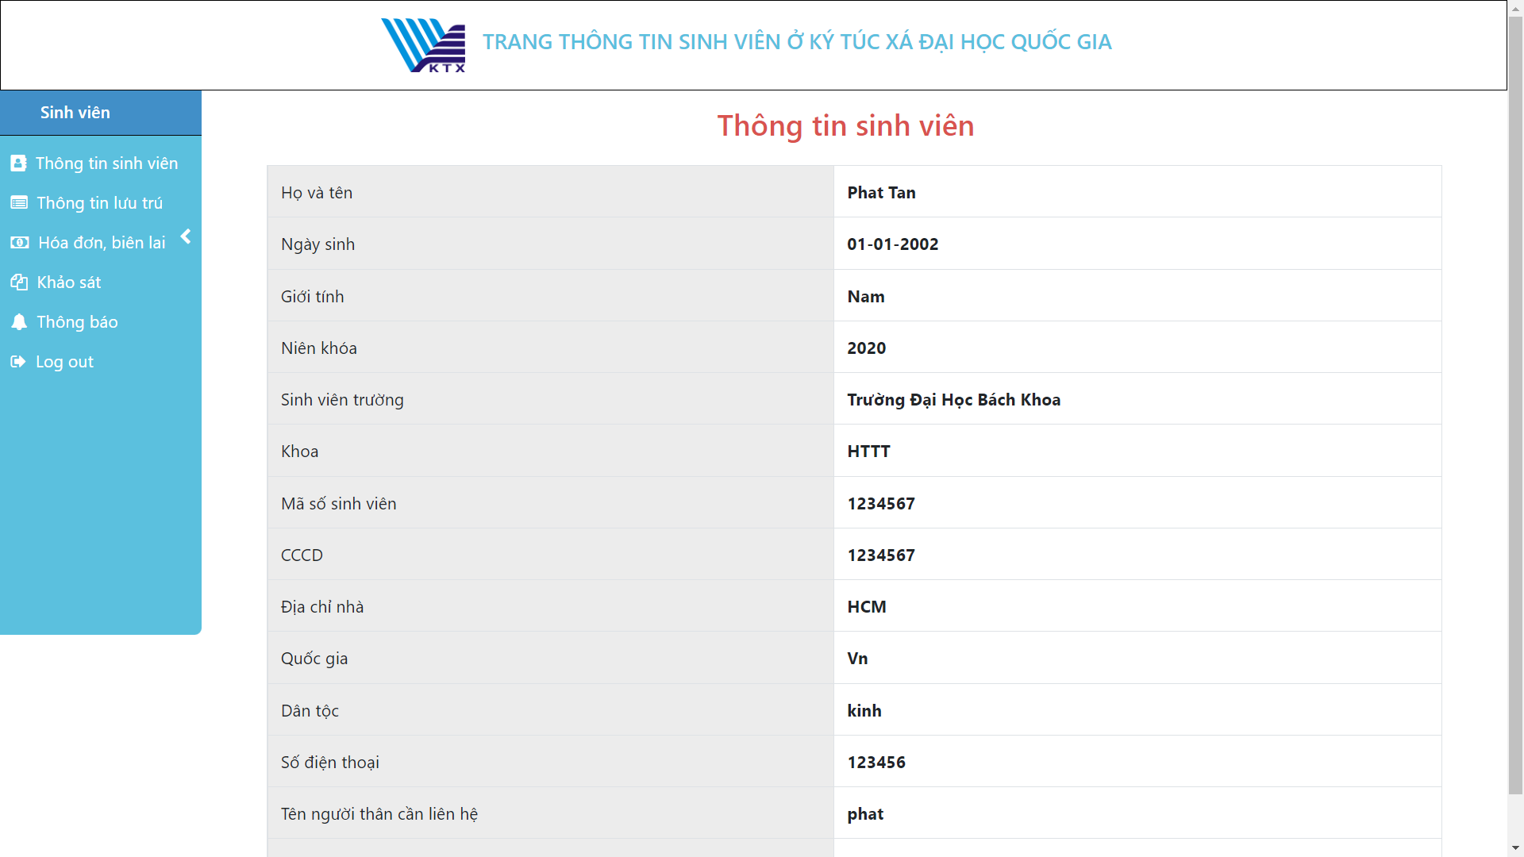

18. View student profile page

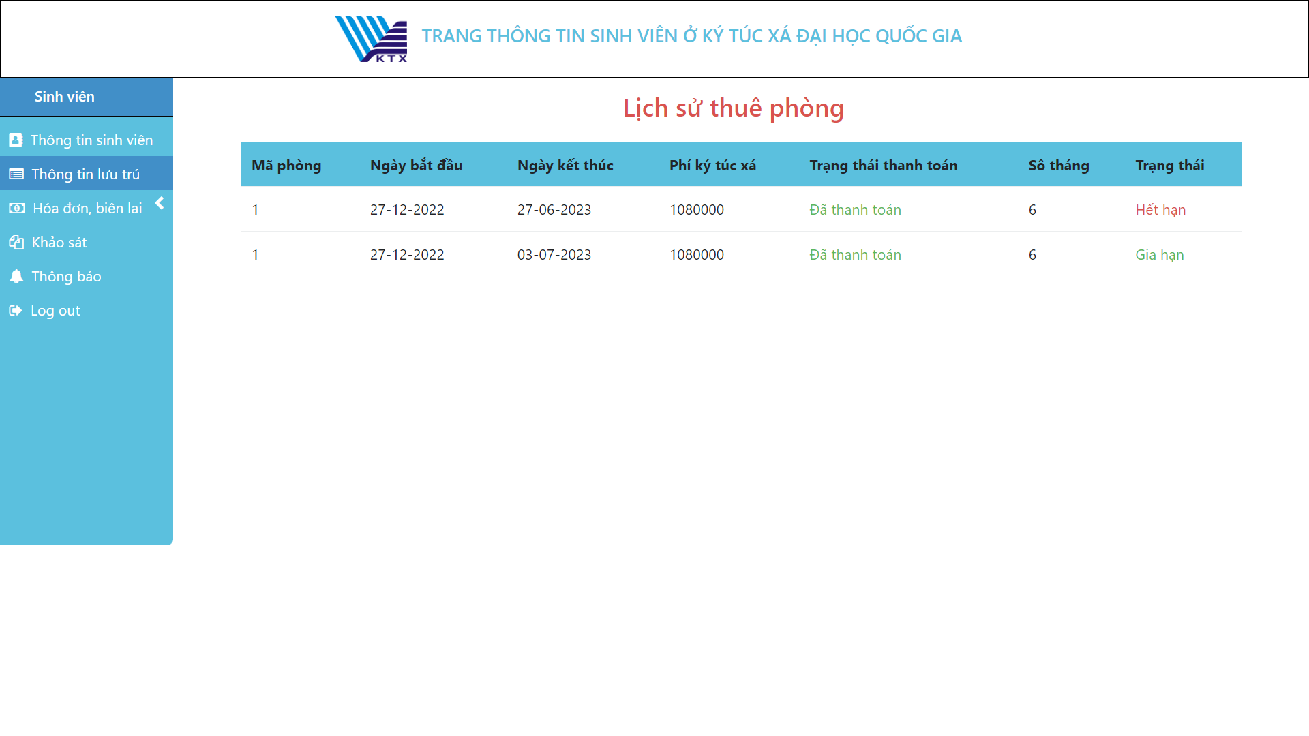

19. View stay history page

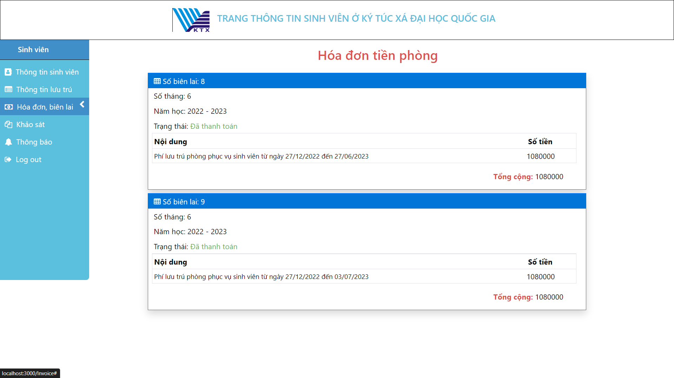

20. Accommodation bill page for student

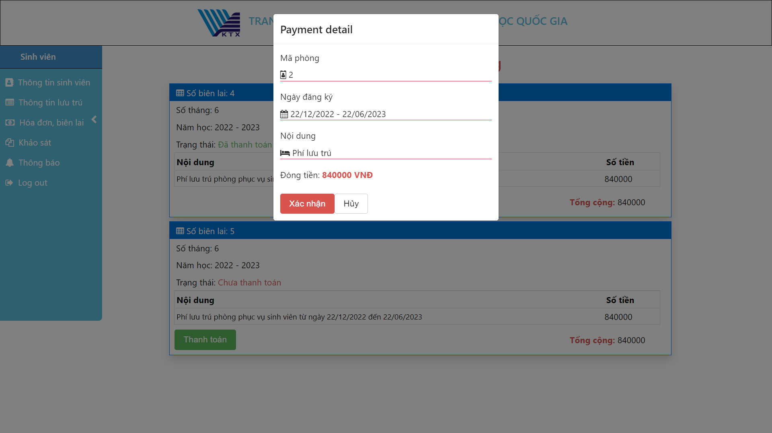

21. Payment accommodation bill form

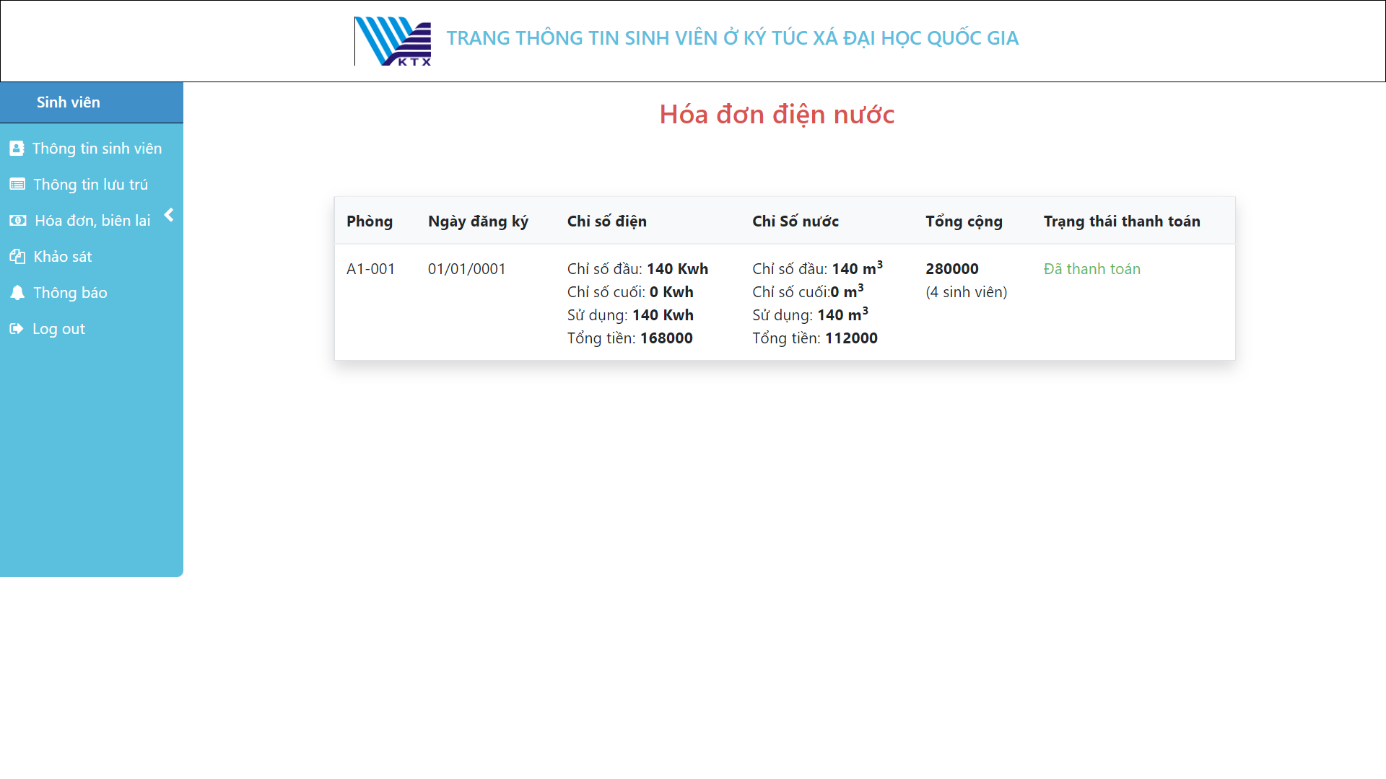

22. Electrics waterlog bill page

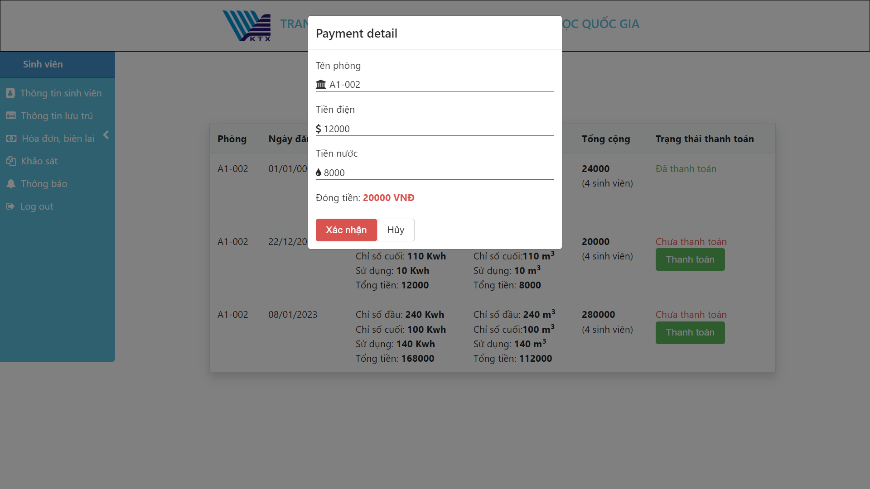

23. Payment of electric water bill form

# **CHAPTER V: CONCLUSION**

## **1. Project achievement**

From the essential needs of the students and the school, the group had the first ideas about the dormitory management website, namely the Ho Chi Minh National University Dormitory. From the objects, designs, and models, my team has built the most complete website. The group has built 2 different websites, one for students who need to register for dormitories, and the other for administrators, managers, and control of the dormitory. Although the group had difficulties in completing the project, thanks to the mutual help between members and teachers, the project was successful. Here do some functions of our system:

* Sign in for student, employee, administrator.
* Manage employees
* Manage students
* Mange dorm rooms
* Payment cost for student, employee, administrator.
* Arrange room
* View profile, view stay history
* Statistics

We used ReactJs and SQL server technologies to build the systems. Thanks to the ASP.NET, our project is separated into many modules easily, which helps us solve a lot of problems about project management.

## **2. Limitations**

Due to the limited time of the study, the study has the following limitations:

* Not logged in with Facebook, google.
* The interface is not compatible with devices such as mobile and tablets.
* There is no data recovery and backup function yet.

## **3. Development direction**

In the future, the team will develop and complete the project, specifically as follows:

* Logged in with Facebook, Google.
* The interface is compatible with devices (Laptop, PC, Tablet, Mobile).
* Build recovery and backup function.

# **CHAPTER VI: SELF ASSESSMENT**

|  |  |  |  |  |
| --- | --- | --- | --- | --- |
| No | Name | Role | Contribution | Grade |
| 1 | Dinh Hoang Tri | Leader | **Report**  - Make a word  - Check member progress  - Report format  **Chapter 1:** Overview of the topic  **Chapter 3:**  - Login for administrators, employee and students (Activity, Sequence, Class diagram).  *-* Dorm room management: insert, delete, update, search (Activity, Sequence, Class diagram).  **Chapter 5:** Summary  **Demo**  - Sign in/out  - Manage room registration | *10/10* |
| 2 | Nguyen Tan Phat | Member | **Report:**  **Chapter 2:**  - Dormitory management center organization chart.  - Process survey operations, main activities.  **Chapter 3:**  - Employee management: insert, delete, update employee information (Activity, Sequence, Class diagram)  - Payment cost: insert, delete, update invoices for administrators, employees (Activity, Sequence, Class diagram).  - Payment cost: view bill information, make payments to students (Activity, Sequence, Class diagram).  - Entity class diagram (Database)  **Demo:**  - Employee management  - Payment cost | *10/10* |
| 3 | Nguyen Anh Nguyen | Member | **Report:**  **Chapter 2:**  - Regulations and procedures in student management.  **Chapter 3:**  - Usecase diagram for administrators, employees, and students.  - Student management: insert, delete, update student information (Activity, Sequence, Class, State diagram).  - Statistics: electricity bill, room debt, number of unpaid students, number of available rooms (Activity, Sequence, Class diagram).  **Demo:**  - Student Management  - Statistics | *10/10* |
| 4 | Ho Tuan Trung | Member | **Report:**  **Chapter 2:**  - Software requirements  **Chapter 3:**  - Describe and list actors and usecases.  - View personal information (Activity, Sequence, Class diagram).  - View stay information (Activity, Sequence, Class diagram).  - Manage room arrangements: registration, change and cancellation (Activity, Sequene, Class, State diagram).  **Chapter 4:**  - Implementation and testing  **Demo:**  - Manage room registration  - View personal information  - View your stay information | *10/10* |